About a Gator #51: Logan Washburn
February 2016
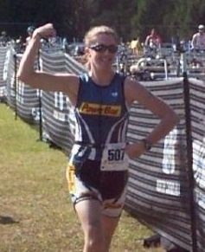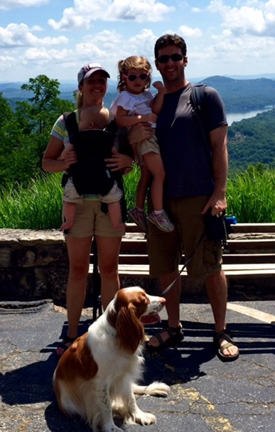
- SVYMG: What is your endurance sports background?
Logan: I grew up as a swimmer on a swim team since age six. In high school, I also ran cross country and played lacrosse. I ended up playing lacrosse at Virginia Tech and then joined the club lacrosse team while in grad school at the University of North Carolina. While in graduate school in 2003, a friend did a triathlon and I was interested. I borrowed a bike with toe cages and muscled my way through my first sprint tri. I became hooked, bought a cheap road bike, and started competing in a few triathlons of various distances over the next few years. Overall, I have completed six half-Ironman distance events and at least 20 sprint or Olympic distance events. I also ran the New York City Marathon in 2007 and I’ve run a few half-marathon and 10-mile races. The last few years I’ve been less active because I have had two children (ages 1 and 3).
- SVYMG: What are your top 3 endurance sports goals?
Logan: My three endurance sports goals are…
  - Well, cycling is my weakness. I REALLY want to improve on the bike!
  - I would love to do an ironman a few years from now when my kids are a little older.
  - Continue to do triathlons and be fit for many years to come.
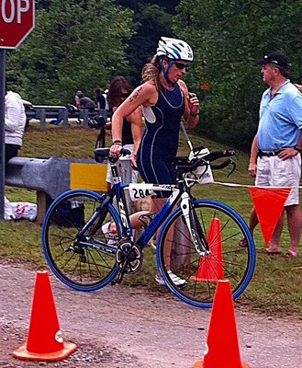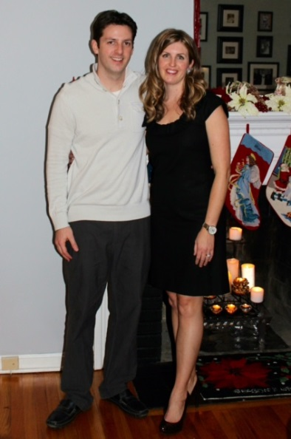
- SVYMG: What has been your favorite race in which you've participated?
Logan: Funny enough, my favorite is the "Lake Logan" Olympic Triathlon, outside of Asheville, NC. I have completed that race six times. I first noticed it because it had my name and was only a couple of hours from where I was living (in North Carolina). However, it is the most beautiful race venue and, even though it takes place in August in North Carolina, it is always cool because it is high in the Great Smoky Mountains National Park. It has wonderful scenery, it’s wetsuit legal in a clear mountain lake, it includes rolling hills... and many of my friends compete in the race every year because we all love it! We always made a trip out of it and actually CAMPED the weekend of the race :). I'm replacing it this year with the Rev3 Pocono Mountains Olympic Triathlon!
- SVYMG: What is the race that you'd most like to do?
Logan: The Ironman World Championship in Kona, HI. I have been to Hawaii four times and it is my favorite place on the planet. I saw the course in person and I know it's brutal, but it would be so amazing to be around that competition in such a beautiful place.
- SVYMG: What song would you most like to hear at the starting line of a race? How about the finish line?
Logan: I LOVE music and always train with it... To start, maybe an old-school rap pump-up song like House of Pain’s "Jump Around" or Salt-N-Pepa’s "Push It." At the finish, either Survivor’s "Eye of the Tiger" or Journey’s "Don't Stop Believin’."
- SVYMG: What has been your best endurance sports experience to date?
Logan: I don't know about best, but the most memorable was in 2009 when I was doing a half Ironman triathlon and had a bike crash at the water bottle hand-off at mile 18. The volunteer didn't let go of the water bottle fast enough and I got pulled sideways and went down hard on my left side. I was hurting, but I was also mad because of what happened and all the training I had done. To top it off, it was less than three weeks before my wedding! I got my bike straightened up and hopped back on and finished as hard as I could while only holding on with one hand. The pain from the crash helped me ignore any other normal race pains. Turns out, I separated my shoulder and had road rash all down my arm and leg, but I still managed to finish under 5:40. My husband still thinks I'm nuts!
- SVYMG: Do you have an endurance sports tip or two that you'd like to share?
Logan: Always do whatever YOU can do… Don't compare yourself to others. Other than that, drink a LOT of water and rest when your body is telling you that it needs it!
- SVYMG: If you have one, who is your favorite professional endurance sports athlete?
Logan: Paula Newby-Fraser is my favorite. Both of mydegrees are in exercise science and physiology. Even though she became a standout and accomplished triathlete, I vividly remember watching her 1995 Kona race collapse in class when learning about proper hydration, fuel, and "bonking." I also remember thinking that triathletes were crazy for all of the things they put their bodies through on a physiological level... Haha!
- SVYMG: What is one interesting thing about yourself that has nothing to do with endurance sports that you'd like to share?
Logan: This past August, I moved to Pennsylvania from North Carolina due to a job transfer for my husband. This club has helped a lot with my transition!
- SVYMG: Any other background info you'd like to share?
Logan: I have a wonderful husband (Mike), a three year old girl named Finley, and a one year old boy named Luke. I also have an awesome dog, Ralphie. I work part-time at the Spring Valley YMCA as a personal trainer and I will also be taking the USAT Level 1 Coaching Certification course this April! Other than work and family (and triathlons), I love to cook, listen to music, and to dance.
