About a Gator #50: Mike Aliprantis
November 2015
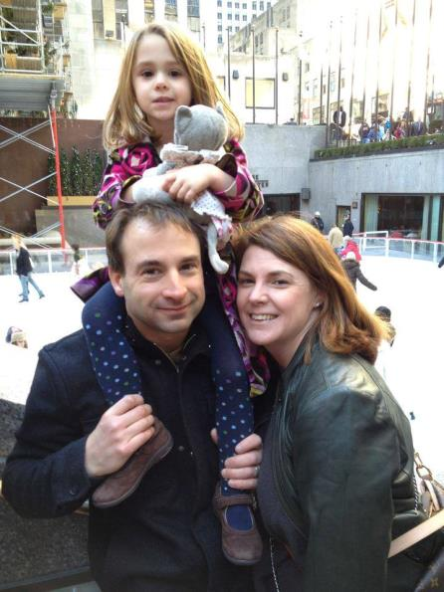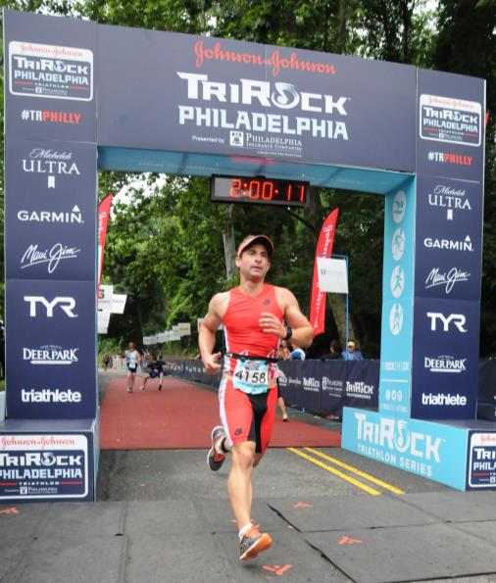
- SVYMG: What is your endurance sports background?
Mike: Outside of a few 5K races, my background consists of three triathlons over the past two seasons. I grew up as an ice hockey player and only recently gained interest in triathlons through a friend who has always spoken about how much I was missing. After one cold February 2014 afternoon playing hockey and a couple beers, he finally convinced me to sign up for my first race, “Escape the Cape”. I have to say, waking up the next morning realizing I signed up for my first tri with a start in the ocean and getting there by jumping off the Cape May ferry motivated me to improve my swimming really quickly!
- SVYMG: What are your top 3 endurance sports goals?
Mike: Since I’m relatively new to endurance sports, I am really just looking for improvement. Considering I wasn’t capable of swimming more than two laps less than two years ago, it makes me want to continue to try to improve and maybe one day extend the length of my races. The last goal is to overcome pre-race jitters and get a good night sleep before events.
- SVYMG: What has been your favorite race in which you've participated?
Mike: I don’t have a long resume of races, but each one I have really enjoyed for different reasons. The events I have done at the beach I like the best as they are very convenient from our beach house in Cape May. They also allow my family to easily get out and watch me race while enjoying a day at the beach.
- SVYMG: What is the race that you'd most like to do?
Mike: Austin Tri Rock… I’m moving to Austin, Texas in the new year.
- SVYMG: What song would you most like to hear at the starting line of a race? How about the finish line?
Mike: Anything by Avicii.
- SVYMG: What has been your best endurance sports experience to date?
Mike: I would say the 2015 TriRock Philadelphia Triathlon. Most would consider it to have been a complete disaster for me. The swim for which I trained really hard was cancelled due to the weather. And then I blew a tire during the bike leg. On top of the blown tire, I collided with an oncoming cyclist as I had no control of me bike with a deflated tire. Since my rim was now inoperable, I ended up carrying my bike a couple of miles back to transition. Despite all of these troubles this race was the most memorable race as I somehow persevered through the adversity to complete the race, get my finisher medal, and shake hands with the CEO of my company (Johnson & Johnson) who was waiting at the finish line. Also, helping raise over $500,000 for CHOP as part of my company’s fundraising efforts made this a very rewarding overall experience.
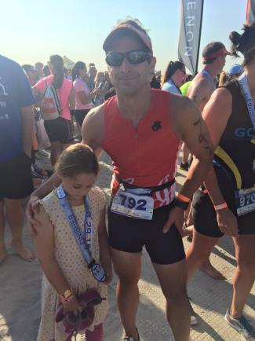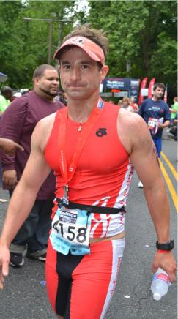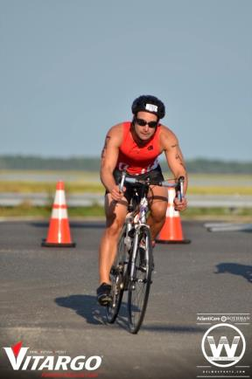
- SVYMG: If you have one, who is your favorite professional endurance sports athlete?
Mike: I don’t really have one, but I have to say that the drive and determination of the members in the club are truly inspiring! I also really appreciate the encouragement and tips from everyone along the way.
- SVYMG: What is one interesting thing about yourself that has nothing to do with endurance sports that you'd like to share?
Mike: My family and I are moving to Austin, Texas in January.
- SVYMG: Any other background info you'd like to share (family, career, hobbies, etc.)?
Mike: I currently live in Skippack Township and work at Johnson & Johnson as a lead financial systems analyst. JNJ is a huge supporter of the TriRock Philadelphia Triathlon. I plan to try to return to Philadelphia and compete in that race once we are settled in Austin.
Editor’s Note: Mike, it’s been great getting to know you the past couple of years, especially as we’ve both worked to improve our swim technique in the evening Tri Swim workouts. Best of luck in Austin, stay in touch to let us know how things are going, and definitely let us know if you are in town for TriRock Philadelphia in June 2016 so we can catch up with you and cheer you on to a less eventful finish than last year… Once a Gator, always a Gator!

