About a Gator #49: Heather Irwin
September 2015
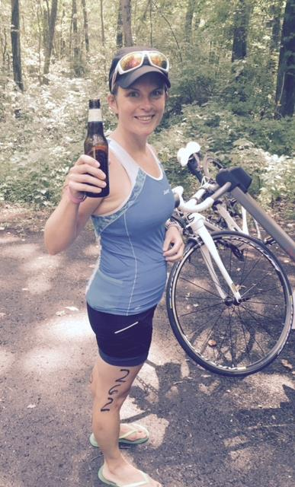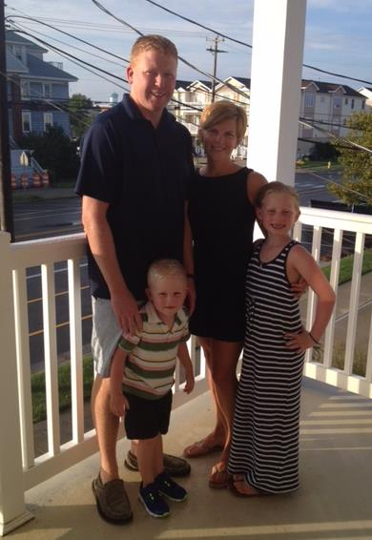
- SVYMG: What is your endurance sports background?
Heather: I have always loved to swim and grew up swimming on the swim team. After college I bought a mountain bike and actually rode in the Sea Gull Century in Salisbury, MD and Bike New York where you bike the five boroughs of New York City. Not sure what I was thinking doing these on a mountain bike!! I had always thought about doing a triathlon but hated running so I dismissed this thought. It wasn't until the summer of 2011 and after the birth of my second child that I started to run. I had never run in any type of race and my friend asked if I wanted to run the Philadelphia Rock and Roll Half Marathon that fall. Again, I'm not sure what I was thinking, but I agreed and got hooked. Then I took the “Intro to Tri” class at the YMCA one summer and met some women that were training for the Sherox Triathlon… This was my first triathlon experience.
- SVYMG: What are your top 3 endurance sports goals?
Heather: My endurance goals are to…
- Complete a Full Marathon
- Complete a Half Ironman triathlon
- And clip in on my bike and get a wet suit!!
- SVYMG: What has been your favorite race in which you've participated?
Heather: My favorite has been the Lucy Town Half Marathon in my hometown of Jamestown, NY, the birthplace of Lucille Ball. It was a small race, but it was fun to run back home where I grew up and see my family and friends cheering along the entire course.

- SVYMG: What is the race that you'd most like to do?
Heather: A Half Ironman event. I haven't decided which one yet, but I’m shooting for 2016.
- SVYMG: What song would you most like to hear at the starting line of a race? How about the finish line?
Heather: At the starting line… House of Pain’s “Jump Around” and at the finish line… U2’s “Beautiful Day”.
- SVYMG: What has been your best endurance sports experience to date?
Heather: I will never forget the feeling of crossing the finish line of my first half marathon! It wasn’t pretty… I finished in 2:40… but I had such a sense of accomplishment; I had tears in my eyes when I finished. Then, fast forward four years… I had a personal best at the Love Run this year taking 35 minutes off from my first half!
- SVYMG: Do you have an endurance sports tip or two that you'd like to share?
Heather: My tips are…
- Don't ignore your nutrition… It is key.
- Try to find a balance between training and family (this has been tough for me at times).
- SVYMG: Who are your favorite professional endurance sports athletes?
Heather: She’s not a professional, but I have a friend that I grew up with who was a very good high school runner. She got injured and started dabbling in triathlons. She now races for Team Wattie Ink. I am also inspired by all the moms out there training for anything from a 5K to an Ironman triathlon.
- SVYMG: What is one interesting thing about yourself that has nothing to do with endurance sports that you'd like to share?
Heather: I went to West Virginia University and played the clarinet in the “Pride of West Virginia Marching Band”… Yes, I am a band geek at heart!
- SVYMG: Any other background info you'd like to share?
Heather: I am a Registered Dietitian and I work at Paoli Hospital. I love everything to do with the field of nutrition. Also, I will be celebrating my 10th wedding anniversary on September 10th. I have two great kids… Bridget (8) and Connor (4)… that keep me very busy!!
