About a Gator #48: Eric Afre
August 2015
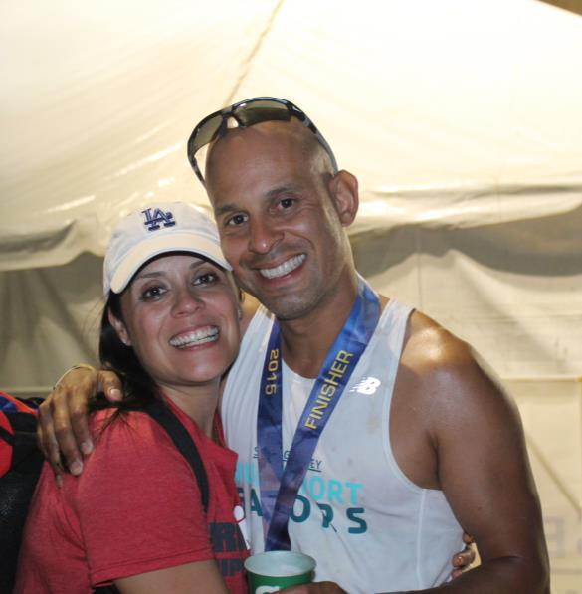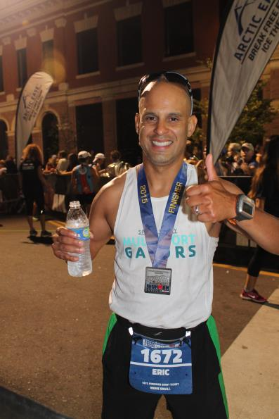
- SVYMG: What is your endurance sports background?
Eric: My background is real simple…SOCCER! I’ve been playing soccer since I was five years old. I was that kid that played all year without a break. After my long soccer career was over, I decided that I was going to jump into some endurance races, which started four years ago. Since, then I have completed two marathons, three half marathons, two 10k’s, one 15k, and a handful of triathlons including three sprints, three Olympics, a half Ironman, and, just recently, an Ironman.
- SVYMG: What are your top 3 endurance sports goals?
Eric: My tops 3 endurance goals are to…
  - Finish an Ironman event with my wife, Irene
  - Complete another Ironman event at an overseas location
  - Qualify for and participate in the Boston Marathon
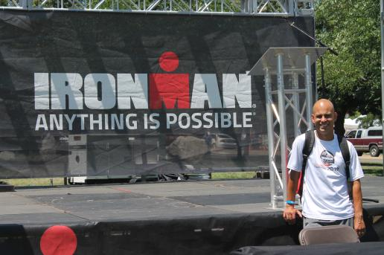
- SVYMG: What has been your favorite race in which you've participated?
Eric: My favorite race was my first Ironman in Boulder, Colorado earlier this month. The reason this was my favorite race is because I was able to complete it in front of my wife. The journey that it took to get this done was not easy. In addition to that, the view, the crowd, and the overall experience were beyond first class. I would do Boulder again in a heartbeat, but this time I would fly to Colorado, not DRIVE!!!!!!!!!!!!!!
- SVYMG: What is the race that you'd most like to do?
Eric: I would love to do Ironman Madrid or Ironman Austria.
- SVYMG: What song would you most like to hear at the starting line of a race? How about the finish line?
Eric: At the starting line… Rage Against The Machine’s “Killing In The Name” and at the finish line: Black Sabbath’s “Ironman”.
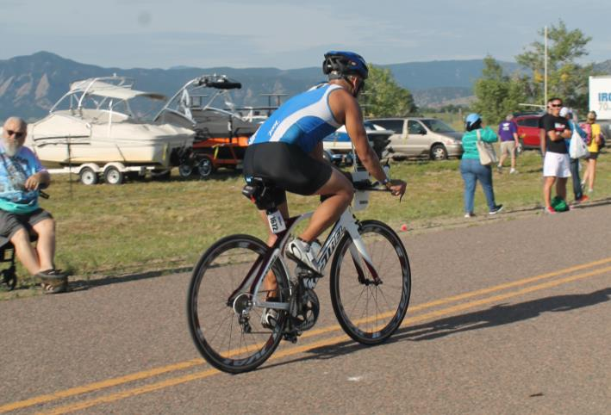
- SVYMG: What has been your best endurance sports experience to date?
Eric: I would have to go back to Ironman Boulder. Besides the obvious (landscape of the course and the beautiful swim) my experience began the moment I arrived in Colorado. I re-united with three good old friends from San Antonio, Texas who introduced me to the triathlon world. The running joke all the time was about us completing an Ironman together. Yes, go figure they chose Boulder, Colorado, not taking the altitude and travel into consideration. I remember not sleeping the night before and getting ready for the race around 4:00am. The entire time I was playing in my head “So, what if I don’t finish this thing? Man, if I don’t finish my wife is going to kill me! I can’t disappoint my kids! OMG what would the Gators think of me” (Editor’s Note: We’d still love you!)… The moment all four of us lined up for the swim I knew I would be okay. We looked after each other in the swim, bike, and run. The moment I saw that red carpet everything around me went silent. I could see the bright lights and was thinking to myself…”I made it! I want my bed!” Then, hugging my beautiful wife near the finish line was the best ever!
- SVYMG: Do you have an endurance sports tip or two that you'd like to share?
Eric: Take your training seriously, have fun, and do not neglect the nutrition part of it.
- SVYMG: Who are your favorite professional endurance sports athletes?
Eric: Andy Potts and Craig Alexander
- SVYMG: What is one interesting thing about yourself that has nothing to do with endurance sports that you'd like to share?
Eric: I lived in Guatemala, Central America for nine years. During my time there, I was able to travel throughout Costa Rica, Belize, El Salvador, Honduras and Mexico. Also, my grandfather played for the Honduras National Soccer Team and represented his country in two World Cups.
- SVYMG: Any other background info you'd like to share?
Eric: My wife, Irene, and I were born and raised in the Los Angeles area. After one year of being married we had our beautiful daughter, Emilia Afre. Six months after Emilia was born we relocated to San Antonio, Texas, where we lived for three years. During that time our Texan son, Alessandro Rafael, was born. However, it doesn’t stop there… We then decided to embark on another adventure and relocated to Collegeville… You got to love corporate life!!!!


