About a Gator #46: Jeff Spillane
July 2015
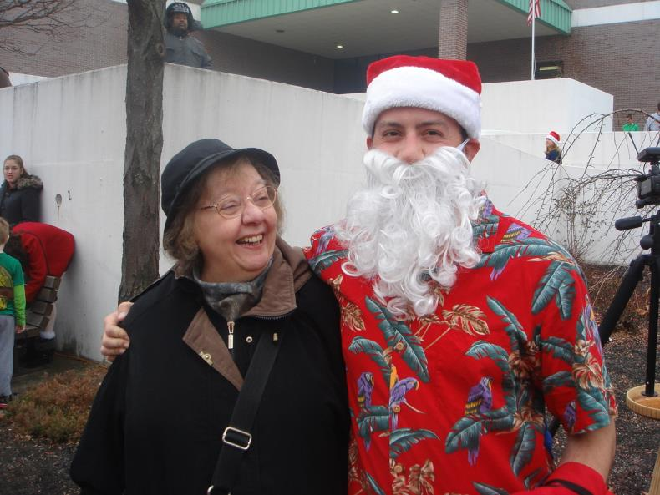
- SVYMG: What is your endurance sports background?
Jeff: I’ve done the big three “races”… Funky Santa (2012), Rocky Run (2014), and Key West Triathlon (2014).
- SVYMG: What are your top 3 endurance sports goals?
Jeff: My top three endurance goal in order are…
- Get through the 2.4 mile swim at Ironman Lake Placid within time
- Finish the 112 mile Lake Placid bike course before 5:30pm
- Cross the Lake Placid finish line after 26.2 mile run before 11:59pm on July 26, 2015.
- SVYMG: What has been your favorite race in which you've participated?
Jeff: Funky Santa Run… it was literally the first time I had run for anything (other than running to catch a bus) since college. When I finished, I ran into my Mother at the finish area. She had stopped by to see what was going on… when she saw me she asked what I was doing there. I told her I was there for the run. She then asked seriously, “but why are you here?” I said, “I just ran the Funky Santa run”… She looked at me confused and said, “But you don’t run…”
- SVYMG: What is the race that you'd most like to do (include why if you'd like)?
Jeff: Right now I just want to finish Ironman Lake Placid Ironman.
- SVYMG: What song would you most like to hear at the starting line of a race? How about the finish line?
Jeff: I thought I wasn’t allowed to listen to music during an Ironman… so I’ve been practicing without music. But I guess maybe if I had a song… “I Wanna Get Better” by Bleachers.
- SVYMG: What has been your best endurance sports experience to date?
Jeff: Hmm, maybe the Rocky Run… that was fun. And yes, I ran the whole thing wearing the boxing gloves.
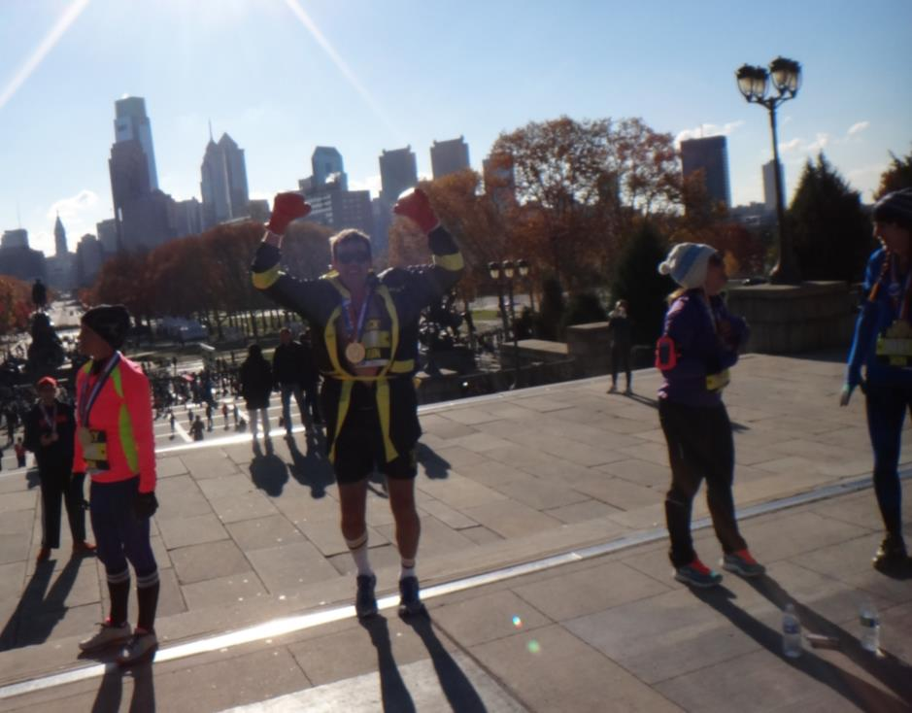
- SVYMG: Do you have an endurance sports tip or two that you'd like to share?
Jeff: Don’t go on a ship for two months and return four weeks before an Ironman and think it’s going to be easy.

- SVYMG: If you have one, who is your favorite professional endurance sports athlete?
Jeff: Mickey Mantle… he played at a time when you actually had to endure to play.

- SVYMG: What is one interesting thing about yourself that has nothing to do with endurance sports that you'd like to share?
Jeff: One interesting thing is I had nothing to do with endurance sports until a year ago… I was a spectator a few times but for most of us that know… you don’t build a lot of endurance from watching.

- SVYMG: Any other background info you'd like to share (family, career, hobbies, etc.)?
Jeff: I work as a college professor in New York. I teach college kids how to drive ships. Not fishing boats or little party boats… Ships. What’s the difference between a boat and a ship? You can put a boat on a ship… but you can’t put a ship onto a boat. I have an Unlimited Tonnage Master’s license. So whatever size boat or ship it is, I can drive it. It takes about ten years of actively sailing on large cargo vessels to get that license. Most of my time was driving tankers up and down the west coast. But I’ve done a few “round-the-world” trips on containerships, bulk cargo (grain) ships, Car Carriers, etc.
So I travel a lot for work which makes training difficult. My contention is that it’s difficult but not impossible to finish these races with a difficult schedule. We’ll find out in a week how far off I am. I do believe it would be a lot easier if you followed a training plan religiously.
