About a Gator #45: Rebecca Bonawitz
June 2015
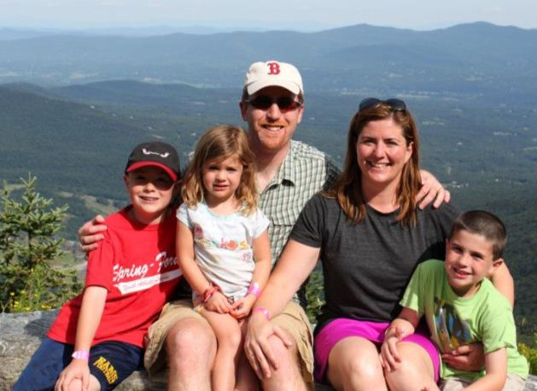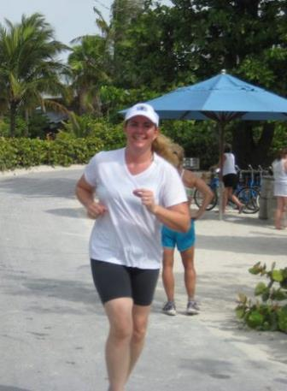
- SVYMG: What is your endurance sports background?
Rebecca: Growing up I was involved in four sports per year including cross country, basketball, track and swimming. To get around in my hometown and later, when I lived in Boston, I rode my bike. After college I moved to Boston and continued to run, particularly with the “Hash House Harriers” (combining two great things together) and then got working on my bucket list and the Boston Marathon was on it. So, I raised the funds to get in, which I think was more painful than the training.
I moved to Pennsylvania with my husband and continued to race here and there with my neighborhood group, the “Bartlett Drive Running Club”. We did a few relays as well as competed in the “20 in 24” (Philadelphia running event) a few times , the Philadelphia Half Marathon, and a Warrior Dash.
I started my tri adventure with Maribeth with the “Intro to Tri” class for a few years and finally dipped my toes into competing, and I’ve pulled a friend into it with me so I minimize my excuses not to train. Right now I have exclusively done sprints and I’m looking forward to my first Olympic distance event this summer.
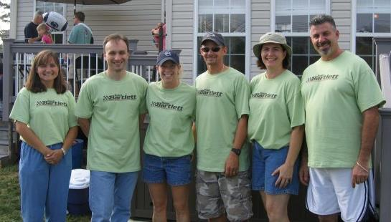
- SVYMG: What are your top 3 endurance sports goals?
Rebecca: My top three goals are…
- Complete 50 triathlons by age 50
- Complete an Olympic distance triathlon
- Get faster in my runs
- SVYMG: What has been your favorite race in which you've participated?
Rebecca: Doyle’s Emerald Necklace… It’s a small race held the weekend before the Boston Marathon that starts and finishes at a local bar. The neighbors come out to cheer and the after party is really great!
- SVYMG: What is the race that you'd most like to do?
Rebecca: I would love to do a Spartan race, preferably in Fenway Park, because Boston is wicked pissah.
- SVYMG: What song would you most like to hear at the starting line of a race? How about the finish line?
Rebecca: Starting line… the National Anthem. Finish line… Justin Timberlake’s “SexyBack”.
- SVYMG: What has been your best endurance sports experience to date?
Rebecca: The Boston Marathon
- SVYMG: Do you have an endurance sports tip or two that you'd like to share?
Rebecca: Lube more than you think you need to and get more sleep than you are used to.
- SVYMG: Who is your favorite endurance sports athlete?
Rebecca: Team Hoyt (not professional however most inspiring to me).
- SVYMG: What is one interesting thing about yourself that has nothing to do with endurance sports that you'd like to share?
Rebecca: I am probably the fastest chugger you have ever met!
- SVYMG: Any other background info you'd like to share?
Rebecca: My career path was set at age 16 when I blew out my knee playing basketball. I went to the University of Vermont for Physical Therapy and met my best friend who I married eight years later. I have three children… Will (11), Jamie (9), and Abby (7).
