Spring Valley Multisport Gators Sponsors 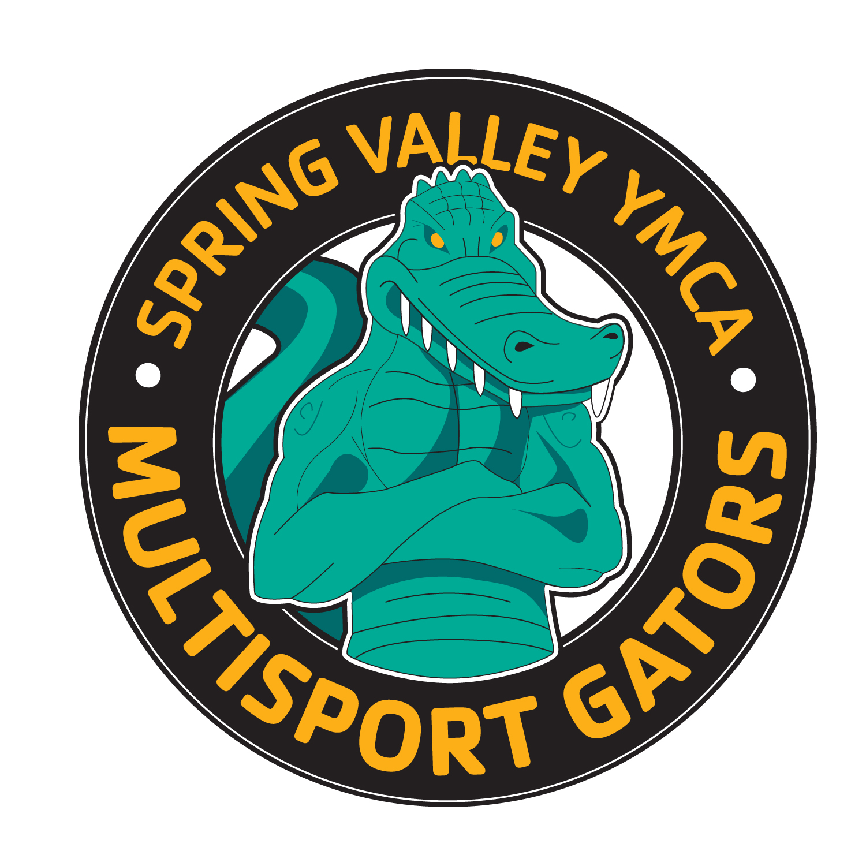

Sponsor | Demographic Info | Club Benefit
Centre for Healing Arts  Dr. Mike Connelly  CLUB LEAD SPONSOR | 695 N Lewis Rd.  Limerick, PA 19468  (610) 495-4550  http://www.centreforhealingarts.com/ | Complimentary exam, xray and 1 hour massage.  Also if a member has insurance benefits I would use them. If not cash fees follows:  - $30 Adjustments (normally $55)  - $10 physical therapy modalities (normally $15)  - 1 hr massage $55 (normally $70)  - 1/2 hr $30 (normally $40)
Chester County Running Store | Suburbia Square Shopping Center  38 Glocker Way, Pottstown, PA 19465  610.327.4843 (phone)  610.327.4864 (fax)  www.runccrs.com/ | 15% Discount on products
Bikeworks | 500 Main Street  Harleysville, PA 19438  215-513-7550  www.guaranteedfun.com/ | 5% off Bike Purchases  10% off all other products
TriVillage | www.trivillage.com | 20% off full priced items (code: svmgators20)  5% off already discounted items (code: svmgators5)
Maxout | tina@maxoutstudio.com | 15% off private training and no consultation fees
Infinit Nutrition | Emily Elsbrock  Emily.E@infinitnutrition.us  (513) 791-3500 ext. 104  www.infinitnutrition.us | 10% off on all products and gear (code: SVGATORS)  40% off custom blend formula (held one day per year)
Nutrition in Motion | Joanna Chodorowska  www.nutrition-in-motion.net  info@nutrition-in-motion.net | 10% off nutrition coaching
Mainline Financial | amatarazzo@mlfa.com | 25% discount on federal/state income tax preparation.


