About a Gator #44: Stephanie Stranick
June 2015
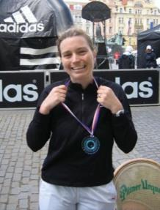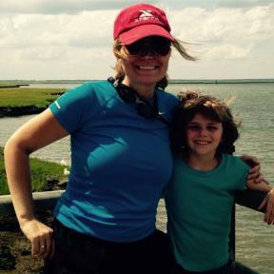
- SVYMG: What is your endurance sports background?
STEPHANIE: I started my endurance sports training in high school and college track and cross country. Over the years I have completed a slew of 5Ks and 10Ks in New York and Pennsylvania plus the Broad Street Run, the Philadelphia Half Marathon, and the Coronado, California Rock and Roll and Prague Czech Republic marathons. While training for Coronado and Prague in 2004, one of my triathlon-crazed friends suggested that I make the leap from pure distance running to triathlon/multisport. So, in 2005 I bought my road bike and started training. In 2009, I finally completed my first triathlon/duathlon at the Philadelphia Diva and I followed this with the Harryman Sprint Triathlon in New York State. To date I’ve completed a dozen or so sprint and Olympic distance triathlons, and one 70.3 IM -Diamondman 70.3.
- SVYMG: What are your top 3 endurance sports goals?

STEPHANIE: My three goals are…
- My primary goal is to overcome my fear of the dark when open water swimming. If I ever make it through an OWS without “stroking out” I will be completely stoked!!!!
- I would love to complete a full Ironman before the age of 45 (I’m 40, so I have a little wiggle room to prep).
- Since I love going off road (trail running, mountain biking, kayaking), I want to delve into more technical trail running and mountain biking, and eventually complete some Xterra Triathlons

- SVYMG: What has been your favorite race in which you've participated?
STEPHANIE: The most visually stunning and absolutely breathtaking race in which I’ve ever participated was the Big Sur, California 10K trail run.
- SVYMG: What is the race that you'd most like to do?
STEPHANIE: Hands down, no question… Ironman VINEMAN 70.3, a Half Ironman distance event that takes place in Sonoma, California…wine country!
- SVYMG: What song would you most like to hear at the starting line of a race? How about the finish line?
STEPHANIE:
- Start song: Peking Duk’s “High”
- Finish song: Beck’s “Que’ Onda Guero”

- SVYMG: What has been your best endurance sports experience to date?
STEPHANIE: Running the Prague marathon, proceeded by tearing up the dance floor at the Staropramen brewery after party.
- SVYMG: Do you have an endurance sports tip or two that you'd like to share?
STEPHANIE: Always remember to stop and smell the roses.
- SVYMG: If you have one, who is your favorite professional endurance sports athlete?
STEPHANIE: David Beckham
- SVYMG: What is one interesting thing about yourself that has nothing to do with endurance sports that you'd like to share?
STEPHANIE: I very recently became a “Big” mentor with the Big Brothers Big Sisters (“BBBS”) “Back on Track” program (in fact, I just met my “Little” this week!) The “Back on Track” program is run jointly by the Montgomery County Public Defender’s Office, BBBS and the Montgomery County District Attorney’s office. The program matches mentors with at-risk youth who are just making contact with the criminal justice system. The Pottstown area in particular is in dire need of “Bigs” for the program, so if you are interested in volunteering or helping out in any way, please do message me at ss1063@nyu.edu or 484-624-7930 for details about the program.
- SVYMG: Any other background info you'd like to share?
STEPHANIE:
- Family: I have a seven year old daughter named Sarah who also loves swimming, biking, and running. Naturally, I want her to do triathlons in the very near future, though we’ll have to see what she has to say about it. Sarah also enjoys yoga and soccer, and she’s just starting to get into golf; we hope to hit the links a bit more this summer. She loves animals and aspires to become a veterinarian.
- Hobbies: I’ve been trying to learn to play the acoustic guitar, I just started playing soccer this year, and I would love to get at least half decent at golf one of these years.
- Career: I work in the legal field as a Contract Lead specializing in Engineering, Equipment, Construction contract negotiations.
