About a Gator #43: Jay Sherman
May 2015
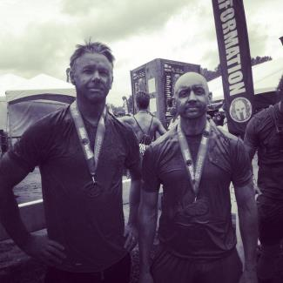
- SVYMG: What is your endurance sports background?
Jay: I started out running in a Warrior Dash with some friends in 2011 just for fun. We enjoyed it and started looking for another race to try right away. That’s when another friend told us about a Spartan race being held at Blue Mountain a few weeks later. We all signed up and got crushed by it… The fact that it was at a ski resort should have given us an idea how difficult it would be.
- SVYMG: What are your top 3 endurance sports goals?
Jay:
  - Finish in the top 10% at the Spartan Race World Championships
  - Complete a Half Ironman
  - Get in better shape

- SVYMG: What has been your favorite race in which you've participated?
Jay: Spartan Race at Blue Mountain in the Poconos. I have run it all four years they have had it, and the course has changed every year.
- SVYMG: What is the race that you'd most like to do?
Jay: This year the Spartan Race World Championship is at Squaw Valley (Olympic Valley, California). I grew up skiing all over that mountain and even worked there as a lift operator for a year. I can’t wait to get back there and see it again!
- SVYMG: What song would you most like to hear at the starting line of a race? How about the finish line?
Jay: “Stronger” by Kanye West (even though I don’t like him, the song gets me pumped up)
- SVYMG: What has been your best endurance sports experience to date?
Jay: The Spartan Race World Championship at Killington, Vermont in 2014. Just being able to finish the race was an accomplishment for me. Over 25% of the people that signed up for this race didn’t finish. Race day temp was in the 30s at the base of the mountain and included swimming in water that was in the 50s and a total of 16½ miles with over 6,000 feet in elevation gain.
- SVYMG: Do you have an endurance sports tip or two that you'd like to share?
Jay: In longer races make sure you have a nutrition plan and that you FOLLOW IT!I have failed on this before and it makes it hard to finish.
- SVYMG: Who is your favorite professional endurance sports athlete?
Jay: Matt “The Bear” Novakovich… He is an elite obstacle course racer in his 40s that pushes the guys in their 20s.
- SVYMG: What is one interesting thing about yourself that has nothing to do with endurance sports that you'd like to share?
Jay: I used to own a bungee jumping company back in San Diego in the 90s.
- SVYMG: Any other background info you'd like to share?
Jay: I grew up in California, and moved to Pennyslvania eight years ago. I am married and have a 10 year old son. I am an accountant and have been working for Comcast for the last three years.

