About a Gator #42: Kelly Ferreri
May 2015
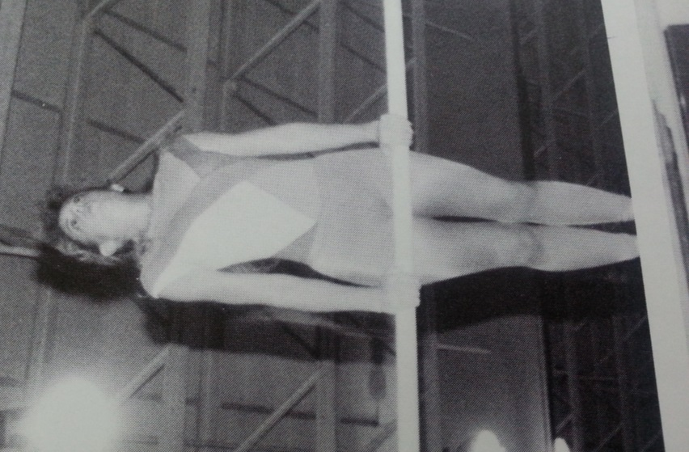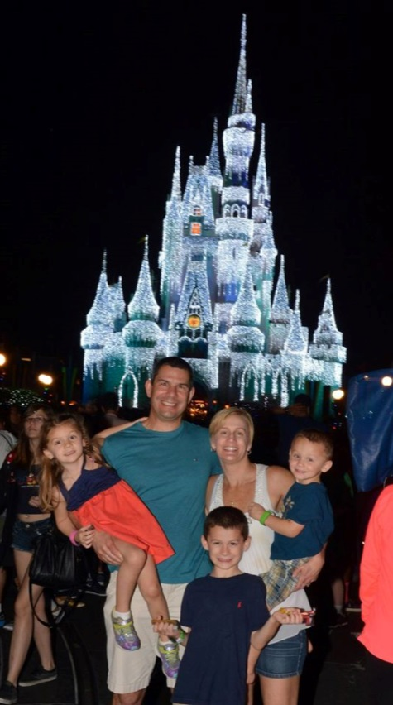
- SVYMG: What is your endurance sports background?
Kelly: I can’t say I have an endurance sports background like most of you are thinking. I grew up playing soccer and competing in gymnastics throughout high school and went to college on a soccer scholarship. After college I was always doing something in the gym… lifting weights, boot camp classes, yoga, etc. I was getting bored with the routines so I asked Allison Wesler about the Tri Club and she had great things to say. After a phone conversation with Danny Friend, I showed up to my first Tri Club workout… Swimming… Well I could float and doggy paddle, but I was up to the challenge! I will always be grateful to Danny and Don Schlichtmann for teaching me how to swim!
- SVYMG: What are your top 3 endurance sports goals?
Kelly: My goals are…
- Maintain a consistent workout schedule
- Always go further than I think I can
- Maybe complete a half Ironman distance triathlon
NAME: Kelly Ferreri
- SVYMG: What has been your favorite race in which you've participated?
Kelly: I have only participated in one triathlon and that was the 2013 Hunting Park TriYouthalon. Don Schlichtmann encouraged me to give it a try so I would get the experience of a race and putting all the pieces together. I finally registered for it the day before and was scared to death. I am proud to say I completed the race and even passed some people along the way!
- SVYMG: What is the race that you'd most like to do?
Kelly: Being from New Jersey, I would like to do the Jersey Girl Triathlon (Long Branch, NJ). My sister-in-law does it every year and I have yet to overcome the fear of the open water swim. It would be fun to compete with her.
- SVYMG: What song would you most like to hear at the starting line of a race? How about the finish line?
Kelly: At the starting line anything from the Dave Matthews Band as he gets my heart pumping and at the finish line “I Lived” by OneRepublic.
- SVYMG: What has been your best endurance sports experience to date?
Kelly: My best experience has been finding a club that encourages beginners and has a lot of team comradery. I am not so much into the races yet. I currently enjoy the individual workouts, staying healthy, and always learning something new.
- SVYMG: Do you have an endurance sports tip or two that you'd like to share?
Kelly: My tips are…
- Have fun and find your tribe!
- Surround yourself with people who have the same vision and encourage you.
- SVYMG: Who is your favorite professional endurance sports athlete?
Kelly: Meredith Atwood, who is the author of “Triathlon for the Every Woman.” She is very inspiring in that we share many of the same struggles… How to manage triathlon training, food, marriage, career, and raising children and enjoy life as we do it.
- SVYMG: What is one interesting thing about yourself that has nothing to do with endurance sports that you'd like to share?
Kelly: Right after high school I was in an accident and suffered a traumatic brain injury. After having my last rights read and doctors telling me I would struggle to learn if I went to college, I recovered enough to go to college seven weeks later.
- SVYMG: Any other background info you'd like to share?
Kelly: I am an introvert by nature and am driven by observation, learning and experiencing new things. I went to college for Sports Medicine and Athletic Training and was an athletic trainer for a few years. I went to graduate school and obtained my MBA and was a financial analyst for many years. After moving from New Jersey to Pennsylvania six years ago, I went back to school and became certified to teach elementary and special education. I taught children with Autism for two years.

I am originally from New Jersey. I have been married to my husband, Tony, for ten years. We have three children… Anthony (8), Giana (5), and Dominic (3). On our 11th anniversary (June 12), we will be starting a new adventure as we will be relocating to Naples, Florida. There is an open invitation to any “Gator” that wants to visit when the weather gets colder in Pennsylvania!

