About a Gator #41: Jeannine Kelly
May 2015
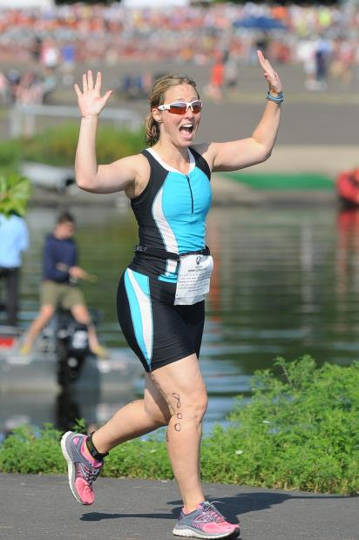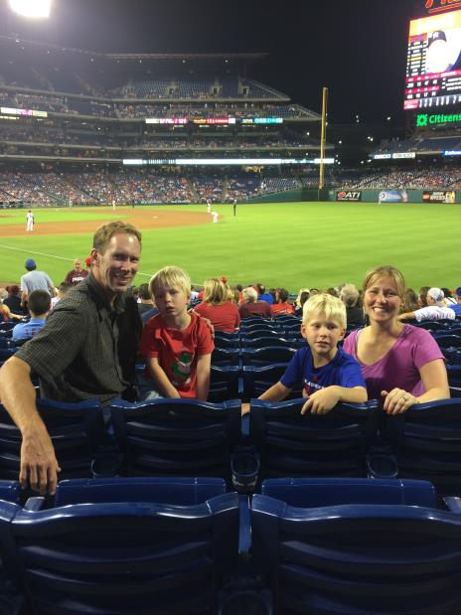
- SVYMG: What is your endurance sports background?
Jeannine: I don’t have a long history of endurance sports. I started running in 2010 when my brother and sister-in-law convinced me that I should sign-up for the Broad Street Run. I thought they were crazy considering I failed the required 1½ mile run in high school gym class consistently every year! I would probably still fail since I’m so slow but I don’t dread running like I did back then! I did survive the Broad Street run and actually enjoyed it. I was shocked! I’ve done the Broad Street Run four times, one half-marathon, three sprint triathlons, and a few long distance bike events.
- SVYMG: What are your top 3 endurance sports goals?
Jeannine: My goals…
  - I would love to run a 10 minute mile. I know this is slow for many but this would be awesome for me. I don’t know how to get there and would love any advice or tips. I’ve heard over and over again that I should do interval training. Does it really make that much of a difference? I really love chatting with my girlfriends when I run so I haven’t really focused on speed, but I have focused on enjoying time away from my two wonderful but exhausting little boys (Chase, 6 and Austin, 4).
  - I would like to do an Olympic triathlon.
  - If successful with an Olympic triathlon, I may consider a half Ironman triathlon.

- SVYMG: What has been your favorite race in which you've participated?
Jeannine: I really like the Steelman in Quakertown. It is such a great course and the lake is beautiful.
- SVYMG: What is the race that you'd most like to do?
Jeannine: I would like to do a triathlon with an ocean swim. I haven’t picked a specific one yet.
- SVYMG: What song would you most like to hear at the starting line of a race? How about the finish line?
Jeannine: I always get pumped when “I Gotta Feeling” by the Black Eyed Peas comes up on my running playlist. Sometimes if I’m slowing and feel like I can’t make it I’ll skip ahead to that song and put it on repeat mode and it never fails… My mental game improves significantly!
- SVYMG: What has been your best endurance sports experience to date?
Jeannine: I’ll never forget the first time I did the Broad Street Run. When I saw the finish line I was overcome with emotions. My eyes were filling with tears, my chest felt tight, and I could hardly breathe. The voice in my head was going…. “S*** Jeannine, you are going to pass out before you get to the finish line…control yourself”! I made it to the finish line but this stands out because running has always/will always be my biggest challenge.
- SVYMG: Do you have an endurance sports tip or two that you'd like to share?
Jeannine: Have fun! In the summertime, I spend a lot of time at the beach with my family. My favorite training is with my dad. We get up early and take the paddleboard out into the ocean. He paddles on the board alongside of me swimming. I love it! It is fun to hang out with him and it gives me a sense of security when out in the ocean.
- SVYMG: What is one interesting thing about yourself that has nothing to do with endurance sports that you'd like to share?
Jeannine: I enjoy traveling. I just switched from a US focused job to a global job, so I’m hoping that I’ll have the opportunity to do some work travel in the coming year and tack on some fun to the trips. With that said, I’m learning that global travel is exhausting! My first trip was to the Philippines four weeks ago.
- SVYMG: Any other background info you'd like to share?
Jeannine: I love spending time with my family! I grew up in Collegeville and now live in Schwenksville, less than ten miles away from my family home. I’m fortunate that everyone still lives close by.
I married an awesome guy, Bill, in 2006. We met online, which wasn’t all that common in 2002. Bill was turning 40 a few months after we met. He still harasses me that I broke-up with him several times because of his age! I remember him clearly saying, “the only person I don’t want to spend my 40th birthday with is you!” This is so unlike Bill, which makes it even funnier! Well, I will be 40 next February so he has started getting his revenge. He even has our two boys harassing me!
