About a Gator #40: J. D. Landis
May 2015
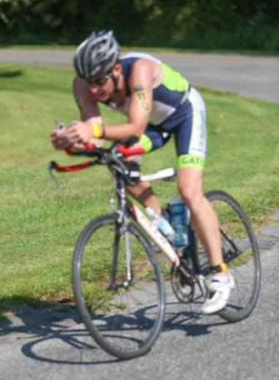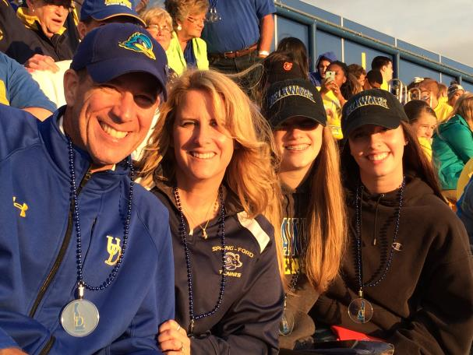
- SVYMG: What is your endurance sports background?
J.D.: Believe it or not there are several reasons why I got into this sport. I always loved to watch the Kona Ironman on the Wide World of Sports when I was a kid. I thought to myself “that is insane”, but I was very intrigued. I also thought “why”. It was not until a few years ago after quitting smoking after 20 years that I started to think about getting my body out from somewhere between science and science fiction. I started by simply walking the dogs… Then running down the hills… Then going to the gym. My neighbor told me about a triathlon in Dewey Beach (Delaware) that I should do; it was a short sprint distance event. Now, you have to understand that my concept of “triathlon” was 140.6 miles. I didn’t know that there were shorter distances. I signed up for Dewey Beach. That gave me something to work towards and was the beginning, of what I hope to be a lifetime of early morning swims in the bright sun, sights and sounds on a bike with no limitations (except when your legs say “enough”), and the seclusion of a run where solutions to complicated thoughts are made… Those are what keep me coming back for more.
- SVYMG: What are your top 3 endurance sports goals
J.D.: My endurance goals are…
- To run faster (running like Don or Tim would be nice).
- To complete a full Ironman triathlon.
- To ride my bike from my house in Schwenksville to the family Christmas tree farm in Harbeson, Delaware.

- SVYMG: What has been your favorite race in which you've participated?
J.D.: I love the beach, so my favorite race is the Dewey Beach Triathlon. While it is a sprint distance, it is also the first competitive triathlon in which I competed. My goal every year is to do better than the year before, conditions permitting.
- SVYMG: What is the race that you'd most like to do?
J.D.: I still have my sights set on Ironman Lake Placid, providing I may someday get time to train properly.
SVYMG: What song would you most like to hear at the starting line of a race? How about the finish line?
J.D.: There are two “must listen to” songs before a race. The first is “Fight the Good Fight” by Triumph… I have listened to that song before every competition since I was in high school. The other song is “Lose Yourself” by Eminem.
- SVYMG: What has been your best endurance sports experience to date?
J.D.: They all have their own keepsake moments, but I truly enjoy the Steelman Triathlon at Lake Nockamixon. I have volunteered the last couple of years and enjoy the people who run the race. I especially enjoyed last year seeing my team out in droves and lighting up the course; it made me proud to be a Gator!
- SVYMG: Do you have an endurance sports tip or two that you'd like to share?
J.D.: My tips are…
- Enjoy the experience……look around once and a while when racing.
- While getting old sucks living life is awesome!
- SVYMG: If you have one, who is your favorite professional endurance sports athlete?
J.D.: Even though he is not a professional athlete my favorite is Dan Friend. When I came to the club a few years ago I thought I was in decent shape… Well that assessment was not entirely accurate. Dan helped me through, encouraged me, and was there to truly transform my body and soul; basically he kicked my ass! That helped me find something I had been without for many years. I owe him for that. When people who have not seen me in a few years see me, they say “What happened to you?” My response is “Body by Friend”.
- SVYMG: What is one interesting thing about yourself that has nothing to do with endurance sports that you'd like to share?
J.D.: I am a cancer survivor and have been clean for 20 years. I appreciate the support you have shown Brian while he and his family go through some tough times.
- SVYMG: Any other background info you'd like to share (family, career, hobbies, etc.)?
J.D.: I am supported by my wife, Karen, my 14 year old daughter, Cassidy, and my 20 year old daughter, Kirsten, who attends the University of Delaware (where else is there?). They all put up with my crap, stinky clothes, and equipment. As you all may know, I have a family Christmas tree farm in Delaware, which is a great escape and great place to train. You also know I work way too much, but as a VP of a culinary design firm I sometimes have to postpone my training to get the job done.
