About a Gator #39: Erin Gallagher
April 2015
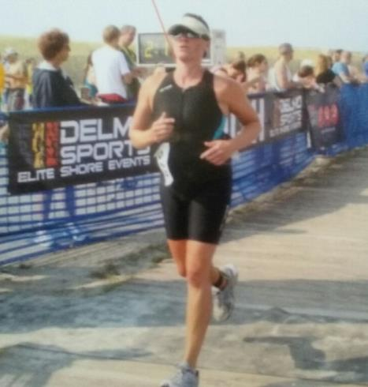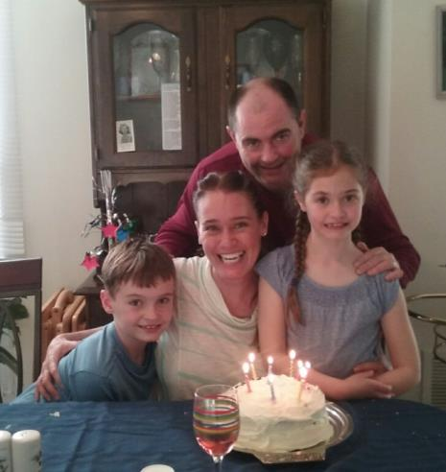
- SVYMG: What is your endurance sports background?
Erin: I’ve only been involved in endurance sports for the past three years but I’ve been an athlete all my life. I always loved to swim and wanted something that would challenge me where I could compete again. I was an artistic gymnast and won two Pennsylvania state championship titles. I was also a rhythmic gymnast (ball, hoop, ribbon, rope) and won a national title for that sport when I was 17.
- SVYMG: What are your top 3 endurance sports goals?
Erin: My first goal is to stay healthy, stay in shape and model good habits for my kids. My second goal is to always improve my swim time. And, third, I would like to improve my cycling.
- SVYMG: What has been your favorite race in which you've participated?
Erin: The Tri the Wildwoods Aquabike in August 2014 was my favorite race. It is a great physical challenge to swim in the ocean and I beat my swim time from the last ocean swim I did at the same race by almost two minutes.
- SVYMG: What is the race that you'd most like to do?
Erin: I’m looking forward to the Steelman this coming August because I’ve only done ocean swims and I am excited to switch it up and swim in a lake.
- SVYMG: What song would you most like to hear at the starting line of a race? How about the finish line?
Erin: Starting line – “My Songs Know What You Did in the Dark (Light Em’ Up)” by Fall Out Boy. Finish line – NONONO’s “Pumpin’ Blood”.
- SVYMG: What has been your best endurance sports experience to date?
Erin: This past summer’s race in the Wildwood’s was my best experience.
- SVYMG: Do you have an endurance sports tip or two that you'd like to share?
Erin: Don’t let your head get in the way of your sport by over thinking. Also, your body has muscle memory, so just let it do what it knows how to do.
- SVYMG: What is one interesting thing about yourself that has nothing to do with endurance sports that you'd like to share?
Erin: I love to write and hope to publish a book someday!
- SVYMG: Any other background info you'd like to share?
Erin: My husband, John, and I will be celebrating our 10 year anniversary in June. I have two children... My son, Sean, is 9 years old and my daughter, Maura, is 8 years old. I am an adjunct Psychology professor at Manor College and aside from triathlons, boxing is one of the other sports really enjoy doing.

