About a Gator #38: Kerri Brannen
April 2015
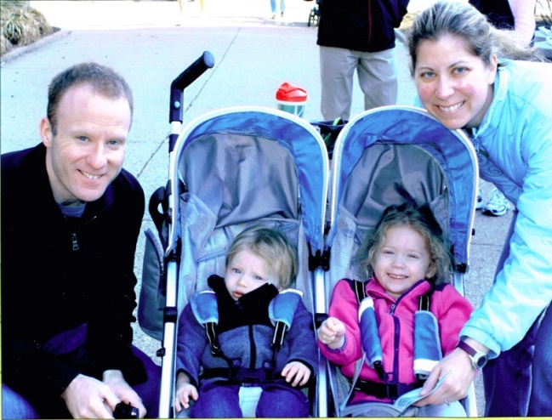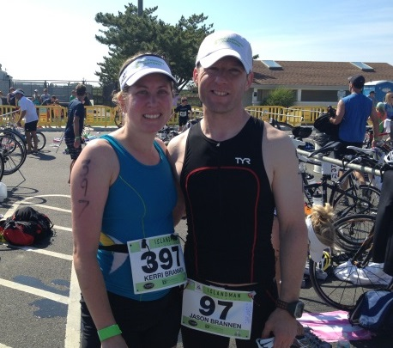
- SVYMG: What is your endurance sports background?
Kerri: I have been running since I was nine years old when I joined the CYO track team. I loved running and competing from the start. I ran through elementary school, high school, and college, and I was mostly a sprinter and middle distance runner. But it wasn’t until I was out of college for about a year that I ran my first 5k. Then my first real endurance event was the Sea Isle 10 mile run a few years later, which really wasn’t a pleasant experience since it was rainy. But the following May I ran the Broad Street run and the same year I ran my first half and full marathons. Since then I have run Broad Street ten times, completed several half-marathons, and completed three marathons. While I love running, I didn’t really enjoy the marathons, so in 2009 I decided to give triathlons a try. I competed in my first triathlon in Brigantine, New Jersey; interestingly, it was also the first time I swam in open water. That season I competed in two others and I was hooked. Since then I have competed in at least one triathlon almost every year with the exception of 2013 when I had my son. Most of the triathlons I have competed in have been sprints and taken place down the shore, but last year I competed in my first Olympic length triathlon at Steelman. It was really a great experience and I’m looking forward to doing it again!
- SVYMG: What are your top 3 endurance sports goals?
Kerri: I’m planning on completing the Diamondman Challenge half-ironman distance event in September and surviving that is a goal. Also, I would love to run a marathon in under four hours. Finally, it would be fun to compete in a destination tri where I could actually see in open water! Oh and I would love not to be last out of the water!... Top 50% would be nice!
- SVYMG: What has been your favorite race in which you've participated?
Kerri: My favorite race is the Broad Street run. When I first ran it I think there were only about 5,000 finishers. It has always been a great run even if it is much more crowded than it use to be. I’m looking forward to doing it again in a couple weeks!
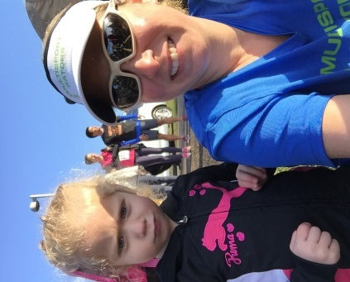
- SVYMG: What is the race that you'd most like to do?
Kerri: Any destination tri that is in clear blue water. I’d like to see where I am going!
- SVYMG: What song would you most like to hear at the starting line of a race? How about the finish line?
NAME: Actually, I don’t think too much about songs at the start of a race. Usually, I’m too nervous. At the end it’s always nice to hear something upbeat.
- SVYMG: What has been your best endurance sports experience to date?
Kerri: I’m still waiting for a good one! I guess that is the way athletes are… always looking for a better performance!
- SVYMG: Do you have an endurance sports tip or two that you'd like to share?
Kerri: “Just keep swimming!” My daughter likes Finding Nemo and in it the character Dory says “Just keep swimming”. I’ve actually thought about this at times during races. Last year at Broad Street, I actually was saying to myself “Just keep running,” because I was slow and it hurt! But I think it is good advice because if you keep moving, eventually you will finish.
- SVYMG: What is one interesting thing about yourself that has nothing to do with endurance sports that you'd like to share?
Kerri: I teach at Widener University. I earned my Ph.D. in business in 2007 from Temple University, but started teaching college as a graduate student in 2002. I think it is funny that I am qualified to teach college, but I really enjoy it.
- SVYMG: Any other background info you'd like to share?
Kerri: I have been married to Jason Brannen (another Gator) since 2008 and I love competing in triathlons with him. We have two children, Keira (4 years) and Aiden (19 months). I was in the pool swimming about 12 hours before Keira was born and competed in a triathlon when she was less than 4 months (yeah, I am that kinda crazy, but I did take 2013 off from triathlons since Aiden was born in September). Also, I love to run. My favorite part of a triathlon is when I get to the run. I am usually pretty far behind at that point, so it feels good to pass people.

