About a Gator #37: Steph Babiec
April 2015
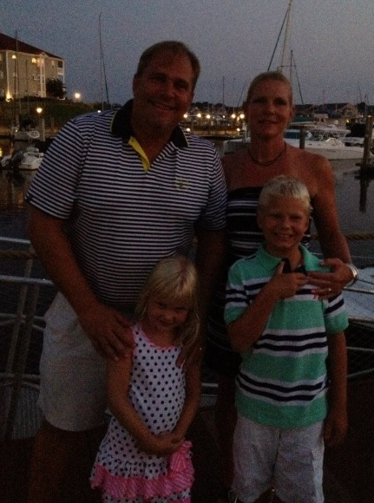
- SVYMG: What is your endurance sports background?
Steph: I started running again about 4-5 years ago when I quit smoking for the first time. I couldn’t even run one minute without stopping. It was really humbling for someone who ran track in high school and ran through college, but I am stubborn and kept at it. Since then I’ve now completed the Broad Street Run three or four times, done a few 5ks, and have finished three triathlons. I did my first tri at the Upper Main Line YMCA (UMLY) in 2013, but I was totally unprepared. My best friend from college (Cobie) asked me to do the run portion of a sprint relay tri that year, but she had to drop out due to illness. The idea stuck with me so I searched in our area and saw the UMLY event. I loved every minute! Cobie passed away suddenly and unexpectedly last February… Every time I race or I am struggling with a workout I think of her and it helps me keep moving (I know she’s laughing at me even in my struggles and it makes me smile and keep going).
- SVYMG: What are your top 3 endurance sports goals?
Steph: My three goals are…
- Finish Eagleman alive (Editor’s Note: Eagleman is an Ironman half distance event taking place on Sunday, June 14).
- Continue to improve in all disciplines.
- Learn to enjoy the swim more.
- SVYMG: What has been your favorite race in which you've participated?
Steph: I have enjoyed all of them for different reasons. I really liked the TriRock Philadelphia Olympic triathlon last summer. I was thrilled to be doing it and had a great time! All parts came together well (even though the run was rough).
- SVYMG: What is the race that you'd most like to do?
Steph: I don’t have any future ambitions after Eagleman. But I like doing races with our group… The support is awesome! I might be talked into something else. I like the training… not so much the races.
- SVYMG: What song would you most like to hear at the starting line of a race? How about the finish line?
Steph: At the start… “Happy” by Pharell Williams… It’s upbeat. At the finish line… “Till I Collapse” by Eminem… It makes me want to run faster.
- SVYMG: What has been your best endurance sports experience to date?
Steph: The 2014 Independence Triathlon. A friend came with me at 4am to be there for support, and I caught up to a woman who had been back and forth with me the entire race… We tied to the second crossing the finish line!
- SVYMG: Do you have an endurance sports tip or two that you'd like to share?
Steph: An instructor at an open water swim mentioned looking at the clouds when you breathe during the swim. That stuck with me for last year’s TriRock Philadelphia and it really helped calm me down, maybe take a longer breath. I had a great swim that day!
- SVYMG: Who is your favorite professional endurance sports athlete?
Steph: All of the inspiring folks on the Gators team!
- SVYMG: What is one interesting thing about yourself that has nothing to do with endurance sports that you'd like to share?
Steph: I took martial arts and earned a blue belt in Tae Kwon Do. I would like to revisit it someday and earn a black belt.
- SVYMG: Any other background info you'd like to share?
Steph: I have been married for 10 years. Mark and I have two kids: Jack (9) and Josie (6). I am a stay at home mom currently, which affords me this opportunity to train with relative ease. We would like to buy a farm so that I can start a CSA (Community Supported Agriculture) and a field grown perennial business. I worked for Morgan Stanley for years and also had a small landscape design/install business. I am fairly handy… I rehabbed my first house from top to bottom. I paint, do stained glass, refinish furniture, grow a ton of food in the garden, and landscape (10 yds of mulch coming my way soon! That counts as a workout right?).
