About a Gator #36: Doug Schmidt
April 2015
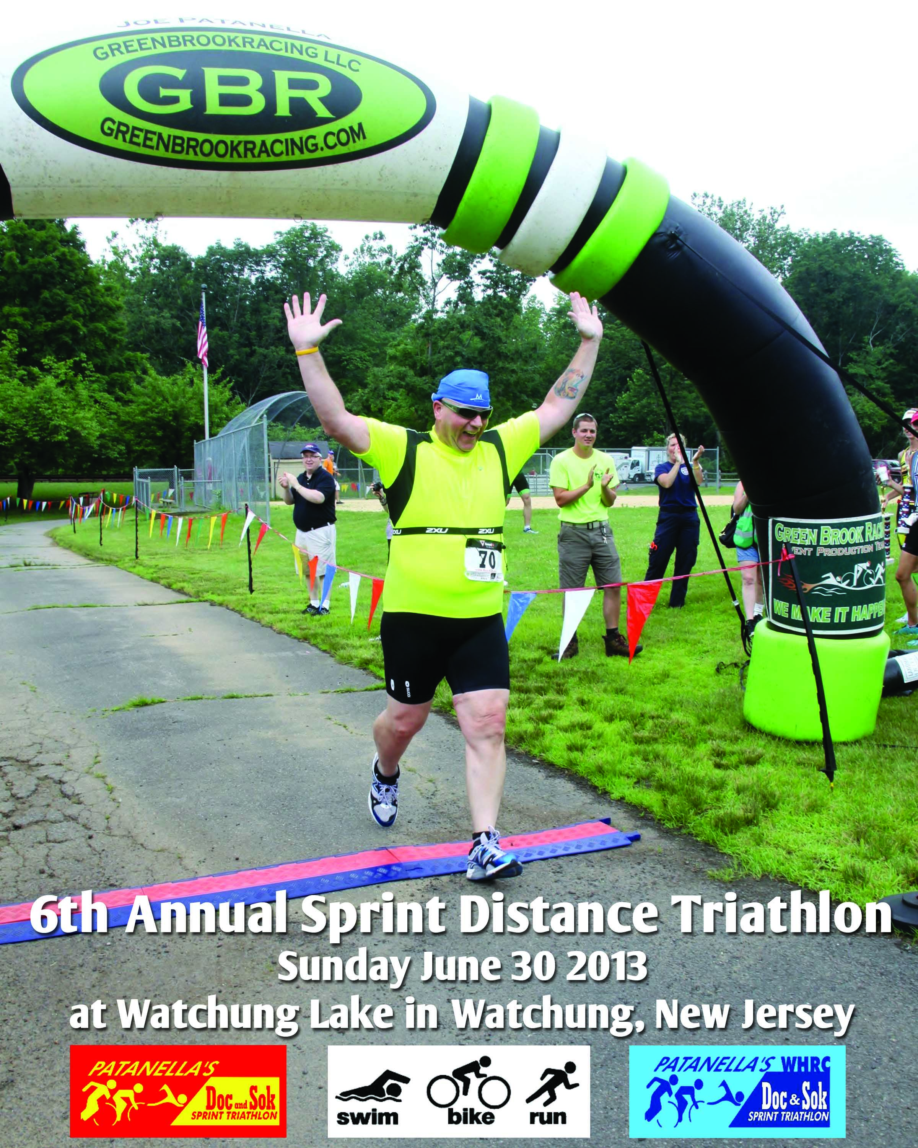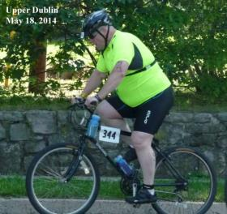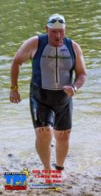
- SVYMG: What is your endurance sports background?
Doug: When I think about it I remember having to run a lot in order to pass a run test twice a year. I can remember running at least twice a week with long runs being not more than 5 miles. I can say that I was able to do 7-minute miles, but that was a long time ago. I got a restart a couple of years ago after I accepted a challenge from my younger sisters to participate with them in a triathlon. At the time I was a member of the Y and exercising at least three times a week. I saw the advertisement for the Y’s “Intro to Triathlon” class a lot and one day I decided to show up to Maribeth’s class. I didn’t know where it would take me but I signed up for my first event for later that same year. My goal was to see if I could do it and at least finish the event. I remember my first “run” session with Maribeth… Running was as hard as I remembered it but Maribeth taught me a couple of things about running that no one had told me before. It was a little easier but I was concerned about my knees and if they would hold up. After I finished my first triathlon I realized that running would be difficult. I had walked most of the 5k but was able to at least cross the finish line in a trot. I felt great having finished! I was hooked! I’ve done two events since: one aquabike and a triathlon where I walked the 5k but still had a great time. I’ve also done two bike rides with the ADA Tour de Cure. I’m training this year for my third – a 62.5 mile ride that my sisters will be riding with me.
- SVYMG: What are your top 3 endurance sports goals?
Doug: My goal is to participate in a bunch of aquabike events with my top goals being…
- Complete an Olympic aquabike
- Complete a half Ironman distance aquabike (57.2 miles)
- Complete a full Ironman distance aquabike (114.4 miles)
As part of my training for these my plan is to participate with my sisters in the Amtrak Century ride from Irvine to San Diego. They have done it before and have told me it’s a great ride.
- SVYMG: What has been your favorite race in which you've participated?
Doug: My first race is definitely on the list but I have to say that the 2014 Lake Davidson, NC event is on the top. It was my second open water race and with an 86 degree lake water temperature it was a great swim.

- SVYMG: What is the race that you'd most like to do?
Doug: I’m looking forward to doing the Steelman at Lake Nockamixon this summer. I missed it last year and hope to get it on the schedule. I’ve enjoyed going to races and meeting new people. I’m looking forward to an event attended by other Gators.
- SVYMG: What song would you most like to hear at the starting line of a race? How about the finish line?
Doug: The National Anthem has been a favorite of mine for some time. I find myself still dropping my left hand to my side and placing my right hand over my heart. And of course I have to find the flag and face it. Follow that with John Philip Sousa’s “Semper Fidelis.” That song has a great cadence. At the finish line, the Marine Corps hymn followed by Mumford & Sons “I Will Wait.” The first time I heard “I Will Wait” was in a Saturday morning spin class the day before my older brother’s memorial service. It had a great speed cadence and it also made me think of my brother and his cycling days. I ended up using the words in my eulogy for him and the song reminds me of him every time I hear it.
- SVYMG: What has been your best endurance sports experience to date?
Doug: I would have to say that the Lake Davidson Tri in North Carolina has been the best so far.
- SVYMG: Do you have an endurance sports tip or two that you'd like to share?
Doug: Perseverance and tenacity… Never give up. It may be hard to train today but the benefit for tomorrow is immeasurable.
- SVYMG: What is one interesting thing about yourself that has nothing to do with endurance sports that you'd like to share?
Doug: I miss singing baritone in the church choir. I’ll get back to that someday. It’s also hard to watch a football game between Navy and Rutgers… I can’t decide which one to root for! I have a lot of hobbies!!!
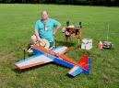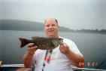
- SVYMG: Any other background info you'd like to share?
Doug: Pictures are worth more than a thousand words… Here are a few. Of course you can find a lot more on Facebook. My son, Doug II, turns 34 this year and my daughter, Kim, turns 30. My wife and I will be married for 38 years this year!
