About a Gator #35: Heather Tracey
March 2015
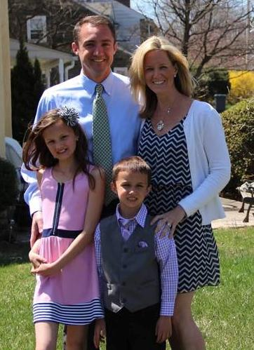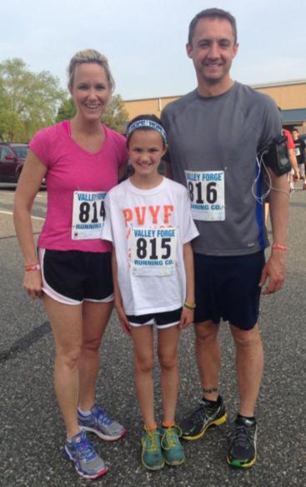
- SVYMG: What is your endurance sports background?
Heather: Endurance sports are fairly new to me. I started running after I had my second child in 2007. It was a way for me to keep my sanity… Just kidding. I really started as a way to get back in shape. With two kids and a husband who traveled a lot for work, I needed an activity that did not require the need for anything other than my commitment. I started with 5k’s and in my first race ever I won my age group! I was hooked from there. Since then I have participated in so many 5k’s that I have lost count; I’ve often won my age group or placed in a lot of them. The one I am most proud of would be the Collegeville Beer and Bagel Run three years ago… I placed first female overall! The trophy was a very large beer stein. I drink from it proudly. I have officially completed in one half marathon and two marathons including the Philadelphia Marathon and Steamtown (Scranton)… Running a marathon is so humbling.
- SVYMG: What are your top 3 endurance sports goals?
Heather: My goal is really just to get more involved with triathlon training.
- SVYMG: What has been your favorite race in which you've participated?
Heather: My favorite has to be the Philadelphia Marathon. The crowds are amazing!
- SVYMG: What is the race that you'd most like to do?
Heather: I would have to say coming from a running background that I really want to do a Disney run. However the triathlon that I want to do is the Independence Tri. My one and only triathlon was the Philadelphia Triathlon in 2013, so getting back into the sport I think that the Independence Tri would be a good race.
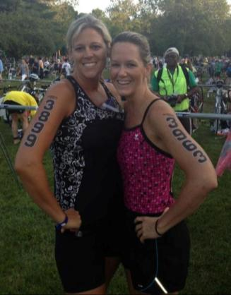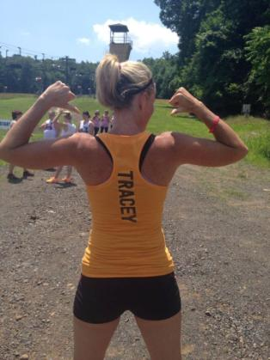
- SVYMG: What song would you most like to hear at the starting line of a race? How about the finish line?
Heather: I have a strange one for the state of a race – “Brave” by Sara Bareilles. And at the finish line I’d love to hear “Feel This Moment” by Pittbull.
- SVYMG: What has been your best endurance sports experience to date?
Heather: My best experiences have been both Marathons – I trained well for each and felt amazing afterwards. Putting the time in made the reward for crossing the finish line that much better.
- SVYMG: Do you have an endurance sports tip or two that you'd like to share?
Heather: Listen to your body and remember you are your only obstacle but also your biggest cheerleader.
- SVYMG: What is one interesting thing about yourself that has nothing to do with endurance sports that you'd like to share?
Heather: I have a twin sister (we look nothing alike). Her name is Tracy…. And it just so happens that my husband’s last name is “Tracey”. My whole life it has always been “Heather and Tracy and now I am Mrs. Tracey!
- SVYMG: Any other background info you'd like to share?
Heather: I have been married for 13 years to my high school love – We met at a supermarket during high school. We have two kids, Hannah (9) and Kyle (7). And of course my first born – Wilson (he is our Boston terrier); he is 13.
