About a Gator #34: Mary Kain
March 2015
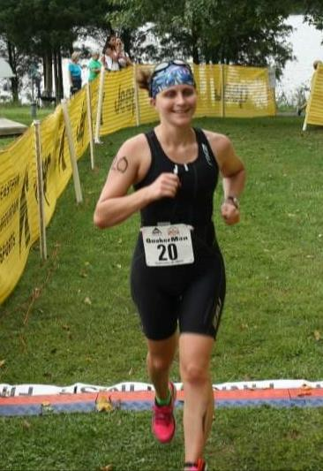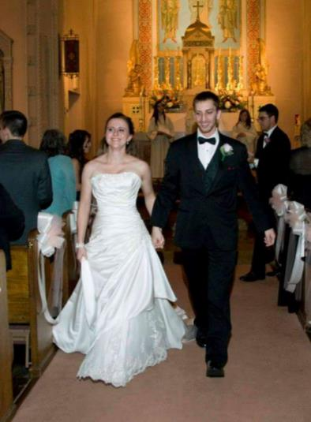
- SVYMG: What is your endurance sports background?
Mary: I’ve been running forever. Dad would run with me around the neighborhood when I was little, and in high school I was on the cross country and track teams all year. I was never the fastest runner, and in college I dropped running entirely to join the crew team at Drexel. It was easily the most exhausting training and intensive experience I’ve ever faced. The only time I’ve come close to it again was training for Ironman Lake Placid 2014. After college I started running marathons again, but quickly moved to triathlon.
- SVYMG: What are your top 3 endurance sports goals?
Mary: This year I want to PR at several different distances….a 70.3 (half Ironman triathlon), a 13.1 (half marathon), and a 26.2 (marathon). Long term I want to break six hours at a half Ironman distance event and also finish Ironman Lake Placid in under 14 hours.
- SVYMG: What has been your favorite race in which you've participated?
Mary: Oh man, there have been so many good races. The Shamrock Marathon (Virginia Beach) will always have a place in my heart, but I think I had the most fun at Quassy 70.3 (Middlebury, CT). It was such a fun, low key little race that packed a wallop. My legs were so dead after the bike I almost fell over in T2! The run was hot and dusty, and I could taste salt and sunscreen when I splashed my face with water. Biking is my weakest leg, so I fell to the back of the pack, but redeemed myself on the run – picking people off one by one until I was closer to the middle. Finally crossing the finish line on that hilly, leg busting course was satisfying, but the soaking wet, ice cold towel they wrapped around my sunburnt shoulders was the kiss that sealed the deal!
- SVYMG: What is the race that you'd most like to do?
Mary: I don’t really have a top race on my wish list. My race plan isn’t very structured; it’s more like “Hmm, I feel like training for a marathon. Which event looks good three months from now? Which one has the coolest name? What’s the swag like?” As soon as I recover from that race I’ll say something like “That was fun, but now I could really go for a tri… What’s good in the month of May?” If I find a race that looks like a lot of fun and I missed it, I’ll put it on my calendar for next year… That’s about as much planning ahead as I do!
- SVYMG: What song would you most like to hear at the starting line of a race? How about the finish line?
Mary: Depends on my mood. If I’m energized and confident at the starting line I’d like to hear “Get Through This” by Art of Dying. If I I’m feeling anxious I’ll turn on the country music…either “Springsteen” by Eric Church or “Neon Light” by Blake Shelton. For the finish line, definitely “Back in Black” by AC/DC.
- SVYMG: What has been your best endurance sports experience to date?
Mary: Finishing my first ironman last summer is definitely my best experience to date.
- SVYMG: Do you have an endurance sports tip or two that you'd like to share?
Mary: Don’t forget to get enough sleep! You recover faster and train better when you’re well rested.
- SVYMG: What is one interesting thing about yourself that has nothing to do with endurance sports that you'd like to share?
Mary: In 2010 I went to Henley, England to compete in the Henley Women’s Regatta. We competed against England’s Olympic B boat and won with open water and best time of the day!
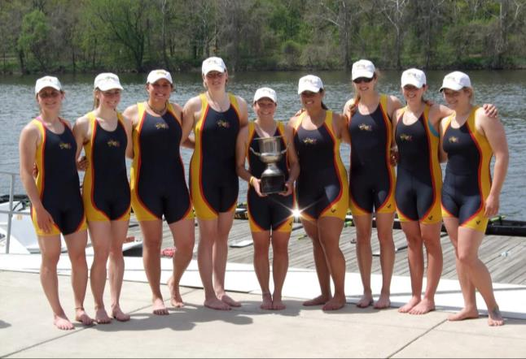
- SVYMG: Any other background info you'd like to share?
Mary: Mark and I have been married for almost 1½ years, but have been together for more than seven years. I work as a validation consultant and have done work in New Jersey, California, and Japan. When I have time for hobbies, I enjoy reading science fiction/fantasy and the occasional mystery.
