About a Gator #33: Maureen Pinkerton
March 2015
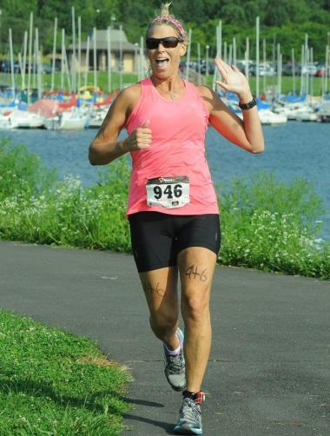
- SVYMG: What is your endurance sports background?
Maureen: I have completed two marathons, seven half marathons, two Olympic triathlons, and six sprint triathlons.
- SVYMG: What are your top 3 endurance sports goals?
Maureen: I would like to…
- Run a sub-four hour marathon
- Complete a long distance open water swim (1.5K or more)
- Complete a half Ironman distance triathlon in 2016
- SVYMG: What has been your favorite race in which you've participated?
Maureen: My favorite race to date was the Rehoboth Beach Marathon I just completed in December of 2014. There is nothing like hearing the ocean and smelling the salt in the air to keep yourself calm as you tackle a long distance. The course is beautiful – 2/3 of the run is on trails which I love.
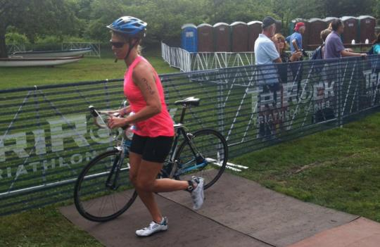
- SVYMG: What is the race that you'd most like to do?
Maureen: I would like to do a half Ironman distance event next year, but I still have to do my research as to which one.
- SVYMG: What song would you most like to hear at the starting line of a race? How about the finish line?
Maureen: At the start of a race, I would like to hear “If You’re Going Through Hell” by Rodney Atkins (the lyrics are actually positive) and at the end I would like to hear “Uptown Funk” by Bruno Mars.
- SVYMG: What has been your best endurance sports experience to date?
Maureen: My best sports experience to date was my first She-Rox sprint triathlon. It was my first triathlon. The camaraderie among the women was incredible, and my first open water swim was euphoric! I wanted to stay in the water and do another lap around the course! I was so inspired by the first group of ladies who participated with all kinds of physical disabilities. A lot of them were out of the water before I started so I got to cheer for them.

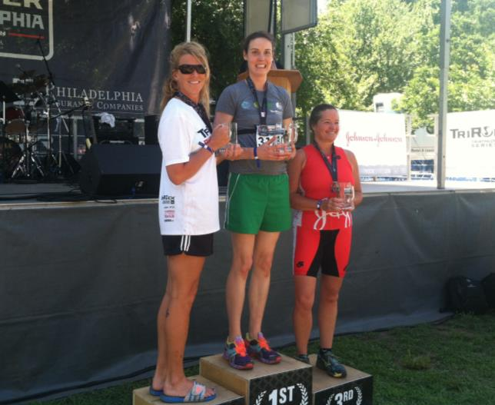

- SVYMG: Do you have an endurance sports tip or two that you'd like to share?
Maureen: I train with my watch but don’t race with it. I do what I am capable of doing at that moment and don’t worry about the time. On the run, I give it my best effort one mile at a time.
- SVYMG: If you have one, who is your favorite professional endurance sports athlete?
Maureen: My favorite professional endurance athlete is Andy Potts. I once chased him down at the Philly Olympic Triathlon to get a picture (after the race of course!).
- SVYMG: What is one interesting thing about yourself that has nothing to do with endurance sports that you'd like to share?
Maureen: I went to Immaculata College on a full basketball scholarship and also played intercollegiate softball and volleyball. I believe I am still the number two all-time leading rebounder to this day.
- SVYMG: Any other background info you'd like to share?
Maureen: I am married 22 years to Lewis Pinkerton and have a 20-year old son, Matt, and a 19-year-old daughter Megan. In 2011, I trained for my first marathon and completed it two days after my mother suddenly passed away. My family surprised me at mile 25.5 and all ran me in. Even though I was way off my goal, all I can remember was the look on their faces and how proud they were of me! I have a picture crossing with my daughter and the look on her face is priceless!


