About a Gator #32: Mike Connelly
March 2015
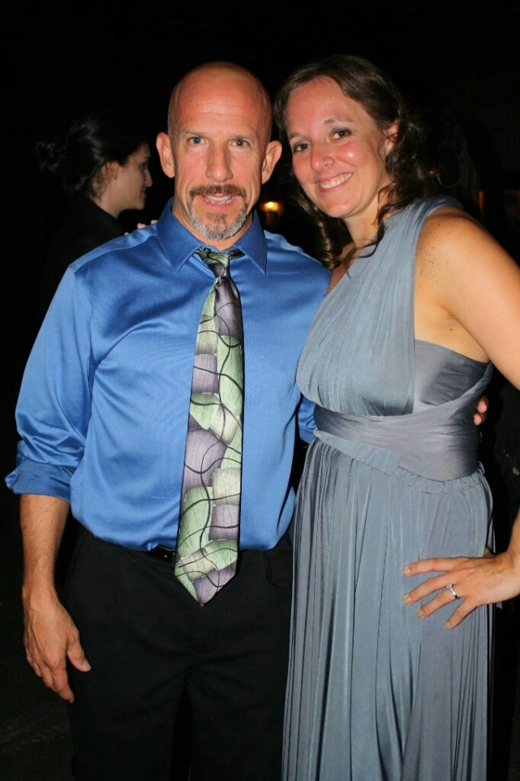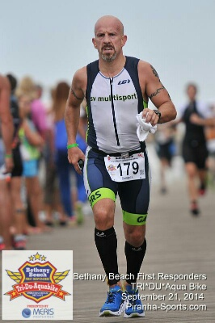
- SVYMG: What is your endurance sports background?
Mike: My background is in running. I started running at the age of 10 following after my older brother, who was a standout distance runner. I very quickly surpassed his records at Upper Perkiomen High School. My high school running career was very successful as I won Pennsylvania state titles in cross country and track. Accomplishments at that level included a 2nd place finish at the Cross Country National Championships and breaking the state record for the 3,200 meters in 1983... That record stood until just recently when it was finally broken in May of 2014... 8:58... good for nearly 32 years! I went to college at West Virginia University on a track and cross country scholarship where I was an NCAA trials qualifier and an Olympic trials qualifier at 10,000 meters where I have a personal best of 28:37.
- SVYMG: What are your top 3 endurance sports goals?
Mike: This year my endurance sports goals are to complete an Olympic distance triathlon and a half Ironman distance triathlon working towards the goal of completing an Ironman distance event in 2016.
- SVYMG: What has been your favorite race in which you've participated?
Mike: My favorite triathlon has been the Steelman, probably because it was my first. Last year my best race was at the First Responders Triathlon in Bethany Beach, Delaware.
- SVYMG: What is the race that you'd most like to do?
Mike: I would like to do Ironman Hawaii in Kona just because it's the most famous.
- SVYMG: What song would you most like to hear at the starting line of a race? How about the finish line?
Mike: This may be a little bit old school, but my heart still beats faster when I hear the Rocky theme song.
- SVYMG: What has been your best endurance sports experience to date?
Mike: Last year’s First Responders Triathlon was my best race of the year.
- SVYMG: Do you have an endurance sports tip or two that you'd like to share?
Mike: Being part of a group (the Gators) has been very helpful. Just reading the emails and seeing the Facebook posts is a big benefit. My tip would be to stay connected because it builds consistency.
- SVYMG: Who is your favorite professional endurance sports athlete?
Mike: My favorite runner of all times is Steve Prefontaine.
- SVYMG: What is one interesting thing about yourself that has nothing to do with endurance sports that you'd like to share?
Mike: I guess the fact that I was voted “most talkative” in high school.
- SVYMG: Any other background info you'd like to share?
Mike: I think everybody knows I'm a chiropractor and I've been practicing for 23 years. Also, I'm getting married on June 13th to the love of my life, Elizabeth Moore. I will apologize in advance for not being at our team’s sponsored triathlon (Steelman French Creek) as I will be on a cruise for my honeymoon. Other things that I enjoy… riding my Harley and playing golf.
