About a Gator #31: Melissa Moffa
March 2015
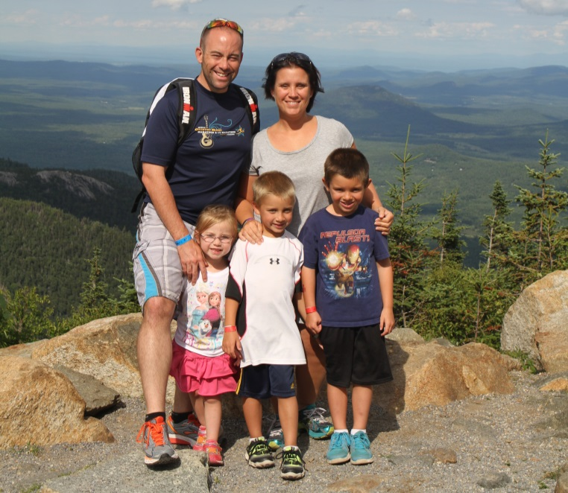
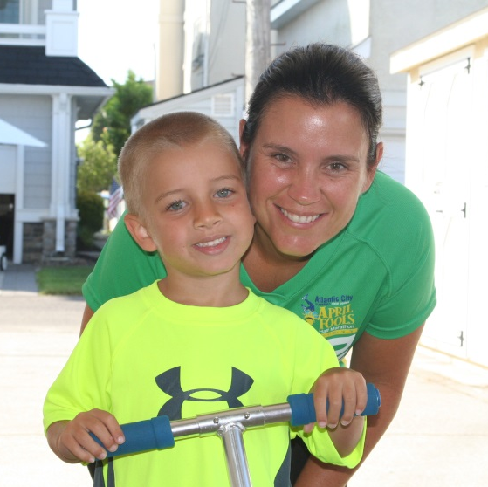 Frank, myself, Joey, Nicholas and Sarah on top of Whiteface Mountain My son, Nicholas, and I after a run on the boardwalk in Ocean City, NJ

- SVYMG: What is your endurance sports background?
Melissa: In January 2011 two of my closest friends approached Amber Davidson (Matt's wife) and I at preschool pick-up about signing up for the Philadelphia Sprint Triathlon. I thought “what the heck, why not, I’m training for a half marathon and can run a 5k”. So as a group of four women we trained on our own (there was no official Tri club at the Y back then). We joined the Monday/Wednesday Tri Swim class, ran for 30 minutes, and went out on our bikes... Oh boy! I did the entire sprint in a bathing suit, running skirt, and sneakers. I had no clue what I had gotten myself into and I LOVED IT! I spoke with Ellen Friend the following year about hiring Danny to coach me for the Olympic distance at the Philadelphia Triathlon (now called Tri Rock). Since then, he has coached me through the Devilman Half Lite distance in 2013 and we’re currently preparing for the Ironman Eagleman 70.3 (Half Ironman distance) in June! After that… well, we will see!
Since starting in triathlon, I have completed several additional sprint and Olympic distance races. I think my biggest accomplishment was swimming the Devilman Half Lite with my wetsuit half off as I panicked and felt like the suit was choking me. Many of you are probably thinking “Didn't she try it on before the race?” Yes, and I actually even competed in it prior to Devilman. I think I was just nervous as it was freezing and the water was bitter! Lesson learned you will GO NO WHERE with your wetsuit half down!
- SVYMG: What are your top 3 endurance sports goals?
Melissa: I would have to say my biggest goal is to have fun while training and racing - or it will feel like a chore and I don't want that. Second is to run another marathon and beat my time. Finally, I’d like to someday compete in an Ironman distance event.
- SVYMG: What has been your favorite race in which you've participated?
Melissa: Even though I would say it was my worst experience, I loved the Nashville Half Marathon. It was an eye opener for me about how much it takes to train for something like this, but to run side-by-side with Frank cheering me on as I wanted to give up was very uplifting!
- SVYMG: What is the race that you'd most like to do?
Melissa: I guess a race that I would love to do is an Olympic distance event in a tropical location! I would race in the beginning of the trip, not worry about being sore, and then enjoy my vacation afterwards!
- SVYMG: What song would you most like to hear at the starting line of a race? How about the finish line?
Melissa: At the starting line I would love to hear “The Lazy Song” by Bruno Mars because it always makes me laugh when I work out. At the finish line I want to hear “Roar” by Katy Perry because I have changed so much from who I was perceived to be and I am a fighter!

- SVYMG: What has been your best endurance sports experience to date?
Melissa: My best endurance sports experience to date was my first Olympic distance at the Philadelphia Triathlon. I was out on the bike loop around Lemon Hill and did not have to get off the bike. Coming down the Black Rock Road hill, I realized I had dropped half of my nutrition somewhere on the course. I saw Frank, my two girlfriends, and Danny and Vince Bellino at the turn to start the second loop. When I came in for my second loop my spirits were lifted because I saw my parents! I was so excited because they weren't supposed to make it but they came! It meant so much to me. I headed out on the run on the hot black top and wanted to cry. I had so much farther to go and the heat was getting to me with no shade in sight. I saw my family and friends cheering me on! Again, it lifted my spirits. As I was approaching the finish line my friend, Jen, ran up to me and said, "Don't walk now... You have trained so hard! Don't let them see you walking!" That's all I needed to hear. She was right! I did train hard and I ran to the finish and felt so proud! It may not have been the best time for my age group or the time Danny thought I would finish in (that time still haunts me), but I finished. And I came back out the next season to compete again!
- SVYMG: Do you have an endurance sports tip or two that you'd like to share?
Melissa: Everyone starts somewhere. I started out running from one mailbox to the next before I became a runner. When I started biking I didn’t realize I had gears on my hybrid bike! In swimming, I would pull my head straight up to breath before I learned how to breathe to the side. Everyone starts somewhere, so don't say “I can't” until you try and fail… and then try again until you succeed!
- SVYMG: Who is your favorite professional endurance sports athlete?
Melissa: Actually my favorite athlete is Michael Phelps. He may not be an endurance athlete but I just remember watching him swim the butterfly against the guy from France and he never gave up! All the way to the end where he did a half-stroke to steal the gold medal… That was amazing! I remind my kids about Michael Phelps before they enter the pool to make sure they swim all the way to the wall!!! Sometimes it only takes a half-stroke to win!
- SVYMG: What is one interesting thing about yourself that has nothing to do with endurance sports that you'd like to share?
Melissa: I opened up my baking business, Somerset Sweets, officially in December of 2013! I love baking and decorating! I also make a delicious cookie tray at Christmas time, so think about me the next time you need a cake or cookies!
- SVYMG: Any other background info you'd like to share?
Melissa: I work for the Special Abilities department at the Y. I started the art, music, and dance programs for children with special abilities about five years ago. I would LOVE for our club to do a triathlon with the children that I work with at the Y. So what do you say...want to help me plan it?

