About a Gator #30: Robert Fletcher
February 2015
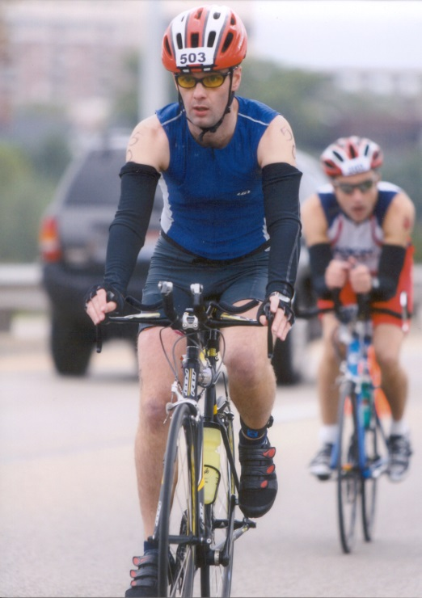
- SVYMG: What is your endurance sports background?
Rob: I was always a soccer and rugby player growing up (England), apart from when my Dad used to drag me out for the occasional five mile run. At University I lived with two international standard orienteers and I started to run with them. This quickly progressed to running the London Marathon in 1999 and 2000. I then got a back injury when I moved to the USA (lots of running and soccer with no strengthening and stretching!), so I started road riding. Once I recovered from the injury I figured if I could turn myself from sinker to swimmer, then I should try a couple of triathlons. I entered a sprint triathlon in Michigan in 2005 and had a great time, so I started to get a little more serious. I completed Ironman Wisconsin in 2006; it was cold, wet and windy. I now stick to Olympic and sprint distance events as children, work, and soccer coaching tend to occupy most of my time.
- SVYMG: What are your top 3 endurance sports goals?
Rob: My top three goals…
- My main goal for the next few years is to remain injury free. I tend to be rather injury prone (Achilles, back, hip flexors….). When I’m injured I am not as easy to live with (apparently!) so I want to focus on quality and not quantity during my training

- I am relatively new to the area so I want to learn about the local races and get to know the athletes better.

- Set a good example for Sophia and Joshua. I want them to understand the importance of healthy lifestyles and exercise.
- SVYMG: What has been your favorite race in which you've participated?
Rob: Many races come to mine… The London Marathons will always stick in my mind. They were my first “major” endurance events and everyone always said they were an amazing experience to run in. I wasn’t sure how running 26.2 could be considered an amazing experience, but they surpassed all expectations! I’ll always remember the crowds when running over Tower Bridge and on the cobblestones around the Tower.
Ironman Wisconsin also sticks in my memory, but not necessarily for the right reasons. I got sick a week before the race, and 24 hours before the race the weather turned and it was cold, wet and windy for the entire race. I successfully finished it, so I can’t be too disappointed, but I was 60 minutes slower than planned! I owe that course another visit!
- SVYMG: What is the race that you'd most like to do?
Rob: I’m really pleased that I’ve completed marathons and an Ironman event already, so I don’t really have a race I desperately want to do. I ran with my daughter, Sophia, when she ran her first 5K last fall (the Spring Valley Y 5K), which was a great experience. I would like to run my son’s first 5K with him when he is old enough.
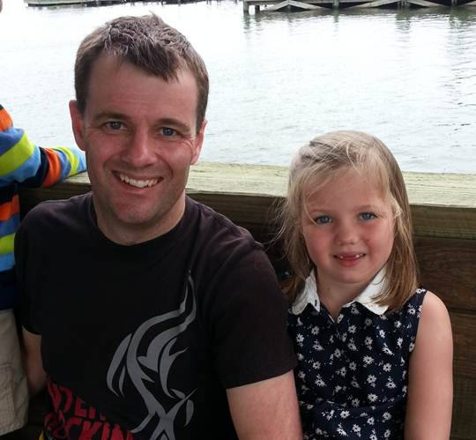
- SVYMG: What song would you most like to hear at the starting line of a race? How about the finish line?
Rob: For the start… “Don’t Stop Me Now” by Queen… It’s a classic high energy song for a race start. I think any classic Motown song for the end of the race… I’m not really hearing the music by the end of a race! (Editor’s Note: I’m mildly disappointed that Elton John’s “Tiny Dancer” was not mentioned ).
- SVYMG: What has been your best endurance sports experience to date?
Rob: Breaking 2:20 for an Olympic distance race… It had been a goal all season and I finally succeeded during my last race of the season.
- SVYMG: Do you have an endurance sports tip or two that you'd like to share?
Rob: Find a group to train with! I used to be too focused on my training plan, especially during Ironman training. It would invariably not fit with a group work out so I would train on my own. This quickly led to short-cuts, sub-optimal training, and missed work outs, which leads to people beating you who you don’t think should be (not mentioning any names, but you know who you are!). Joining the Spring-Valley Y Multisport Gators has been great for me. I’ve had the best winter training for several years because of the group training sessions.
Also, don’t neglect strength training. I used to avoid it, but then I finally got a personal trainer. It was amazingly beneficial for swim and bike and enabled me to break 2:20 in an Olympic distance race for the first time ever.
- SVYMG: Who is your favorite professional endurance sports athlete?
Rob: He’s not a professional athlete, but my Dad, still running marathons at 71, is a great motivation for me. I was in England last week… It is wonderful to still be able to train with him, even if it is not at the intensity it used to be!
- SVYMG: What is one interesting thing about yourself that has nothing to do with endurance sports that you'd like to share?
Rob: I am a terrible singer. I have been told that I couldn’t hit the right note by accident. I was also sent out of a group violin class when I was younger to practice on my own as I was slowing the rest of the class down. It was at this moment that I realized that I should stick to sports.
- SVYMG: Any other background info you'd like to share?
Rob: I am married to Ann, and have two kids, Sophia (aged 7) and Joshua (aged 4), who have me wrapped around their little fingers. I work for Dow Chemical in Collegeville. I moved to this area two years with my job. We moved from a small town in mid-Michigan, so this is definitely an upgrade although I still have an affinity for Detroit sports teams.

