About a Gator #29: Ellen Friend
February 2015
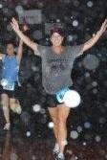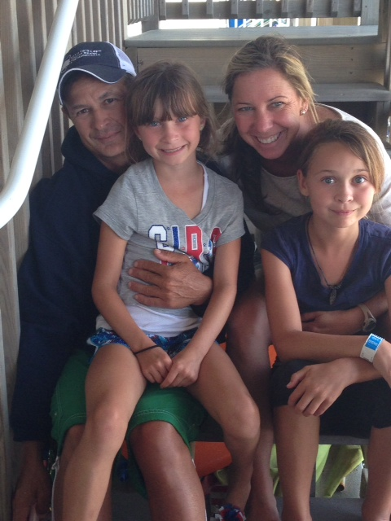
- SVYMG: What is your endurance sports background?
Ellen: After the birth of my second child, I aspired to run a marathon. In 2007 I started training and ran the Broad Street Run, the ING Distance Run, and then the Philadelphia Marathon. I enjoyed running and training with a mixed group of people. Running was my stress reliever. After running the marathon in November, I decided to try a triathlon and registered for the SheRox Philadelphia Triathlon the next month and went on to successfully complete my first triathlon. In total, I have completed the Philadelphia Triathlon, the SheRox triathlon, the Philadelphia Marathon, and the Atlantic City Marathon (2014). I hope to make a giant leap and see the finish line at the Ironman Eagleman 70.3 (half Ironman distance) event this June.
- SVYMG: What are your top 3 endurance sports goals?
Ellen: My goals are…
- Finish Eagleman with a smile on my face
- Not be sore after Eagleman
- Still enjoy triathlons after Eagleman
- SVYMG: What has been your favorite race in which you've participated?
Ellen: My favorite race was the Atlantic City Marathon this past October. I ran the marathon in honor of my brother, who passed away suddenly. My family and parents were along the course and at the finish line. They were so proud and happy to see me. I smiled the entire race. I was filled with a sense of peace and closure. The course was nice. I highly recommend this marathon and I would do it again.
SVYMG: What is the race that you'd most like to do?
Ellen: I would love to one day qualify for and run in the Boston Marathon.
- SVYMG: What song would you most like to hear at the starting line of a race? How about the finish line?
Ellen: AC/DC’s “Dirty Deeds Done Dirt Cheap” at the start and “Fireball” by Pitbull at the end. But I also always need a little Prince with “Baby I am a Star” and “Let’s go Crazy”.
- SVYMG: What has been your best endurance sports experience to date?
Ellen: My best endurance sports experience would have to be watching Danny finish his first Ironman in Cozumel, Mexico. I was in awe of him and every athlete from the professionals to the age groupers. It was a great experience and lots of fun. We are so proud of him!
- SVYMG: Do you have an endurance sports tip or two that you'd like to share?
Ellen: Bodyglide and Uncrustable peanut butter and jelly sandwiches… Never leave home without them!
- SVYMG: If you have one, who is your favorite professional endurance sports athlete?
Ellen: My favorite endurance athlete is the one who conquers their fears, faces their challenges, believes in themselves, and crosses the finish line.
- SVYMG: What is one interesting thing about yourself that has nothing to do with endurance sports that you'd like to share?
Ellen: I love cooking.
- SVYMG: Any other background info you'd like to share?
Ellen: I volunteer coach for the organization “Girls on the Run”. I have been doing this for almost five years. It is a great curriculum that teaches girls the skills to handle peer pressure and improve confidence and self-esteem while participating in running activities and games. At the end of the 12 weeks the girls run a 5K. I love to see their faces when they cross the finish line… Each girl starts out thinking she cannot run a 5K but the facial expressions at the finish line are priceless! I get emotional every year at the race. It is what life is about!

