About a Gator #28: Andy Rosebrook
February 2015
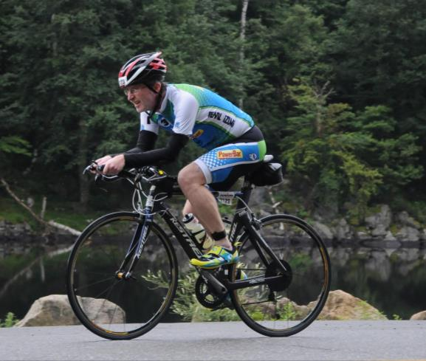
- SVYMG: What is your endurance sports background?
Andy: I was a cross country and track runner in high school. I was also part of a last ever Northern California Championship cross country team in 1986 and competed in the first ever California State Championships in 1987 (Vacaville Bulldogs). I made it to the Section championship meet in track in the two mile event (9:54). I also played water polo for four years in college at California Maritime Academy (despite the fact that the first water polo game I ever saw was one in which I played).
After college, I found working out on a submarine to be very difficult and I wasn’t very active for the next 14 years and I gained 100 pounds. One day at work I joined a weight loss challenge, and later a co-worker challenged me to do a triathlon. My first triathlon was the Lake Arrowhead Sprint Triathlon in 2003. I finished in the bottom ten and had to walk my bike up the hills, but I was bitten by the tri bug because of the amazingly positive vibes I felt from the folks who stuck around to cheer me to the finish line.
Since that day I have done 72 triathlons, including 7 Ironman distance events, 20 Half Ironman distance events, and I am a five-time finisher of the Quassy Revolution (Olympic distance triathlon on Saturday and a half Ironman distance triathlon on Sunday that includes over a mile of vertical climbing). I qualified for the Revolution 3 Series Age Group Championships in 2014, a year when I also was just 18 seconds from my first podium finish at Revolution 3 Pocono Mountains 2014 where I was the fastest finisher to not get a podium finish (Editor’s Note: The Rev3 series merged with the Challenge series in 2014 and Rev3 events are now part of the Challenge series).
- SVYMG: What are your top 3 endurance sports goals?
Andy: My top three goals are…
- Have fun
- Stay healthy
- Qualify for USAT Nationals
I have already crossed a few bucket list items off including finishing Kona (2007 lottery winner), completing the 2008 Boston Marathon, and participating in the 2011 Ironman Canada event (the classic course in Penticton) and the 2013 Ironman Lake Placid race (at the pre-race dinner, held in the Olympic ice arean, I sat on the spot where the Miracle on Ice dogpile was following the USA’s victory over Russia).
- SVYMG: What has been your favorite race in which you've participated?
Andy: Revolution 3/Challenge Quassy is my all-time favorite race. The course is absolutely beautiful and just keeps hitting you with hill after hill after hill on both the bike and run. When you finish that race you know you have accomplished something. I have finished every Rev 3 event at Quassy including six half Ironmans, five Olympics, and a 5K Glow Run held there… I love Quassy so much!
- SVYMG: What is the race that you'd most like to do?
Andy: Once my kids head off to college and I can save up the money, I would love to do Triathlon Le Alpe d'Huez in France. I love to watch the Tour De France and to be able to compete on that famous course would be amazing.
- SVYMG: What song would you most like to hear at the starting line of a race? How about the finish line?
Andy: At the start… “Let’s Get It Started!” by the Black Eyed Peas. And at the finish… “Celebration” by Kool and the Gang… This was the song playing as I crossed the finish line at Kona.
- SVYMG: What has been your best endurance sports experience to date?
Andy: My favorite race experience hands down was Kona (the Ironman World Championships) in 2007. I was in “tri- geek” overdose mode all week. The 60 seconds just before the start, while floating in the water, was absolutely electric with the feelings of tension, hope, fear, and anticipation. The amazing dark and stillness of the “Energy Lab” (something the elite athletes will never experience since they pass through during the daytime), the out of body experience of running done Alii Drive that final time to the finish, and then hearing Mike Riley call out your name was something I wish every triathlete could experience.
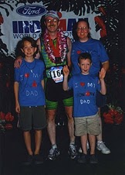
- SVYMG: Do you have an endurance sports tip or two that you'd like to share?
Andy: Stay patient! Many people expect too much too soon and create unrealistic expectations for themselves before they have any idea how their body will respond. Unrealistic expectations take the fun and the joy out of the whole triathlon experience. But if you set small goals and enjoy the ride, you will see the progress and the performance improvements come over time. I went from walking up the hills on my bike to ripping off top 10% overall bike splits, and turned my weakness into my strength, but it took a whole lot of time in the saddle and a lot of work but it is so rewarding to look back and see how far you have come.

- SVYMG: Who is your favorite professional endurance sports athlete?
Andy: Bill Rodgers (four-time Boston Marathon winner and Olympian) was my first sports hero. Growing up in the Boston area, I got to see him on the course at Boston every spring. Bill participated in and won the second race I ever completed and handed out the medals to the age group winners. I met him and Joan Benoit in Boston in 2008 after the Women’s Olympic Marathon Trials (held the day before the Boston Marathon) and it was so cool!
In triathlon, I have met a lot of pros thanks to being part of the Revolution 3 Age Group team, but my favorite is Richie Cunningham. In 2012, after Richie came over to me and asked me how my race went at Eagleman (where he finished 2nd) I became a fan for life!
- SVYMG: What is one interesting thing about yourself that has nothing to do with endurance sports that you'd like to share?
Andy: I am a Senior Project Engineer for the Nuclear Regulatory Commission. I inspect nuclear power plants all over the country. Protecting public health and safety can be a thankless job but it is very rewarding knowing you have made difference.
- SVYMG: Any other background info you'd like to share?
Andy: I have been married to my beautiful wife, Tammy, for over 24 years, and we have two boys, Adrian and Matthew, who are in high school (a senior and a freshman). All of them are martial artists. Tammy is an owner and Tai Chi instructor for White Eagle Martial Arts at the YMCA. Adrian is a black belt and Matthew is a green belt, so everyone in my house can kick my butt! We have two kuchi dogs who were rescued from Kabul Afghanistan by US troops that adopted their mother. We also have two Savannah cats (rescued from the Berks animal shelter) and two Bengal cats from Reading.
