About a Gator #27: Tiff Pfluger
February 2015
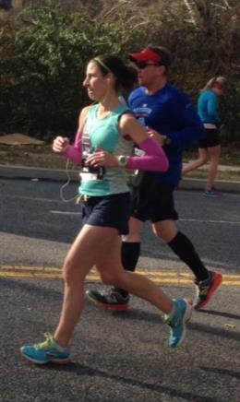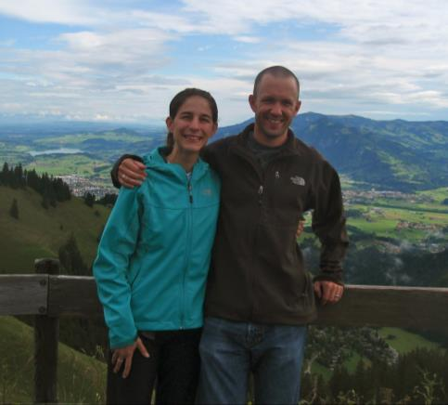
- SVYMG: What is your endurance sports background?
Tiff: I’m that crazy Gator that signed up for an Ironman before ever attempting a triathlon, not knowing if I could swim and I didn’t even own a bike. I have, until recently, considered myself “just a runner.” My background is running cross country and track in high school and college, then building up to half and full marathons over the last 10-12 years. I ran anything from the 400m to the two mile in high school, but then focused on the 800m, 1500m, and steeplechase in college. Steeplechasing over barriers and water pits was definitely the most fun! Women’s steeplechase was a new NCAA event at the time, so I was only able to compete in it during my senior year, but I was only 17 seconds from a Nationals qualifying time and placed third at our Conference Championship, which was my biggest success through four tough college years. These days I enjoy any road races from 5K up to the marathon. I think I’ve raced in eight marathons so far with hopefully more to come, including the 2016 Boston Marathon.
- SVYMG: What are your top 3 endurance sports goals?
Tiff: My top three goals are…
  - Not only finish, but enjoy my FIRST triathlon this spring.
  - Hear the words "You are an Ironman!" in Lake Placid this summer alongside my husband and teammates.
  - Tackle an ultramarathon in the near future.
- SVYMG: What has been your favorite race in which you've participated?
Tiff: Since high school I've always enjoyed being a part of a relay team. The team aspect of any sport is what I find to be the most fun and rewarding. Winning the inaugural Challenge Atlantic City relay (Ironman distance) with Michelle Leonard and Steph Bieloski, only a mere 5 seconds ahead of second place, is probably my most memorable and favorite race. The overall conditions and course made my marathon leg quite difficult, leading to my slowest 26.2 miles ever, BUT the win as a team made it so worth it!
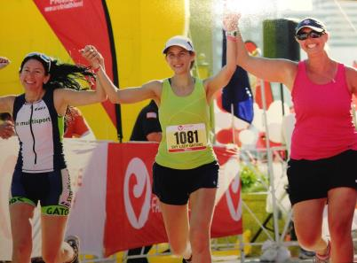
- SVYMG: What is the race that you'd most like to do?
Tiff: For over 10 years I have had my eyes set on the Boston Marathon and I expect to toe that line in 2016. The tradition of that race and just knowing that you need to earn your spot was always so inspiring to me.
- SVYMG: What song would you most like to hear at the starting line of a race? How about the finish line?
Tiff: If I can dance and sing to it, I like it. All upbeat music in general makes me happy and ready to race. In fact, I am pretty sure I was listening to a “Frozen” soundtrack song when I crossed the line in at the 2014 Philadelphia Marathon and I was pumped!
- SVYMG: What has been your best endurance sports experience to date?
Tiff: After years of trying, I finally qualified for the Boston Marathon this past November at the Philadelphia Marathon. There are two reasons why this was the best overall experience beyond just the BQ:
  - 1. I thought I had it in the bag six weeks earlier at the Chicago Marathon, but I went out too fast. I was able to shake it off, regroup, and come back stronger.
  - I was lucky enough to have my husband, Tim, pace me through a smarter race. I may not have talked too much during the race, and may have even yelled at him once or twice, but crossing the line together, knowing I achieved my goal WITH him, was priceless!
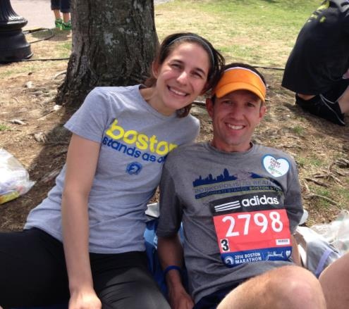
- SVYMG: Do you have an endurance sports tip or two that you'd like to share?
Tiff: Keep it simple and enjoy yourself. I honestly compete better when I follow these two things.
- SVYMG: Who is your favorite professional endurance sports athlete?
Tiff: As is the case for most of us, Rinny (Mirinda Carfrae) is up there. I love watching her in “Beast Mode”, and listening to her talk gets me all fired up! I also look up to American marathoners Shalane Flanagan and Kara Goucher… They both have so much passion for the sport.
- SVYMG: What is one interesting thing about yourself that has nothing to do with endurance sports that you'd like to share?
Tiff: Tim and I lived in Reno, Nevada after college and had a fantastic low-key year there. I worked as a receptionist at a veterinary hospital, a fitness consultant at a gym, and a ticket seller at a ski resort. I remember driving my little blue Neon in tons of snow up the mountain (sometimes needing chains on my tires to reach the top) where I would sell lift tickets for a few hours then get to ski myself. Unfortunately that fairytale of a life ended when we moved back to Pennsylvania so I could attend veterinary school. We call Lake Tahoe, especially Squaw Valley, our happy place and ended up getting married there in 2009.
- SVYMG: Any other background info you'd like to share?
Tiff: Fellow Gator Tim and I have been married since 2009, but have been together since I was 19. It was a Moravian College Track Team romance. We have five pets… two dogs named Lion (13 years old and a running champion in his own right) and KT (10 year old Boxer) and also three cats named Punk, Pickles, and Owl. Pickles is my calico sidekick and, after Tim, is considered my best friend. I swear she listens and talks to me like a human sometimes!
I am a small animal veterinarian in Limerick where I have been a general practitioner (medicine, surgery, emergency… you name it) since graduating school in 2008. To the surprise of most people, I am also a Certified Veterinary Medical Acupuncturist where I can treat all kinds of conditions from acute and chronic pain to neurologic conditions.
My favorite pastimes outside of running, cycling, and swimming are singing and dancing, but the trouble is I can’t really sing or dance.
