About a Gator #26: Jason Brannen
January 2015
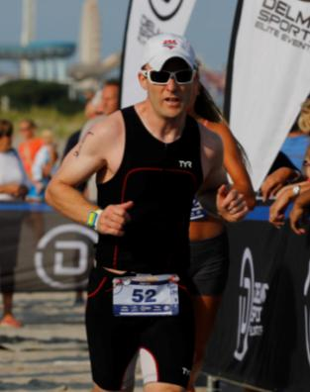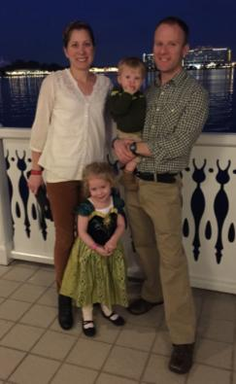
- SVYMG: What is your endurance sports background?
Jason: I do not have much of an endurance sports background. In high school I played baseball and ran track. I never competed in anything longer than 400 meters. Then in college I played club hockey. It was not until I met Kerri while I was completing my medical residency that I got involved in any kind of endurance events. Initially it was just the occasional 5K road race. Then in 2009 I ran the Broad Street Run for the first time – in a blistering 9:57 per mile pace!
In 2010, I decided to try to compete in a triathlon. The most daunting task for me was the swim. I had never really swum before, so I started taking basic swim classes at the Phoenixville YMCA. When I first started swimming in the pool I could not even finish one length. After a few months and after working through a lot of bad mechanics, I figured I could complete the ¼ mile swim that was part of a sprint race. I started by doing sprint triathlons at the Jersey Shore with Kerri. Some of our favorites include the Islandman (Avalon, NJ) and Wildwood triathlons. I can attest to the fact that ¼ mile swim in the open ocean is very different than in a pool! Anyway, I survived them and we try to participate in these races every year.
In 2012, I ran my first half marathon with Kerri in Atlantic City. Then in 2013, we joined the Spring Valley Multisport Tri Club and my perspective on the sport changed. Now, I am involved with and inspired by like-minded people. I have also set my goals a little higher this year with a Half Iron distance race at the end of the summer.
- SVYMG: What are your top 3 endurance sports goals?
Jason: First, I would like to compete in and finish a Full Iron distance race. I think the keys for me (and probably everyone) are remaining relatively injury free and being able to find the time to commit to it. Second, I would like to finish my first marathon, hopefully in under four hours. Third, I would like to plan a destination race with Kerri, maybe in the Caribbean, in Florida, or out West.
- SVYMG: What has been your favorite race in which you've participated?
Jason: My favorite race was the Steelman Triathlon last year. Being a member of a team and having Kerri compete in it with me was great. Having a few guys that you know and trust in your swim wave does a lot to help motivate you and at the same time alleviate anxiety.
- SVYMG: What is the race that you'd most like to do?
Jason: Probably Ironman Cozumel 70.3. I like the thought of swimming in clear blue waters and the after party must be great!
- SVYMG: What song would you most like to hear at the starting line of a race? How about the finish line?
Jason: I would start with “Them Bones” by Alice in Chains… It is heavy and fast and great to get going with. At the finish it would be Bill Conte’s “Gonna Fly Now”… Nothing goes better with physical exhaustion than the Rocky Theme song!
- SVYMG: What has been your best endurance sports experience to date?
Jason: Finishing the Atlantic City half marathon in a dead heat with Kerri… I think I edged her out at the line!
- SVYMG: Do you have an endurance sports tip or two that you'd like to share?
Jason: Have a plan. Before, I would do random workouts whenever I had time. Now having a plan really gives me structure and allows me to set attainable goals. Also, if you miss a workout for whatever reason, don’t let it bring you down. Move on to the next one. Life happens.
- SVYMG: Who is your favorite professional endurance sports athlete?
Jason: I don’t have a favorite professional endurance sports athlete. The individuals that I do admire in the sport are the athletes that can have a career, a family, and are able to compete. I believe we have quite a few people like this in our club.
- SVYMG: What is one interesting thing about yourself that has nothing to do with endurance sports that you'd like to share?
Jason: I had the opportunity to travel to Australia and New Zealand in 2009. While I am not an adrenaline junkie I bungee jumped off the oldest permanent bungee installation in the world – Kawarau Bridge in Queenstown, New Zealand. Also, I had the opportunity to explore the Great Barrier Reef in Australia.
- SVYMG: Any other background info you'd like to share?
Jason: I am an anesthesiologist who specializes in the care of the cardiac surgical patient. I am married to a fellow member of the club, Kerri Brannen. We have two children, Keira who is 3, and Aiden who is 16 months.
