About a Gator #25: Suzanne Angelaccio
January 2015
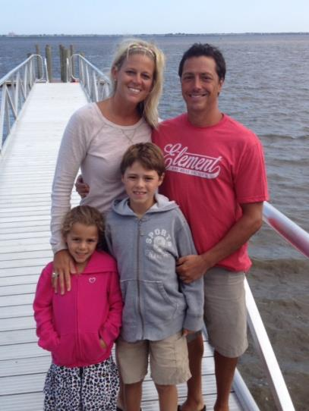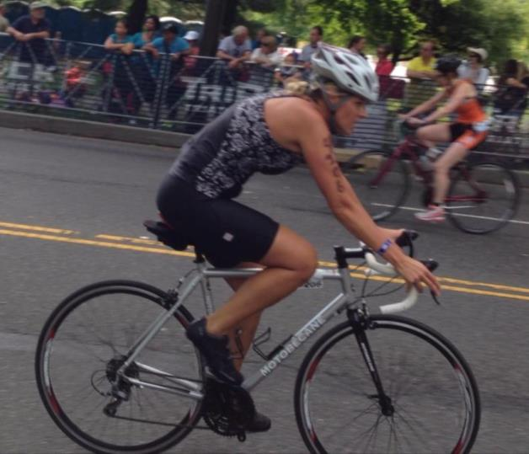
- SVYMG: What is your endurance sports background?
Suzanne: My endurance sports background is short but sweet. I feel like my time in this sport is just beginning. I started in June 2013 with the TriRock Philadelphia – Sprint distance triathlon. The following year I added a few more races to my accomplishments: The Independence Triathlon and TriRock Philadelphia. I have done a few of the mini tris with the Gators at the Y and I feel that those were just as competitive as my other races! So far I have only done Sprint distance tris, but I plan to change that this year. I have done a Tough Mudder in 2012 and I’ve completed two half marathons and have another one planned for March. I started doing endurance sports to challenge myself. I have always admired people who said they have done “triathlons” and “marathons” and I wanted to be one of those people… And I am! I need to keep challenging myself to tell myself that I can do whatever I put my mind to… It’s all mental… Just keep going!
- SVYMG: What are your top 3 endurance sports goals?
Suzanne: My top three endurance sports goals are…
    - To be more consistent with my tri training during 2015
    - To master the swim now that I have a wet suit and have more options for open water swim practices
    - I would love to make podium
    - Increase my race distances. Opps…you asked for 3 goals.

- SVYMG: What has been your favorite race in which you've participated?
Suzanne: My favorite race so far was my first triathlon at the TriRock Philadelphia. It was June 2013 and my husband and best friend and I raced it together. There is nothing like your first race. I crave that feeling in your stomach as you drive to the race early in the morning and the anxiety and nervousness as you stand there ready to jump into the water. In fact, the open water swim in the Schuylkill was my first open water swim ever. I trained in the Spring Valley YMCA pool and never trained in open water. So it was quite a change for me. I did the bike on my mountain bike and sneaks while others zipped by me on their fancy road bikes. When I crossed that finish line I cried. Never in my life did I think I could say “I did a triathlon.” I was damn proud!
- SVYMG: What is the race that you'd most like to do?
Suzanne: I am telling myself this year is my year. I often dream of being able to say I did a 70.3 distance race. Maybe someday!
- SVYMG: What song would you most like to hear at the starting line of a race? How about the finish line?
Suzanne: I don’t really have a specific song I would like to hear at the beginning of a race. But to get psyched up I love listing to dance/club music. I love the crazy beat to get me ready! At the finish line… “Wild One” by Flo Rida!
- SVYMG: What has been your best endurance sports experience to date?
Suzanne: A special experience I will remember is June 2014 when I returned to TriRock Philadelphia with my open water swim training, a road bike (not a mountain bike), and much more running under my belt. In the end, I shaved a little over 10 minutes off my time from June 2013. I credit a lot of that to the Gators helping me train properly and the support from the group!
- SVYMG: Do you have an endurance sports tip or two that you'd like to share?
Suzanne: My tip would be to have fun! Most of all, smile when you cross that finish line because that’s your moment! Plus, the camera is there to take a good shot of you!!
- SVYMG: Who is your favorite professional endurance sports athlete?
Suzanne: Mirinda Carfrae – I think she is a robot or a bionic woman of some sort.
- SVYMG: What is one interesting thing about yourself that has nothing to do with endurance sports that you'd like to share?
Suzanne: A few interesting facts about me are that after I graduated from college I was a flight attendant for about a year. It was a fun time. I also went sky diving twice (not while I was a flight attendant!). I will try anything twice! Recently I was certified as a personal trainer and I wish I would have done this sooner. Being active and helping others stay active is something I feel passionate about.
- SVYMG: Any other background info you'd like to share?
Suzanne: I grew up in West Chester, PA. I graduated with a degree in Journalism from West Chester University. When I was a kid I wanted to be a police officer… Clearly that didn’t happen! Growing up I played field hockey, basketball, and lacrosse. I have been married for 11 years to my husband, Tony, who, thankfully, is supportive of my passion for triathlons. We met at a bar in West Chester. For those that know me well you may find that to be a shock! I have two kids who are the loves of my life… Gavin is 10 and Mia is 6. I am still trying to convince my kids to do a triathlon like mommy! My dog, Turbo, is 11 and has the worst breath ever, licks everything, and acts like a cat. I work part time at the Y as a personal trainer and I always make time to get my workouts in. Being part of the Gators group has inspired me so much. There are so many different types of athletes in the club who have inspired me in so many ways.

