About a Gator #24: Nabil Radouane
January 2015
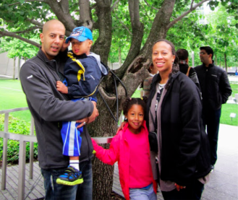
- SVYMG: What is your endurance sports background?
Nabil: Open water swimming is my passion. As a kid, the beach was my playground. I grew up a few blocks from the Atlantic Ocean and swam quite frequently including during the winter season. As a result of quitting smoking in the past four years, I went back to my bucket list and decided to pursue open water swimming as a hobby and a form of therapy. I participate in OWS events for the love of swimming. (Editor’s Note: Nabil learned this week that he has been selected in the lottery process to participate in the “Great Chesapeake Bay Swim”, a very popular 4.4 mile event taking place in June that has participants crossing the Chesapeake Bay in Maryland at its narrowest point.)
- SVYMG: What are your top 3 endurance sports goals?
Nabil: My goals are to swim…
- The Strait of Gibraltar (Editor’s Note: Between Europe and Africa; swim has been completed by less than 500 people; typically takes 6-7 hours)
- The Triple Crown of Open Water Swimming; includes Catalina channel (20.1 miles between Catalina Island and Southern California mainland), Manhattan Island swim (28.5 miles around the island), and the English Channel (21 miles).
- SVYMG: What has been your favorite race in which you've participated?
Nabil: I have to pick the Little Red Lighthouse Swim (Hudson River swim; Editor’s Note: it is typically 10K; last year it was extended to 7.5 miles) due to the view while swimming under the George Washington bridge and all the scenery and landscape that the Big Apple has to offer.
SVYMG: What is the race that you'd most like to do?
Nabil: Definitely the Strait of Gibraltar swim. Ever since I was a child, growing up in Morocco and visiting the northern coast, I was inspired to someday swim the Strait of Gibraltar a distance of 9 to 12 miles.
- SVYMG: What song would you most like to hear at the starting line of a race? How about the finish line?
Nabil: I usually read before an event (notice I don’t call it a “race”), which helps me to relax and take my mind off the event. At the end of most of my events they play the song “Happy” (by Pharrell Williams) and I have gotten used to hearing it at the end of each event and look forward to hearing it.
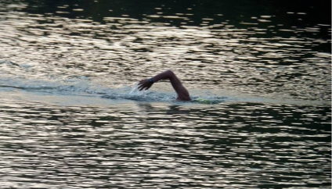
- SVYMG: What has been your best endurance sports experience to date?
Nabil: The Lake George 5K swim… Beautiful nature and crystal clear water.
- SVYMG: Do you have an endurance sports tip or two that you’d like to share?
Nabil: Daily yoga and meditation.
- SVYMG: What is one interesting thing about yourself that has nothing to do with endurance sports that you'd like to share
Nabil: I speak three languages… French, Arabic, and English.
- SVYMG: Any other background info you'd like to share?
Nabil: My gratitude to my lovely wife, Alexis, and my kids, Nadia and Adam, and the family cat, Cisco, for their love and support! And the camaraderie and support by the fellow Gators.

