About a Gator #23: Byron Solvason
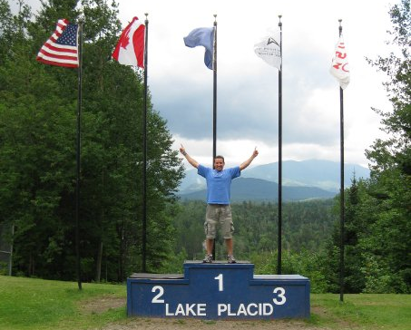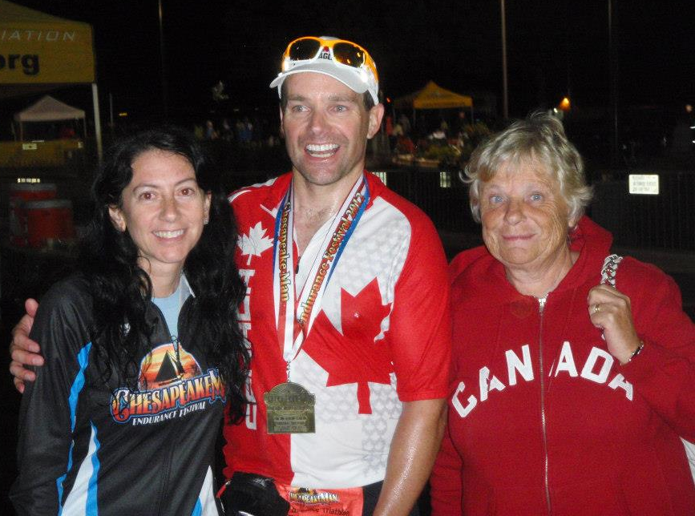
January 2015
- SVYMG: What is your endurance sports background?
Byron: I’ve been doing this stuff for the past seven years, starting with a sprint triathlon in 2007. Did I mention I did the backstroke? Yep, I thought I was going to die in the water, so I had to flip over and site every so often. I must have looked so funny. Oh, I met a guy in transition one year at IRONMAN Lake Placid that told me he did the swim backstroke too… for IRONMAN Lake Placid (i.e. 2.4 miles)! So, that should give you the confidence that YOU CAN AND WILL get through it with flying colors! Doing research on where I began just brought some things to light. Without much training, I think I am built more to go FAST and do short distance stuff. I placed 3rd in my age group at my final race of my inaugural year of triathlons in a super short sprint race. My swim time was almost 3 min/100m… aha, ha, ha, ha! Most of us are well under 2 min/100m and that’s swimming for endurance lengths. However, half IRONMAN distances seem to be my nemesis, and I’ve never had a great one. Most of my full IRONMAN distance events have resulted in better finish times than double my half IRONMAN times. Translation.. I need more training and discipline.
- SVYMG: What are your top 3 endurance sports goals?
Byron: Great Question!
- I’d like to finish well in an IRONMAN race, somewhere around the 11 hour mark, but the stars need to align, and I have to put more work in, and, oh yeah… NUTRITION needs to be spot on too! 28 more weeks to practice this and perfect it before my next event (IRONMAN Lake Placid… July 26, 2015)!
- I’d love to do some adventure type races (eg. trail runs, canoe/kayak/tough mudders, etc.) I just haven’t gotten around to putting them on the calendar. After Lake Placid I will get one on the calendar.
- SWIM/RUN – improve dramatically in both of these areas, and that’s what the plan is for this year.
- SVYMG: What has been your favorite race in which you've participated?
Byron: IRONMAN Lake Placid – the crowd support is super fantastic, the scenery just cannot be beat, the swim is majestic, especially when you see the fog lifting off the lake, and, of course, the pain that the hills can inflict on the legs… It just hurts so good! Remember to SMILE.. The day will be over before you know it, so ENJOY IT!! I am one to high five the majority of the spectators, especially when I need a burst of energy, and it helps to raise my spirits and livens them up for all the other triathletes as well.
- SVYMG: What is the race that you'd most like to do?
Byron: Wow, I’d have to say Kona, just because it’s the iconic race with the best of the best there, as well as many special interest athletes, too. And, having been there, I can know with certainty that you are racing in paradise! What a great way to spend a boat load of money, and justify it by making it into a family vacation at the same time!
I also think RAAM (Race Across America; 3,000 mile bike race from Oceanside, CA to Annapolis, MD) would be pretty cool to do, but those guys that hammer this out are on another level on the bike. But that intrigues me as well, and I’d do it to raise money for a charity if this ever comes to fruition. But that would be after a break from IRONMAN distance events, and I’d need a big focus on improving fitness and endurance on the bike for that long of a haul. Who knows, maybe if the run improves, there could be an ultra in the mix.. ha, ha, ha!
- SVYMG: What song would you most like to hear at the starting line of a race? How about the finish line?
Byron:
- Starting Line: Art Of Dying’s “If You Can Get Thru This” (Michelle recently played this song in a tri spin class)
- Finish Line: Skillet’s “Awake & Alive”
- SVYMG: What has been your best endurance sports experience to date?
Byron: BEST… It depends on your definition of “best”. If you think “best time”, it was Chesapeake Man 2011, where I struggled out a 12:25 flat. However, I’d have to say IRONMAN Lake Placid in 2008 and 2009 and Chesapeake Man 2012 were my favorites. My parents were there for Lake Placid 2008, my first full IRONMAN distance event, and it poured all day long! For Lake Placid 2009 Michelle and two great friends were there to cheer me on, with one of my friends jumping on the bike course in town and running and cheering me on as you make the right hand turn from Mirror Lake Drive up the hill, around the lake, and back for your second loop… It was a picture out of the Tour De France. For Chesapeake Man 2012, I flew my mom out to watch me race, and I did that one in my dad’s honor with not enough training, and my watch died. Had I known it, I was on pace to beat my best time ever, but I gave in on the last six miles or so of the run, and came out with a 12:34… Oh, and Michelle earned me a penalty by running alongside me when I came back for the final loop… Too funny! But it was great to have my mom there, and it brought back memories of her and my dad watching me during these long endurance events. Suffice it to say, the BEST events to me are those where you can share in the moments and memories of those you love and cherish. So this year, I am pushing to shave an hour off my prior best time to bust into the 11’s for sure for him. I’ll be persevering through the pain, knowing that I am alive and able to compete in this, and think of him cheering, yelling and pushing me on.
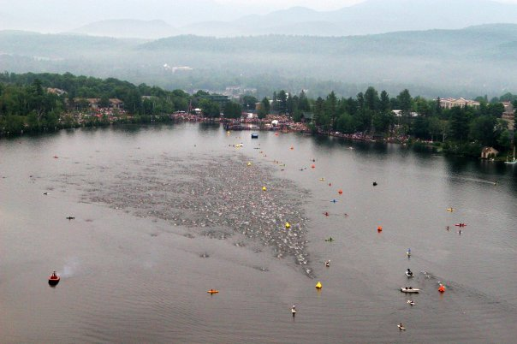
- SVYMG: Do you have an endurance sports tip or two that you'd like to share?
Byron: In prior years, it would have been to “Do as I say, not as I do”… I have never put a ton of structure, nor effort, into being disciplined and training smart for an endurance event. I would bike two times per week, and run maybe 1-2 times per week (usually 1) and swim… ha, ha… 3-4 times maximum before an IRONMAN race. BUT, this year will be different. I’d now have to say, “Learn from your mistakes”.. I’ve made many, and I’ve proven the fact that to do well, you need to have a well thought out plan, and then work your plan and put in the time. Don’t focus on MILES, focus on TIME! You can get so caught up in hitting mileage, when it’s irrelevant. If you want to run for 1½ hours, then head out 45 minutes and turn around and head back. If you were trying to hit ten miles in that time period and you only ended up at 9¼, so what?! You still put the time in and your heart, lungs, legs, etc. all have reaped the benefits of a 1½ hour workout. Call it a day, go replenish nutrients with a quick protein shake as soon as you are done, and CONGRATULATE yourself by checking off yet another workout done!
Another BIG, HUGE tip… Practice your nutrition. For your longer training rides and runs, practice with what you will race with in terms of both fluids and whatever “fuel” you will be using. DON’T change it up. Find out what they are using at the race, and if you plan on using that stuff, then get it NOW, try it out and see if it works for you. My first IRONMAN Lake Placid experience was a GI disaster with the last 13 miles of the run being a walk from porta john to porta john. Not a great experience, but a very memorable one that left a lasting impression.
Final Big Tip… Race YOUR race. Save some for the second half of the bike, and try to practice achieving negative splits, this will help; you have a long, long, tired run ahead of you. Again, save some for the second half of the run; this is where training smart using your heart rate, staying in your zones, not redlining early, and keeping up on your nutrition will reap huge dividends. I am confident that if you nail this, it’s worth close to an hour of time off your race, no question. Don’t redline, when you do, you deplete all your glucose stores, and you will crash very quickly. This is why aerobic training in your proper zones is important. You are training your body to use fat for fuel rather than consuming your precious glucose stores. Oh, I should say this goes double for the swim… at least for me. I’m not gaining much time by sprinting it out in the swim, but I will kill my glucose stores early on, and sack myself for the rest of the day (or at least the next few hours). Wait, aren’t I one of those guys hammering it out on the bike?! Yep… got a lot to learn folks.. practice, practice, practice! Trust me, hammering doesn’t work, unless you’re in a sprint.
- SVYMG: Who is your favorite professional endurance sports athlete?
Byron: Andy Potts is a newer stud on the seen, but I am in complete awe of Mirinda Carfrae. I think she’s just from another planet. She must have a transmission in her legs, because she just seems to have another gear, and when she passes her competitors, she hammers one more gear to show them how dominant she is and simply punishes their mental state as she barrels by them, and they have no answer for the power she puts down on the run.
- SVYMG: What is one interesting thing about yourself that has nothing to do with endurance sports that you'd like to share?
Byron: I have an identical twin brother that many of you may have heard about. Funny that we went different directions in our careers, etc. when we graduated. He became a roofer with some friends (hugely lucrative business might I add) and I went into accounting. He had a terrible car accident but recovered, and it forced him to change occupations. He went back to school for accounting and is now a CA (like a CPA – accountant here) and has his own practice back home in Winnipeg, Manitoba, Canada. The past couple of years he has dabbled in some half marathons as well. Funny how we both ended up doing similar things a little later in life, yet we are 30 hours apart by car!
I have also met some really interesting people along my journeys and have included some photos. Also, the link below is to something very motivational… Charlie Plaskon is legally blind, and was in his late 60s when I met him in the elevator of our hotel while doing IRONMAN Louisville in 2009. Watch this when you need a pick me up, or a kick in the ass!... https://www.youtube.com/watch?v=YghEDKYj5ZI
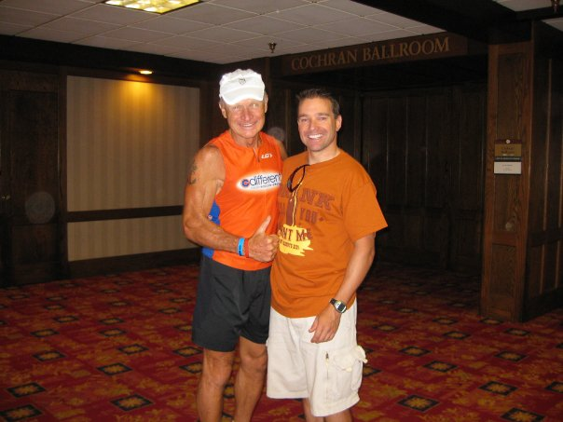
- SVYMG: Any other background info you'd like to share?
Byron: We have four “furnimals” largely in part due to my lovely wife Michelle’s bleeding heart! One was mine to begin with, one was hers, one was her sister’s dog, and another was her cousin’s/uncle’s/aunt’s dog that they gave up. We have a family of a chocolate lab, lab mix, a cockapoo, and a Bernese Mountain Dog (gentle giant). I’d be remiss if I didn’t mention that this past September, I married the most beautiful, kind hearted, spirited woman that I am lucky to be able to call my wife. It’s so nice to find someone that shares in a lot of the adventure that you enjoy, and we get to spend a ton of time together training, suffering, laughing (sometimes crying.. right Michelle?!) as we continue on this multi-sport journey. Oh, and we joined this really cool tri-club a year ago now, and met a ton of the most awesome kind hearted, positive people that we are fortunate to now be able to call our friends. Go Gators!
