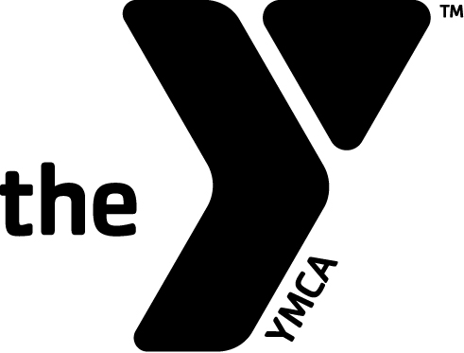
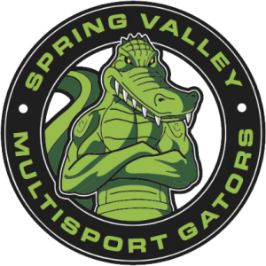

Hello Gators and Prospective Gators,
Wow! What an exciting year we had in 2014! We were able to establish ourselves as a full-fledged USAT triathlon club and accomplish many great feats through the collective efforts of all of you! 2015 promises to be even more exciting and fun now that the groundwork is laid. We are eager to get started and invite all of you (and your family and friends) back for many amazing experiences. We’d like to take this opportunity to formally communicate the new club fee structure for 2015 as well as provide some information on the many benefits available to you by being a Spring Valley YMCA Multisport Gator.
Let’s get right to the fees… There are two options, both of which cover complete membership for all of 2015:
- Individual membership: $125
- Family (includes two members from the same household): $200
While the new fee structure is a bit higher than was communicated over the summer due to YMCA budget finalization, I think that you will see some significant financial benefits over the 2014 fee structure and outstanding additional benefits that can be derived from your membership…
2014 Fee Structure: $50 club fee plus $40/month for full Tri Club workout access = $530/yr.
2015 Fee Structure: $100-$125/person for the entire year… $0 additional fees... About the cost of a typical sprint or Olympic distance race entry fee and a $400+ savings over the equivalent 2014 cost.
So what do you get for this membership?
- Spring Valley YMCA Multisport Gators T-shirt
- Access to a minimum of 10 hours/week of coached group training workouts in all triathlon disciplines throughout the entire year (even when other Y programs are taking a break)
- Access to an amazing coaching staff of eight that includes a certified USAT coach and a second to be added during 2015 (individualized coaching is also available)
- Personal Training Peaks basic account that will be populated with the club’s workouts as well as your individualized heart rate zones and can be used to plan and track your workouts.
- Option to participate in club events such as mini-triathlons and the “Gator Fitness Challenge”.
- Sponsor discounts
- Periodic performance seminars hosted at the Spring Valley YMCA
- Weekly Gator newsletters that include detailed information about the club’s past and future accomplishments as well as a plethora of other useful information, tips, etc.
- Access to the club’s “Who’s In?” race calendar to help you plan your season
- Access to custom “Gator gear” including uniforms, training/racing accessories, and spirit wear
- Access to the club’s private Facebook group
- Access to new Website page on the Spring Valley YMCA website that will soon include significant member content
We are excited to have you continue your membership or start a new membership! Following are some details about the renewal process…
- When can I renew? Membership renewal will take place starting on January 1, 2015. All memberships must be renewed by January 31.
- Where can I renew? At the Y front desk or online at the Y’s registration website (once there, click “Program Search”, enter keyword “Gators”, click “Triathlon Training”, and select the Individual or Family option).
- Is the full fee due in one payment? This is preferred but we are flexible if you would like to spread your membership fee over multiple payments.
- What if I want a family membership that includes more than 2 people? Additional family members can be added for $125/person or $200/couple.
Spring Valley Y Multisport Gators Leadership
- Head Coach- Danny Friend
- President- Jon Wesler
- Vice President- Brent Voynar
- Secretary- Don Mack
- Treasurer- Byron Solvason

