About a Gator #22: Kenneth Beauchamp
December 2014
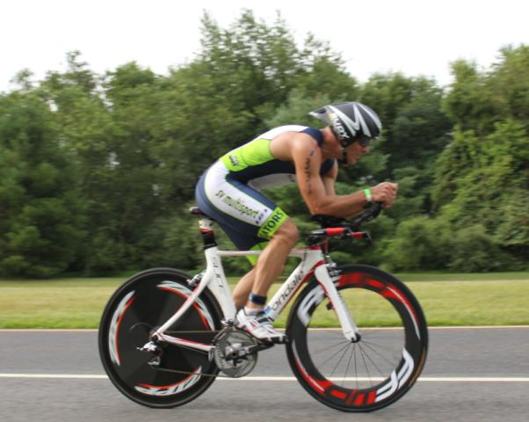
- SVYMG: What is your endurance sports background?
Ken: I began my endurance sports background as a runner. In my mid-30s I was, through my job, introduced to cycling. After a couple of years of riding, and still running, I sought out opportunities to compete in both sports. I found a triathlon and, without a single day in the pool, entered and raced. Other than the swimming, I greatly enjoyed the event and continue to this date enjoying the opportunity to train and compete. To date most of my experience in endurance sports has been half-marathons and sprint level Tri’s/Du’s with one triathlon at the half-lite distance.
- SVYMG: What are your top 3 endurance sports goals?
Ken: My top three endurance goals are:
  - Continue to enjoy training and racing. Only the pros should feel like they are “working” when they are training.
  - Compete at all distances of triathlon and duathlon.
  - Continue to train and race until the day I die.

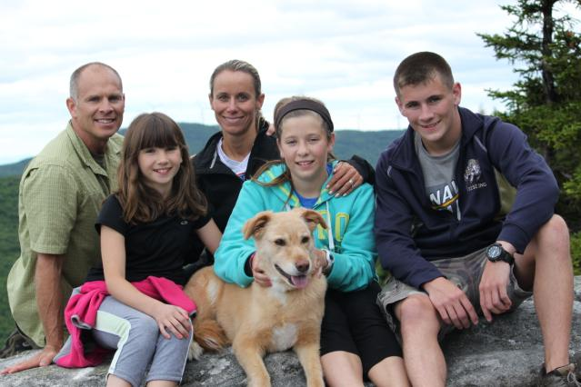

- SVYMG: What has been your favorite race in which you've participated?
Ken: I don’t think I have a favorite race because I enjoy each race for its individual nuances. That said, I think my favorite course is in Bear, Delaware. The Tri-it and Diamondman triathlon courses are flat and fast and I always enjoy going fast.
- SVYMG: What is the race that you'd most like to do?
Ken: I would like to do the “Cycle to the Sun” race in Maui, Hawaii. The race is 36 miles long starting at sea level and going to the top of Haleakala Volcano at 10,000 feet. This past summer Kelly and I rode a 10 mile portion of the course and it was an awesome experience. The challenge is not only in the unrelenting climb, which reaches 18% from time to time, but also in the weather changes as you pass through several unique climate zones.
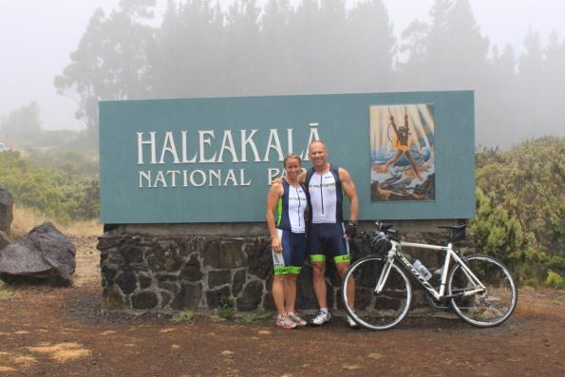
- SVYMG: What song would you most like to hear at the starting line of a race? How about the finish line?
Ken:
- Starting line: The National Anthem. I have spent 10 years in the military and another 18 years in the Secret Service. Serving my country and honoring those that have gone before, and given all, brings me great pride and motivation to race hard.
- Finish line: It doesn’t really matter as I am too tired to enjoy the song any way.
- SVYMG: What has been your best endurance sports experience to date?
Ken: My best experience was probably the half-marathon in Philadelphia last month. I had a set goal to run a seven minute/mile pace for the race and I did so with, what felt like, relative ease. I know I would not have wanted to run 26.2 miles at that pace but I didn’t really believe I could run the 13.1 miles that well either!
- SVYMG: Do you have an endurance sports tip or two that you'd like to share?
Ken: First, get a good training partner that has equal abilities/potential and challenge them to challenge you. Nothing will help you achieve your goals better than a friend who has similar goals and abilities. Whether you are building a training plan or actually out executing that plan, a partner that can push you as much as you are able to push them is essential (I expect you to finish stronger on our next run Schlichtmann!!).
Second, enjoy your training. For the most part you should always find ways to enjoy the training that you do. As far as I know, none of us on the Gators team are pros and, therefore, the training we do is ultimately to stay healthy and fit (at least it probably should be). If we put too much stress on ourselves… over training, racing, winning, etc… we lose focus on that main goal of fitness and health. This by no way means you shouldn’t challenge yourself and put in some tough training to accomplish those challenges. Just keep perspectives (and sometimes egos) in check so that you can continue to train, race, and stay fit for many years to come.
- SVYMG: If you have one, who is your favorite professional endurance sports athlete?
Ken: I enjoy watching the pros, but really have no particular favorites. Anyone who can push themselves beyond what they should be physically able to do, pros or amateurs, is fun to watch as they accomplish their goals.
- SVYMG: What is one interesting thing about yourself that has nothing to do with endurance sports that you'd like to share?
Ken: Though I truly cannot think of anything interesting about myself, my wife says I must answer the question. Therefore, I am not sure it is very interesting but I enjoy woodworking and building things. I also enjoy photography primarily of people and landscapes.
- SVYMG: Any other background info you'd like to share?
Ken: I was born and raised on a farm in northern Michigan. We were poor and had very little creature comforts that many take for granted. It was those meager beginnings which taught me that hard work and dedication pay off.
Upon graduation from high school I spent 10 years in the military and earned a Bachelor’s degree. After the military I became an Agent with the Secret Service, a role I have been in for 18 years. In three years I plan to retire from the Service and dedicate more time to my wife, five kids, two grandchildren, and my training/fitness.
