About a Gator #21: Adrienne Foster
December 2014
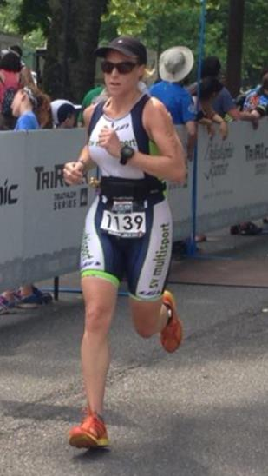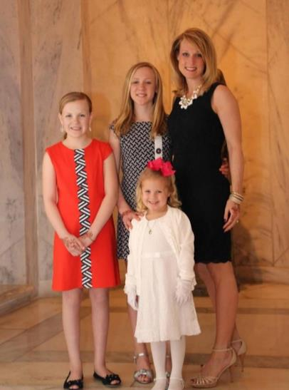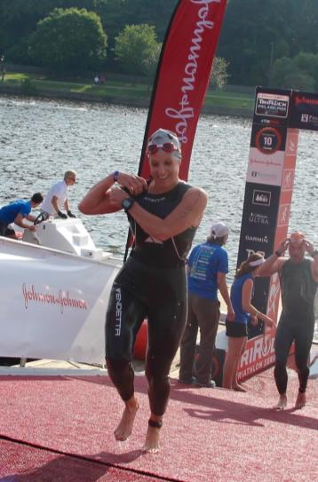
- SVYMG: What is your endurance sports background?
Adrienne: I have been “running” on and off since high school. I spent just one year on my high school track team and absolutely hated it! As an adult, I started running as a stress reliever and a way to keep my weight in check. I recruited a neighbor and began running one mile loops around my neighborhood wearing cotton t-shirts, giant Bose headphones and designer sunglasses. After this “serious” training, I took a chance and signed up for the Broad Street Run – I have been hooked ever since! I have run five half marathons (my favorite being the Washington, DC Rock and Roll) and three marathons – the last being the 2014 NYC Marathon with my husband, Jim. I am new to the sport of triathlon and NEVER……in a MILLION years… did I ever imagine participating in a sport that involved swimming! Last year, just six weeks out from the Chicago Marathon, I found myself sidelined with medial tibial stress syndrome. The only activity my doctor allowed me to participate in was of swimming. Other than doggie paddling, I did not know how to swim and, quite honestly, I had a fear of water. Determined to keep my fitness level up for my marathon, I signed up for the adult beginner swim at the Y followed by the Y’s “Intro to Tri” class led by none other than our Maribeth Baker! While in my class I always kept an eye on this crazy group of people biking on the pool deck. Fast forward… You can find me on occasion biking with this crazy group!
- SVYMG: What are your top three endurance sports goals?
Adrienne: My three goals are…
- Finish IRONMAN Lake Placid 2015
- Qualify for the Boston Marathon
- Learn to love the swim
- SVYMG: What has been your favorite race in which you've participated?
Adrienne: I have two favorites: Bay to Breakers in San Francisco (12K running race) and The Lenape Survival Challenge (takes place in Schwenksville, PA; two person team race involving a 4.6 mile trail run and a 2+ mile canoe leg).
- SVYMG: What is the race that you'd most like to do?
Adrienne: I would be lying if I didn’t say Kona (IRONMAN)… but only if I could spend a month in Hawaii!
- SVYMG: What song would you most like to hear at the starting line of a race? How about the finish line?
Adrienne: When I started my first marathon Bittersweet Symphony by the Verve was playing… It brought tears to my eyes! I love finishing to anything Justin Timberlake or Jay-Z – Holy Grail is one of my favorites.
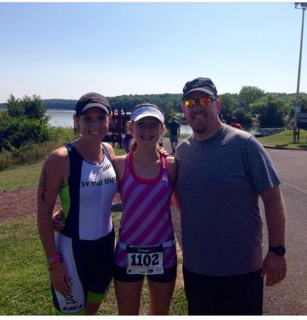
- SVYMG: What has been your best endurance sports experience to date?
Adrienne: The TriRock Philadelphia triathlon! It was my first Olympic distance race that took place just two weeks after I had a major water panic attack at the Independence Tri. I was a complete head case and considered dropping out of the race. I was determined to conquer the swim, so I signed up for every open water clinic and enlisted the help of Nabil Radouane. The race itself turned out to be the most amazing experience and I enjoyed every moment! There is no better feeling than overcoming your fears and doing the unthinkable!
SVYMG: Do you have an endurance sports tip or two that you'd like to share?
Adrienne: Recovery is just as important as the workout itself. Ice, roll, and invest in a good Physical Therapist and/or massage therapist.
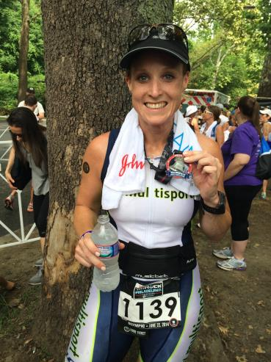
- SVYMG: Who is your favorite professional endurance sports athlete?
Adrienne: Mirinda Carfrae! She had an epic Kona performance this year and she is so inspiring to watch… She has a never say die attitude.
- SVYMG: What is one interesting thing about yourself that has nothing to do with endurance sports that you'd like to share?
Adrienne: I love to bake and I make a coconut cake to die for! The cake includes nine layers and takes two days to make. I recently baked the cake and drove to Richmond, VA to hand deliver it to a customer. BTW, the filling alone takes nine cups of coconut and five cups of heavy cream among other heart clogging ingredients… Thank God I exercise!
- SVYMG: Any other background info you'd like to share?
Adrienne: I am the mother of three beautiful girls and wife of my best friend, Jim Foster. Family is everything to me and without their support I would not be where I am today. It’s going to be a long eight months of training for me (and my family) as I gear up for IRONMAN Lake Placid. I would like to say thank you to them in advance for putting up with me and lifting me up as I embark on this journey of a lifetime! It will be the thought of seeing them at the finish line that will keep me motivated to complete this race – that and the Lake Placid Brewery! Cheers!
