About a Gator #20: Chris Reiter
December 2014

The Reiters… Lauren, Chris, Andrew, and Heather
- SVYMG: What is your endurance sports background?
Chris: Let’s see, endurance sports background…yeah…um, about that…I don’t really have one. I don’t have much of a sports background at all. Besides the four triathlons I completed in 2014, I only have a single other event to my credit, a 5k race I did in 2013. Sports activity for me has always been about staying healthy, never competition. Endurance racing and competition is still very new to me.
In high school I was on the track team for four years. If I gave you 3 guesses what my primary event was I’m betting you wouldn’t pick it. Distance running? Nope. Sprinter? Nope. Jumper? Heck no. I was on the THROWING squad, which in my neck of the woods meant me and half the offensive line of the varsity football team. My freshman year I trained all three throwing events (discus, javelin, and shot put), but quickly realized I didn’t have the punch for the shot put, so I focused on the javelin and discus from there on out.
We trained for technique, explosive power, and strength. We never ran, with the exception of the ¾ mile warmup at the start of practice, which I hated. While not exactly the rule, we tended to be, ahem, “bigger” guys, which is a nice way of saying we probably could have used some run training. Back then I think I weighed about 230 pounds, which comes in really handy if you’re trying to fling objects into space, but not so good for just about everything else.
My freshman year of college I got involved with the Army ROTC. Given that most of college was coming out of my own pocket, I seriously considered the ROTC scholarship that they offered. To qualify for the scholarship you needed to be able to pass the Army fitness test, which was a set of timed push-ups, timed sit-ups, and a timed two mile run. At the outset the only one I could pass was the push-up test. I knew it would take change and dedication to pass all three. So I changed my diet, adjusted my strength training to focus on more reps and less weight, and started running regularly for the first time in my life. The weight just flew off. By the end of my freshman year I was down to around 165 pounds. I’ll never know if I would have passed the ROTC test since I decided not to pursue the scholarship, but I like to believe I would have nailed it. I learned two major things from the experience: how to control my weight and that I had much more mental fortitude than I had ever imagined. Both learnings have served me well since then.
How I got into triathlon:
Fast forward to 2011, and after a decade of a desk job, two kids, and grad school, I was starting to brush up against 180 pounds, and things were starting to unexplainably hurt. Shoulder pain, knee pain, neck/back, things were just starting to fall apart and I figured my period of youthful vigor was up and it was time to get serious again about exercise, which had become less and less regimented over time. I started up a strict running regimen again, and once again weight started to drop off… Run… Check!
After about a month of running, I started to have bad Achilles pain in my left leg. I knew I needed to slow down with the running, but I didn’t want to let up on my fitness goals. I read somewhere that biking was an Achilles-friendly exercise, so after a long hiatus in the shed I drug my mountain bike out and started alternating bike rides with runs, which allowed my Achilles the time it needed to heal and adapt… Bike… Check!
As far as swimming goes, as a child I never had much opportunity to learn. My high school was small and rural, so we didn’t have a pool. To the credit of my parents, they put in a small above ground pool in our backyard when I was five years old, so I’ve always been comfortable and familiar in the water. My Dad was my first swim instructor… Well, let me rephrase that… He was my first breathing instructor. I recall my first “lesson” in our pool was him grabbing a hold of me (remember this is at a time in my life where I can’t even stand in the 4-foot deep pool), and declaring “we’re going to visit Davey Jones’ locker!” and then drag me under water with him, all the while me struggling to get loose. He’d wait until the bubbles started to come up and/or I reached an acceptable level of thrashing around and then he’d let me go. I recall it didn’t take too many visits to ‘ole Davey before I was comfortable with holding my breath and under water swimming. (Side note: Steve Durante, who is a great swim coach, gets the credit for giving my first official swim lesson when I joined tri-swim class for the first time. No lie… I never had a swim lesson in my life until that date.)
I’d never swum a lap in my life until sometime in late 2012. At the time I was primarily using the gym at my work, even though we had gotten a family YMCA membership so that my kids could be involved in YMCA activities. I asked my wife one evening how much we were paying for the YMCA membership, and the conversation went something like this:
Me: How much are we paying for the Y per month?
Heather: I think around $90, why? (Why does she always ask why?)
Me: Wow, I didn’t realize it was that much. Why do you figure they charge so much?
Heather: Probably because of the pools.
Me: Pools? Do they have a lap pool? I’ve always heard swimming is good exercise.
Heather: Yes, a big one.
Me: Hmmmmmmm.

A few days later I went over to the Y, and walked out onto the pool deck in my flowery Hawaiian swimsuit, jumped in, and proceeded to attempt lap swimming for the very first time. No googles, no ear plugs, and no damn idea what I was doing. I bet the lifeguard was watching pretty closely that day, because I’m sure it wasn’t pretty. However, after I got out of the water that day, I immediately knew that I had to make swimming part of my workout routine. There was just something about it that made sense and felt right, almost like swimming was an “athletic glue” that would tie all other exercises together. (Side note: I felt this same way the first time I tried Yoga, which is why you’ll rarely see me miss a swim or Yoga class.) I went out and bought a jammer, goggles, and ear plugs, and started watching YouTube videos for clues on how to swim better… Swim… Check!
One fine day several months later I was finishing up a circuit in the weight room, and I saw on the TV monitor an advertisement for “Triathlon Training at the YMCA.” I was already running, biking, and swimming, so the idea intrigued me. I stopped in the aquatics office and had a conversation with Danny Friend. We discussed what the club was about, what was offered, cost, etc. At the end of the conversation Danny looks at me and says, “Is your name Chris?” (we’d never introduced ourselves before starting the conversation), and of course I replied “Yes,” and asked him how he knew that. He said his name was Danny Friend and that Ellen was his wife. I worked with Ellen many years back and I’d actually met Danny at a social gathering at his house over a decade prior. A major point for Danny that day for remembering me after all those years. I’d be lying if I said I had even a glimmer of recognition before he told me who he was.
After that initial conversation with Danny I didn’t immediately join the club, but several months later I decided to register for the Independence Triathlon and that was the trigger that finally pulled me in. Joining was a fantastic choice that has in a relatively short amount of time led to many memorable “firsts” in my life. I’m in an athletic renaissance period, I don’t know how long it will last, or how far it will take me, but I’m committed to finding out. I am thrilled that I stumbled upon the Gators because I’m having the time of my life training, racing, and socializing with the club.

SVYMG: What are your top three endurance sports goals?
Chris:
  - Complete my first half marathon in March 2015
  - Complete my first 70.3 distance triathlon in 2015
  - Complete a full 140.6 distance triathlon in 2016
  - (sneaking in a 4th) I want a podium finish. Any podium, any race, I just want one. I may need to pull a Tanya Harding on Tim Pfluger to help me get there (KIDDING!), but I mean to see it done. If I can’t get it done in the age group divisions I’m bulking back up to 230 and I’m going to work the Clydesdale circuit! (KIDDING AGAIN!)

After I completed my first triathlon, I had two distinct thoughts:
  - That was a huge amount of fun.
  - I might actually be pretty good at this.
As long as triathlon remains fun and as long as I keep progressing with my times I will continue to do so. I don’t know where my “wall” is, but I know I haven’t hit it yet. There is more gas in the tank and I’m searching for E. These goals are all about finding out where E is.
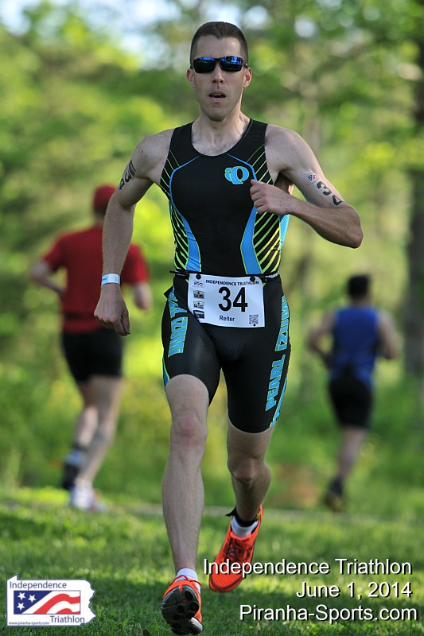
- SVYMG: What has been your favorite race in which you've participated?
Chris: The first Olympic distance race I did was the 2014 Anthracite in Jim Thorpe, PA. It’s run by the Hazleton YMCA (very well run and very well priced!), and you ride the 25 mile bike course through the surrounding coal region towns of Summit Hill, Lansford, Nesquehoning, and Jim Thorpe. My Mom is from Lansford and I still have family in the area, so for me the race was nostalgic. Besides that though, the Anthracite is challenging and the venue is really great. It’s the only race so far I’ve decided I’m definitely doing again in 2015.
- SVYMG: What is the race that you'd most like to do?
Chris: I don’t have one in particular. Right now I’m more about completing certain distances before specific races. Everybody seems to love Lake Placid so I’ll go with that.
- SVYMG: What song would you most like to hear at the starting line of a race? How about the finish line?
Chris: Guns N’ Roses is my favorite band, so at the starting line I’ll go with “You Could Be Mine.” Self explanatory.
I’m also a big Tom Petty fan, so at the finish line I’ll go with Tom Petty’s “Rebels”… It has this triumphant musical arrangement and if you stretch your mind a little the lyrics are a metaphor for triathlon. Besides, I figure “rebels” is a pretty endearing term for people who think swimming 2.4 miles, biking 112 miles, and running 26.2 miles in a row is a normal, sane thing to do.
Since the song is somewhat dated, and I don’t think ever gets played on the radio I figure most folks have never heard it. So here’s a link: http://www.youtube.com/watch?v=3jBi8XfKzk0.
- SVYMG: What has been your best endurance sports experience to date?
Chris: My best race statistically was the 2014 Philadelphia Tri-Rock sprint. The whole race went extremely well, but it was the bike portion that really stood out for me. I did the race on the only bike I had at the time – my Fuji Cyclocross bike. Cyclocross bikes are basically road bikes that are built stronger, since Cyclocross involves off road racing with jumps and obstacles. This bike actually has a sticker on the frame that says, “Suitable for off-road use and jumps < 30cm.” It’s durable and versatile and I love it, but it’s not very aero. These bikes have a taller and slacker geometry than usual road bikes, and the bottom bracket sits just a bit higher as well to help in jumping obstacles. On the road though that higher bottom bracket means you have MUCH steeper lean angles before the pedal will touch down.
Tri-Rock is a huge event, there were 1,184 participants in the race that day, and the bike course was total havoc. The course itself is very technical, with lots of turns, and adding in that many people meant all kinds of congestion and constant passing and screaming of “PASSING ON YOUR LEFT!”
I was an absolute health hazard on the course, minimally to myself, and probably to other racers as well. Since I knew I wasn’t the fastest in a straight line, I made up for it on the turns. While other racers were slowing down to take turns, I never stopped pedaling. Every turn was me barreling in as fast as possible, braking as late as possible, pedaling through the turns and using every degree of lean angle; trusting the tires weren’t going to slide out on me. Race fever was in full effect.
To cement just how crazy high my risk tolerance was that day – I recall coming into a sweeping right hand turn on the course, and ahead was this traffic jam of bikers who had all slowed down to make the turn. The entire road was blocked with no way around. I should have slowed, but my motorcycling and mountain biking instincts kicked in instead. I bunny hopped off the road to the RIGHT onto the brick lined rain gutter, rode the gutter around the pack, bunny hopped back up onto the road and took off, wondering if I’d get a course violation.
Somehow that day on the bike course I recorded my best bike finish ever. When all was said and done my Garmin computer said I averaged 20.9 MPH, the official results said 20.7MPH. A few weeks prior I rode the Independence Triathlon on that bike and didn’t even manage 20MPH. Pulling off the time I did on the Tri-Rock course still has me scratching my head to this day.
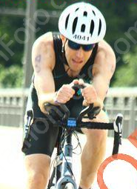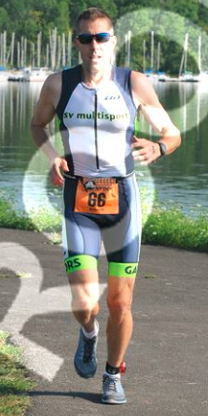
TriRock Philadelphia 2014 Steelman 2014
- SVYMG: Do you have an endurance sports tip or two that you'd like to share?
Chris: The biggest barriers in Triathlon are mental. I’ll only speak for myself, but I know I like to sit in my comfort zone, and pushing past it is tough, but that is how the mental barriers get broken down.
When I started on this path, I’d never swam more than a lap or two continuously, I’d never biked in a large group, I’d never run more than a few miles on the road, I’d never done a brick workout, I’d never gotten up at 3AM to jump in a lake. It was by pushing myself that little bit further, out of my comfort zone, that I have come to realize that I CAN do amazing things that I never dreamed I’d do. Stay in your comfort zone and you just won’t get there.
- SVYMG: If you have one, who is your favorite professional endurance sports athlete?
Chris: I don’t have one. My general view on professional sports is that there is too much incentive to cheat. I still watch for the entertainment, but I choose not to get emotionally invested. I draw my inspiration from the folks in the club who do the 9-to-5, manage a family, train nights and weekends, and then make the podium (or near to it) on race day. Those are the folks who truly inspire me.
- SVYMG: What is one interesting thing about yourself that has nothing to do with endurance sports that you'd like to share?
Chris: I enjoy motorcycling. Mainly on-road but I have a dual-sport in addition to a road bike and will venture off-road on occasion. I have a group of riding friends and I try to lead 2-3 long trips a year where we’ll camp and tour. However this past year I’ve been swapping motorcycle rides for pedal bike rides, so I haven’t gotten out nearly as much as I used to. It’s a good trade-off though. If anybody else is into motorcycling, give me a shout if you ever want to go for a ride.
- SVYMG: Any other background info you'd like to share?
CHRIS: My undergraduate degree is in Computer Engineering from PSU. A few years back I got an MBA from St. Joseph’s. I’ve worked at Merck Pharmaceuticals for the last 14 years as a Project/Program Manager leading the build and deployment of Analytical/BI systems.
I’m married to a very understanding woman (how else could you possibly train for Triathlon and not get divorced?) and have two children, a boy and a girl, ages 9 and 6.

