About a Gator #19: Don Schlichtmann
November 2014
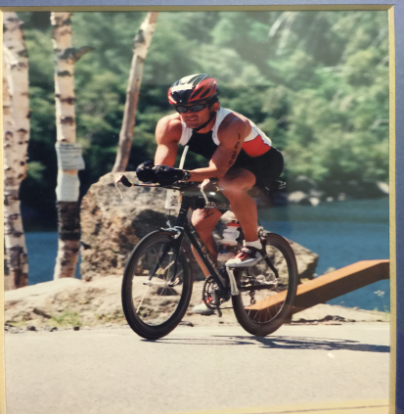
IRONMAN Lake Placid 2005

- SVYMG: What is your endurance sports background?
Don: I began running in junior high school and was a part of my high school track and cross-country teams. I continued to run during my seven years in the Air Force and increase my distance to an occasional half marathon. In 1991 a friend who raced bicycles invited me for a ride and I was hooked. My plan was to race bikes but running was still my first love (besides my wife)! In 1993 we relocated to Virginia and at a road race someone left an entry form on my car for a triathlon. Having only been a recreational swimmer that was going to be a challenge, so I headed to the pool and did the best I could. In 1994 I competed in my first sprint triathlon in the Atlantic Ocean with four-foot seas. From 1994-1997 I competed in 12-15 triathlons per year up to Olympic distance. During that time I had never ridden more then 42 miles. In 1998 I signed up for the Eagleman Half IRONMAN and finished in 4:57 and said I would never do that again! I have since competed in Eagleman five times with my best time at 4:43. My first shot at going long was in 2002 at IRONMAN Florida (10:48), then the 2003 IRONMAN Idaho (13:59), on to IRONMAN Lake Placid in 2005 (11:20) and 2007 (DNF due to torn Achilles).
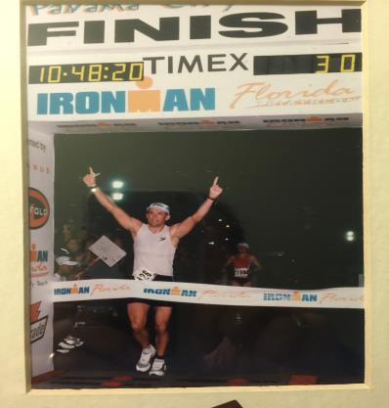
IRONMAN Florida 2002
- SVYMG: What are your top 3 endurance sports goals?
Don: After being sidelined with Plantar Fasciitis and an Achilles injury since 2007 my main goal is to get healthy. In the back of my mind I have a desire to compete again in an IRONMAN, but I have to see how the feet hold up. For 2015 I want to build my endurance and speed and enjoy racing again.
- SVYMG: What has been your favorite race in which you've participated?
Don: Lake Placid is one of my favorite races because it is such a beautiful place to race. Also in 1999 when my wife Kathleen and I raced together. Picture below.
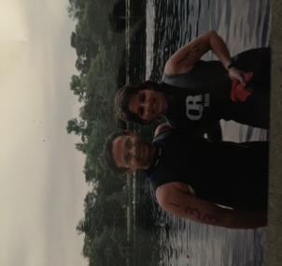
- SVYMG: What is the race that you'd most like to do?
Don: My dream race is IRONMAN Austria. Another awesome scenic race and it’s also the fastest IRONMAN course in the world. IRONMAN Hawaii has also always been in the back of my mind.
- SVYMG: What song would you most like to hear at the starting line of a race? How about the finish line?
Don: I am very patriotic and love my country so I’m a big fan of the National Anthem at the start of the race! At the end of the race I’d like to hear “My God Is An Awesome God” because He gave me the gifts, the abilities and a second chance to do what I love to do.... compete! Above all, He gave His Son, Jesus Christ, so we can get through the challenges of life and be assured of a home in Heaven. No other sacrifice beats that, and it is for anyone who wants to accept it (John 3:16).
- SVYMG: What has been your best endurance sports experience to date?
Don: My best endurance sport experience was IRONMAN Coeur d’Alene. The temperature was 96 degrees (typical/expected temps for race day was to be in the 80s). They only had warm drinks and I pushed through and finished the race. That race had the highest number of competitors DNF up to that point in IRONMAN history.
- SVYMG: Do you have an endurance sports tip or two that you'd like to share?
Don: Be patient in your training. Gains, particularly in endurance, can take years to build. Also, train year round outside in the elements to prepare yourself for the toughest of race conditions! And finally, get a training partner who has similar goals and one who will push you to your limits (thanks Ken)!
- SVYMG: If you have one, who is your favorite professional endurance sports athlete?
Don: I’m a bit old school… Dave Scott, Mark Allen, and Paula Newby-Fraser… They put IRONMAN on the radar!
- SVYMG: What is one interesting thing about yourself that has nothing to do with endurance sports that you'd like to share?
Don: Although I have a degree in Aeronautics, I chose to be a stay at home Dad since my kids were born; they are now ages 15 and 20! Best decision ever! It has also given me the opportunity to coach men’s and women’s soccer at Valley Forge Baptist Academy as well as be a substitute school teacher and bus driver.
- SVYMG: Any other background info you'd like to share?
Don: Hobbies? Who has time for hobbies!! Actually my favorite hobby is coaching athletes particularly those who are new to the sport or have a few pounds to lose!
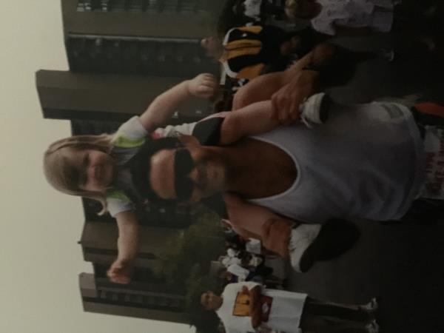
Then (1995)
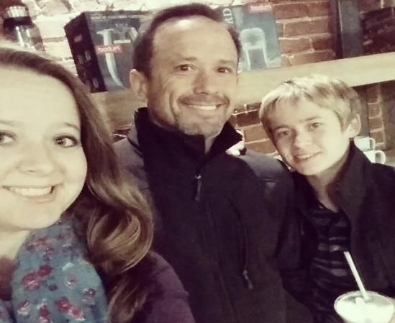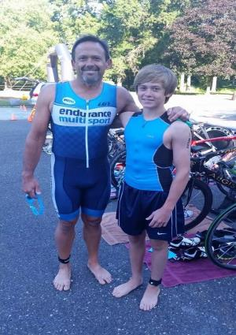
... and Now (2014)

