About a Gator #18: Allison Wesler
November 2014
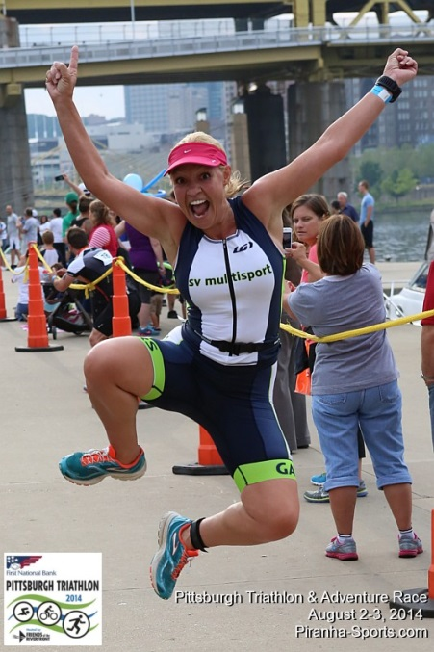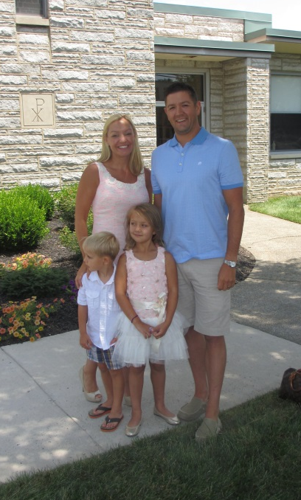
- SVYMG: What is your endurance sports background?
Allison: My first triathlon was the 2012 Independence triathlon. I decided to do it the Thursday before the race!! I knew I could swim, but Jon had bought me a bike several weeks prior and I think I rode it two or three times before the race, and running… well it was only two miles total. I also bought a wetsuit at Dick’s the night before (a “water sport suit” to be exact!!). After the race I was exhausted!!! I remember coming home and taking a nap thinking that it was the toughest thing I had done to my body (aside from child birth)… HAHA! I laugh about it now. A good training is much long than that race. Well, to say the least, after that race I was hooked along with Jon, who had jumped on the “tri-train” the year before. I thought it would be a great way to lose my extra baby weight and to get back in shape while also doing something together as a couple!!
Since that first race I have done Sprints, Olympics, and one Half IRONMAN distance event. This year has truly been an amazing year for me personally. I completed my first Half IRONMAN in St. Croix. I truly never thought I would do that distance. Also I have achieved several podium finishes, which is also something I would have never imagined three years ago. This year taking 1st place in my age group at the Pittsburgh Sprint Tri was a huge accomplishment… Pittsburgh is my hometown so it was extra special!!
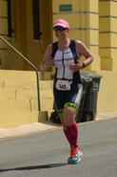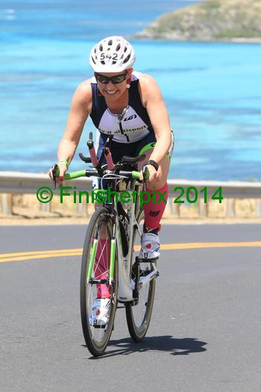
- SVYMG: What are your top 3 endurance sports goals?
Allison: My 3 goals are…
- To become a better runner
- To complete another Half IRONMAN distance event
- Someday….complete full IRONMAN event
- SVYMG: What has been your favorite race in which you've participated?
Allison: My favorite race so far has to be St. Croix… What’s not to love?… Warm clear water (in May), beautiful scenery of blue water… Well, then there is the HOT un-shaded run… but it was a very tough course and a HUGE accomplishment to finish for me. I enjoyed the race and took in every moment I could.
- SVYMG: What is the race that you'd most like to do?
Allison: It has to be to do Kona (IRONMAN world championship)… I love watching the race coverage every year and the amazing people and stories always bring tears to my eyes. It’s the most recognized course when you say “IRONMAN” to someone who has no idea what an IRONMAN is.
- SVYMG: What song would you most like to hear at the starting line of a race? How about the finish line?
Allison: Start… “Boom Clap” by Charli… It’s one of the top songs on my current play list. Finish… “Everything is AWESOME”… Yes, the Lego movie song… because at the end of any race EVERYTHING IS AWESOME!!! (Ha ha… Can you tell I’m a mother of small kids?)
- SVYMG: What has been your best endurance sports experience to date?
Allison: I have sort of a theme… Can you guess? IRONMAN St. Croix 70.3… I encourage anyone who can get there to put it on your Tri-Bucket list.
- SVYMG: Do you have an endurance sports tip or two that you'd like to share?
Allison: Buy the best bike in your budget. I never thought a tri bike would make that much of a difference. Last year I got a tri bike and it truly changed my training and racing. I think it has made all the difference this year.
- SVYMG: If you have one, who is your favorite professional endurance sports athlete?
Allison: I have to say after meeting her in St. Croix… It’s Mirinda Carfrae. She is a tiny bundle of energy…She just might be my adult HERO!!
- SVYMG: What is one interesting thing about yourself that has nothing to do with endurance sports that you'd like to share?
Allison: Aside from being married to Jon Wesler for nine blissful years and having two wonderful children, Zoey (6) and JT (4)… I have never lived in the same place for more than nine years; just an odd fact about me. I was a great baker (might still be, but don’t make the time). I made my the wedding cakes for my sister and two friends. I worked in a famous bakery in my hometown and the owner taught me the secrets to baking a moist cake but also how to decorate cakes and I perfected icing flowers (back in the day).
- SVYMG: Any other background info you'd like to share?
Allison: I played soccer for 13 years and went to Lock Haven University where I played for two years. I was a swimmer as a kid and swam on several different teams between the ages of 5-13. I love team sports and that’s what I love about our club… I have a team to train with to keep me motivated and then on race day we usually have a group to motivate each other and cheer each other on to the finish line.

