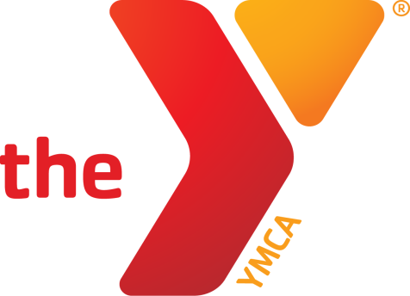


Phoenixville YMCA
1st ANNUAL FALL FUN RUN
5K Run and 1 Mile Family Fun Run/Walk
Saturday, November 15, 2014 at 9:00am
Lower Perkiomen Valley Park, Oaks, PA

COURSE Enjoy a 5K run or 1 mile family fun run the begins and ends at the Lower Perkiomen Park in Oaks, PA. The park is located off of the Oaks exit of route 422. The course will be an out and back, flat and fast paved trail along the Perkiomen and Schuylkill River Trails. Held rain or shine. No refunds.

AMENITIES Professional timing, race shirt for 5K participants, refreshments.

ENTRY FEE/REGISTRATION
$20 5K Pre-registrations. Race shirt guaranteed for the first 250 registrants.
$25 5K Race day registrations starting at 8:00am online through the YMCA. Shirts available while supplies last.
$10 1 mile Family Fun Run/Walk. Participants will receive an award. No T-shirt. Kids 6 and under are FREE.

Register online at www.runtheday.com through November 14, 2014 at 2:00 pm.
Mail registrations to: Phoenixville YMCA, 400 E. Pothouse Rd., Phoenixville, PA 19460, Attn: Michelle Ferretti

AWARDS Age groups awards male and female (5K): 18 & under, 19 – 29, 30 – 39, 40 – 49, 50 – 59, 60 +.

All proceeds from the Phoenixville YMCA 1st Annual Fall Fun Run benefit the YMCA’s Annual Campaign.
Questions? Contact Michelle Ferretti, mferretti@philaymca.org.
Entry Form – PLEASE PRINT – One Per Person (All participants must register)
Last Name ______________________________________________ First Name ___________________________________ Male Female
Address ___________________________________________________________ City/State/Zip _____________________
Team Name ____________________________________________________ Age on race day ___________
Email _________________________________________________________________ Phone _______________________
Registering for: 5K Run 1 Mile Run/Walk Adult T-shirt Size : S M L XL
Fee Enclosed $_____________________ (Checks payable to the Phoenixville YMCA) Coupon Code: _________________
Waiver and Release: I, the undersigned intending to be legally bound, do hereby waive and release all rights, claims, demands, and/or causes against the Phoenixville YMCA and all other race sponsors for any personal injury which I might sustain during the race, immediately known to me or hereafter discovered and for any and all other damages to losses which I might incur now or in the future arising from or out of my participation in this race, and on my travel to and from this race. I verify that I am physically fit and have trained sufficiently. Permission is granted to use my photograph and name for any and all purposes.

Signature: __________________________________________________________ Date: __________________
(Parent or Guardian if under 18)

