About a Gator #17: Vince Bellino
October 2014
- SVYMG: What is your endurance sports background?
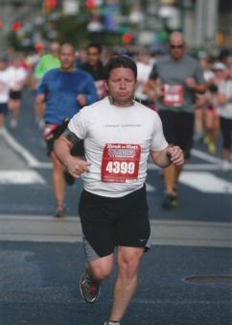
Vince: I started running as a means to stay active in my late 20s. The only time I had run before this was in conjunction with traditional “ball” sports. In fact, I really didn’t see the sense in running for sport as a kid. But my wife and I had opened a baby factory and I was looking for some type of exercise that I could do anytime and by myself. Running seemed to fit the criteria and so I started by running 20-30 minutes around 11:00 pm just about every night.
After a few months of running like this a friend of mine suggested that we run a 5K. That was the first time I ran in a race and I found that I really enjoyed the competitive camaraderie that I experienced. While our kids were very young my run training was pretty intermittent with several starts and stops. However, after quite a few years of mid distance running and racing (5k to half marathon) I thought I might like to try a marathon. During my training buildup for that marathon I ran into Danny Friend whom I hadn’t seen since we were in high school.
Danny was near the end of his training cycle for the Eagleman Half IRONMAN and we started running some longer runs together. Danny would run in first gear and I would spend most of these runs in Zone 4. I was immediately fascinated with his triathlon training and would pester him with questions on these runs. I went to Maryland to watch Danny compete at Eagleman and I was pretty enamored by the entire scene. I loved the way that the pros and the age groupers competed on the same course at the same time. I distinctly remember thinking at the time that racing at this distance was probably not something that I could ever consider. Still I told Danny that after I finished my marathon in October I was going to get a bike and planned to do a sprint triathlon the following summer.
Fast a forward a few months… Half an hour after I finished the marathon in October 2011, in what would was probably my worst running event ever, Danny sent me a text message. It said, “Congratulations!! Call me when you get back. I’ve got a plan for us!!” A couple of weeks later Danny force fed me just enough beer to impair my judgment and then unveiled his “Plan”. We would start a training cycle at the first of the year and build for a half IRONMAN race in the summer (Mooseman) and then a full IRONMAN in November. The IRONMAN race would be Cozumel in Mexico. Wait…..whaaaat?! I still have no idea why but apparently I agreed. I will be competing in my second full IRONMAN event next July in Lake Placid, NY.
- SVYMG: What are your top 3 endurance sports goals?
Vince:
- Have fun training with like-minded people
- Stay relatively fit
- Set a good example for and try to keep up with my kids
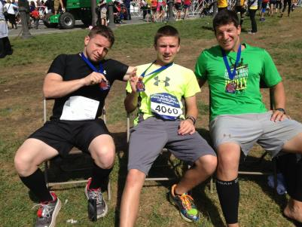
- SVYMG: What has been your favorite race in which you've participated?
Vince: IRONMAN Cozumel hands down. It was the culmination of a very long training season and a lot of sacrifice from myself and, more so, my family. The race went very well and we stayed for a weeklong vacation after.
- SVYMG: What is the race that you'd most like to do?
Vince: I don’t have a specific race on my bucket list. But I do love racing with the team because it allows me to experience the team sport dynamic while competing at my own level. I am very excited to be racing with a bunch of fellow Gators at Lake Placid this year.
- SVYMG: What song would you most like to hear at the starting line of a race? How about the finish line?
Vince: My musical tastes are pretty varied so I’m good with just about anything. I do like “Crazy” by Gnarles Barkley or “Lunatic Fringe” by Red Rider when I’m getting ready to go. At the finish line anything upbeat is okay with me.
- SVYMG: What has been your best endurance sports experience to date?
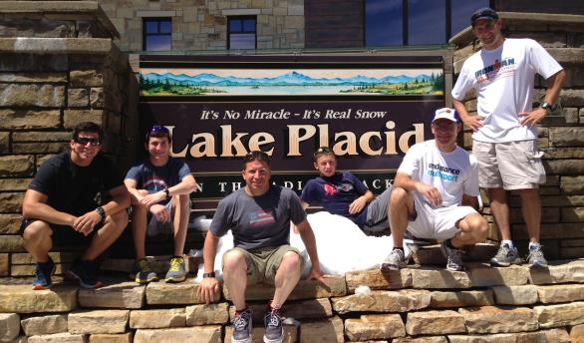
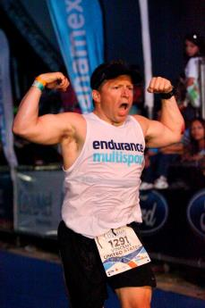
Vince: It would have to be running a strong marathon to finish up my race in Cozumel. I have struggled in the couple of standalone marathons in which I have competed and I expected to end up in a pretty dark place somewhere along the line but fortunately it never happened. I also really enjoyed participating in the Lake George 70.3 relay with some Gator teammates (Anne Welsh and Mindy Mattarazzo) last year and volunteering at IMLP the last two years with the Gators.
- SVYMG: Do you have an endurance sports tip or two that you'd like to share?
Vince: First, make sure you truly appreciate the sacrifices that your family makes to enable your training schedule. This is especially true for long course athletes. Second make sure you take some time during your races to really take in and enjoy the experience. The tunnel vision caused by the hyper focus associated with competitive racing can make this truly difficult. Also last, don’t overcook the bike! You need to leave something in the tank to be able to run when you get off.
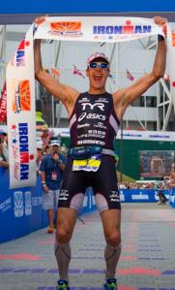
- SVYMG: Who is your favorite professional endurance sports athlete?
Vince: I’m obligated to say Andy Potts since he consistently lists me as his favorite age grouper. This is of course due to the fact that I paced him on the run portion at IM Lake Placid in 2013. (Look how he excited he was!) Honestly, I am a fan of all of the humble hard workers training and racing in both the pro and age group ranks.

- SVYMG: What is one interesting thing about yourself that has nothing to do with endurance sports that you'd like to share?
Vince: My wife, Angela, and I have six kids ranging in age from 8 to 19. Every day at our house is a like a three ring circus.
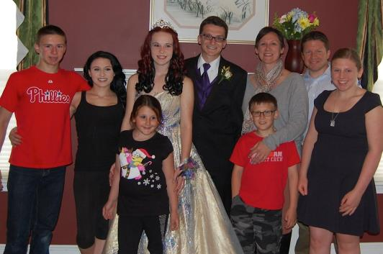
- SVYMG: Any other background info you'd like to share?
Vince: I am a mechanical engineer and work for the local Caterpillar office in the field of electric power generation. Some of my hobbies include home theater, construction and cars.

