About a Gator #16: Bob Lanyon
October 2014
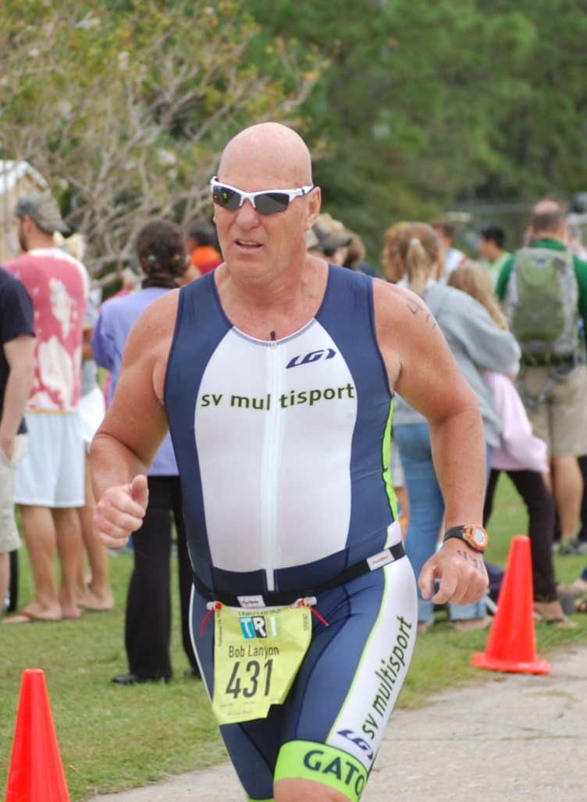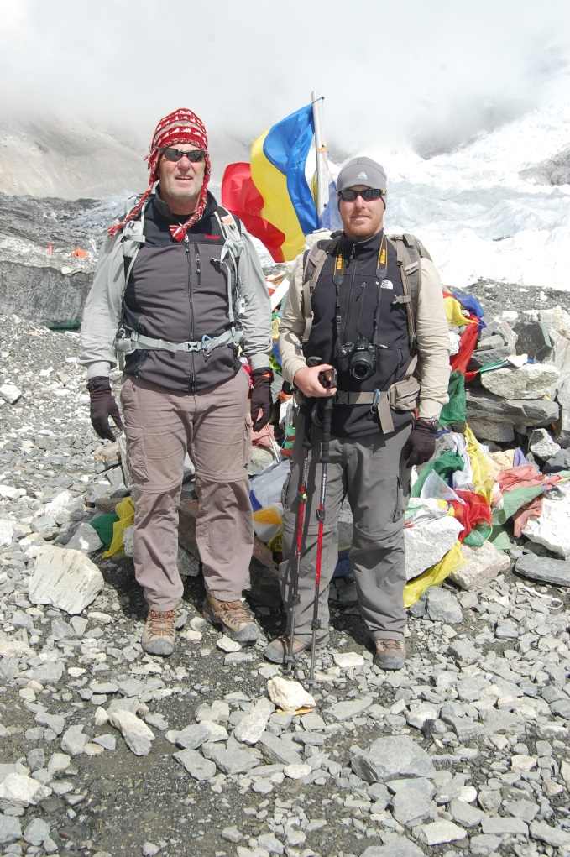
Mount Everest with Justin
- SVYMG: What is your endurance sports background?
Bob: I came from a football and track (shot and discus) background. I didn’t start to run until I was in my 30s. I did my first two triathlons in 1984 after watching an early IRONMAN World Championship on Wide World of Sports. I did a few races along with some runs (10k and half marathons) but then moved to weight training as my primary fitness activity. My son started competing at the 70.3 distance and I did a lot of traveling to cheer him on. I guess I re-caught the bug and have been racing 5-6 sprint events a year for the last five years.
- SVYMG: What are your top 3 endurance sports goals?
Bob: Continue to improve overall, continue to compete into my 70’s (not that far away), learn to enjoy running.
- SVYMG: What has been your favorite race in which you've participated?
Bob: The Cape Henlopen Triathlon… It was my first after I decided to restart and I considered it to be my hometown race as I had a home near Lewes, Delaware.
- SVYMG: What is the race that you'd most like to do?
Bob: I’m looking forward to the Nanjing Man Tri in China on October 12. It will be a challenge from the travel, food, language and not knowing what to expect. It will be the first time that I am racing with my son since that first time at Cape Henlopen. EDITOR’S NOTE: Unfortunately Bob became ill during his China trip and was unable to race. He did have the opportunity to see his son, Justin (who also completed a full IRONMAN event in Australia earlier this year), place 4th in the race, just off of the podium. We are looking forward to Bob’s (andJustin’s) next adventurous race!
- SVYMG: What song would you most like to hear at the starting line of a race? How about the finish line?
Bob: Start – Kenny Loggins’ “Danger Zone (from the movie “Top Gun”). Finish – Toby Keith’s, “As Good As I Once Was”…. I’m not as good as I once was but I’m as good once as I ever was”.
- SVYMG: What has been your best endurance sports experience to date?
Bob: Watching my son finish IRONMAN Australia.
- SVYMG: Do you have an endurance sports tip or two that you'd like to share?
Bob: Make an honest assessment of your strengths and weaknesses and set a plan to improve. Be honest with yourself. Realize that you won’t win every race, but the victory comes when you toe the start line.
- SVYMG: Who is your favorite professional endurance sports athlete?
Bob: Lance Armstrong (still an incredible athlete).
- SVYMG: What is one interesting thing about yourself that has nothing to do with endurance sports that you'd like to share?
Bob: I struggle with nutrition. I don’t like veggies!!!!!!!!!!!!
- SVYMG: Any other background info you'd like to share?
Bob: I was a police officer for 30 years, then worked as a Health and Safety Manager for a large civil construction company for 10 years. After retiring a second time, Mary Cook coaxed me out of retirement and now I work part-time as a lifeguard and lifeguard instructor at the Y. I have a daughter, Alison, and son, Justin, and two grandchildren.

