About a Gator #15: Tim Pfluger
October 2014
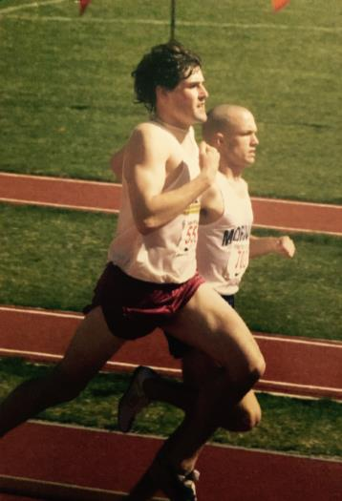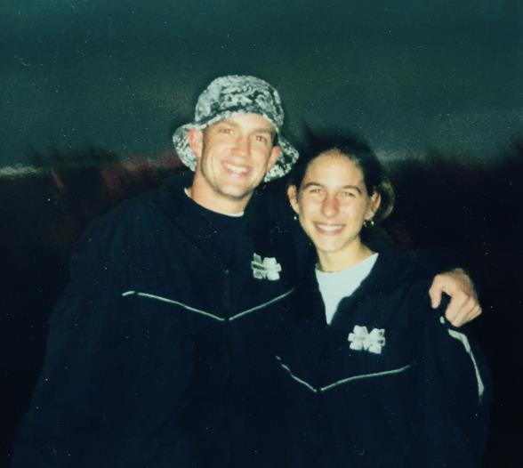
- SVYMG: What is your endurance sports background?
Tim: I started running in middle school with my brother over the summers. He was a few years ahead of me and a member of the high school cross country team. When all my friends started growing and gaining strength, I remained a scrawny little guy entering high school. The start of high school, and the realization that I was half the size of my friends and teammates now, made me realize that my football, baseball, and wrestling careers were over. So, I joined the cross country team, and I began to experience some success in the sport. Throughout high school and college, I was never a big fan of the longer distances, but I kept with it. Track is where I excelled the most as a mid-distance runner concentrating on the mile.
I’ve run countless races since high school, but a few of them remain clear in my memory. My junior year, I had a district meet all day and the prom that night which I’ll never forget. That same season I earned a trip to the state meet where I placed 3rd in the mile. I was pretty burned out my senior year, but the highlight of that year was making it to states in cross country and finishing 11th up at State College.
I decided to attend a small DIII school in Bethlehem, PA called Moravian College. I entered college athletics still feeling burned out from high school. I almost packed it in and transferred to PSU to end my running and become a full-time partying student. With my dad’s advice, I held off filling out the paperwork for PSU and stuck it out my freshman year through the cross country season, indoor track, and into the spring track season. I’m glad I stayed at Moravian because I began to experience success again at the middle distances (and, more importantly, met my future wife). Although cross country was still not my niche, especially at the college 5 mile race distance, I continued running throughout my four years at Moravian. I had a couple of memorable cross country races, but track is where I have the greatest memories. I went on to win the 1500m race four consecutive years at our outdoor conference championships. In the winter track season of my senior year, I ran the race of my life finishing the 1500 meters in 3:55 (4:12 mile equivalent) qualifying me for the NCAA championships. I can still remember finishing and seeing the looks on my parents’ and coaches’ faces.
Although much of what is mentioned above highlights some of my most memorable individual achievements in high school and college, the greatest memories I have from high school and track center around the teams I was a part of throughout the experience. Competing with and sharing experiences with teammates meant more to me than anything. As a part of the cross country and track teams, I met Tiff and we started dating my senior year. Her greatest endurance achievement was probably sticking with me for seven years before I proposed and two more years before we got married. After college, I lost the internal drive to continue running, and I think a big part of it was because I was no longer part of a team.
Post college, I moved out west and only ran off and on. I attempted my first marathon in 2002 in Sacramento. The ski season came early that year, and I only ran three times during the month of November. This didn’t bode well for a December 2nd marathon. I bonked with 4 miles to go and missed qualifying for the Boston Marathon by 43 seconds. That was my last major race for 8 years! Back in PA, I started running consistently again in 2010 with the help of Tiff getting back into it, too, and I ran the Rock-n-Roll (Philadelphia) Half Marathon and the Philly Marathon that fall. I qualified for Boston and regained the running bug. Since 2010, I’ve run the Philly Marathon three times, Boston twice, and Steamtown and Via Lehigh Valley marathons once. After reaching my goal to qualify for Boston, I was looking for something different. I was doing most of my training by myself, and I still really missed being part of a team. After a few conversations with Tim Mosebey and Jon Wesler, I joined the SVM Gators to enter the world of triathlon. I initially had a 5-year plan to do an Ironman. A little over a year into triathlons, I’ve done a few sprints, a couple Olympics, my first 70.3 in the Poconos, and I’m already signed up for IRONMAN Lake Placid in July 2015. You can say that my plan has quickly accelerated and that the tri bug has definitely bitten me. I’m truly happy to be a part of community and team of like-minded, motivated athletes. It’s also great that Tiff is about to take the leap into triathlons this year.

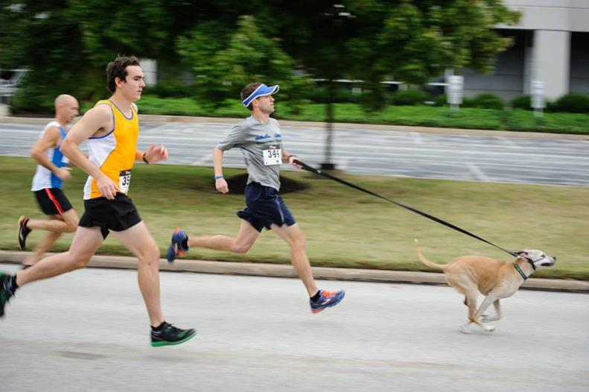
2. SVYMG: What are your top 3 endurance sports goals?
Tim: My top three endurance sports goals are…
  - Watch Tiff qualify for the Boston Marathon and run it with her when we both get there together.
  - Race smart enough to finish my first IRONMAN and share the experience with Tiff and the rest of the Gators racing in Lake Placid in July.
  - Get redemption at Challenge AC 140.6 relay in the very near future. I need to chase down some demons on that boardwalk. I’d love to do some more triathlon and running relays with the Gators too.

- SVYMG: What has been your favorite race in which you've participated?
Tim: Escape the Cape should be a race that every triathlete experiences once. Jump off the ferry and swim to shore! It’s very unique and very well organized.
- SVYMG: What is the race that you'd most like to do?
Tim: The races I’d most like to do include Escape From Alcatraz, Challenge Roth, the Western States 100 mile trail run (probably a long shot), and either the half or full IRONMAN Lake Tahoe race. Without training at altitude, the last two would be extremely difficult.
- SVYMG: What song would you most like to hear at the starting line of a race? How about the finish line?
Tim: At the start… AC/DC’s “Thunderstruck”. At the finish… Either “Stronger” or “Homecoming” by Kanye West.
- SVYMG: What has been your best endurance sports experience to date?
Tim: The 2014 Boston Marathon was the most memorable race experience of my life. The energy and passion felt by the athletes, volunteers and spectators, throughout the whole weekend, was like nothing I’ve ever experienced. Setting a PR in that marathon capped off an amazing weekend with Tiff, my parents, and friends I saw out on the course.
- SVYMG: Do you have an endurance sports tip or two that you'd like to share?
Tim: Set personal goals for yourself and not for anyone else. Shake off tough days quickly. Go naked sometimes! Ok, maybe we should keep our clothes on, but leave the Garmin, headphones and other gadgets at home once in awhile. Training is way more important than any piece of equipment we own.
- SVYMG: Who is your favorite professional endurance sports athlete?
Tim: I loved learning about the Steve Prefontaine story early on in my running career. As a runner turned triathlete, I truly admire Mirinda Carfrae and the intensity she shows on the run after 2.4 miles of swimming and 112 miles of biking. Her focus, mental toughness, and strength are an absolute beauty to watch. It’s amazing to know that if she’s 10-12 minutes down in any IRONMAN going into the run, she will most likely still win it.
- SVYMG: What is one interesting thing about yourself that has nothing to do with endurance sports that you'd like to share?
Tim: My true love is skiing. Tiff and I got married in Lake Tahoe, California in the summer of 2009. The summers there are amazing, but we both have amazing memories of endless powder days skiing at Squaw Valley.
- SVYMG: Any other background info you'd like to share (family, career, hobbies, etc.)?
Tim: My brother, who is married and lives in Switzerland, just became an IRONMAN this year in Zurich. During the previous year, he did his first half marathon and a marathon. Leading up to the IRONMAN he competed in only one Olympic triathlon before taking on the 140.6 distance. I’ve always admired his fearlessness and determination (and insanity). My parents are absolutely amazing. They have been to most of my races throughout high school, college, and beyond. They continue to support me, and I can’t wait for them to experience IM Lake Placid with us!

