About a Gator #13: Steve Gilman
September 2014
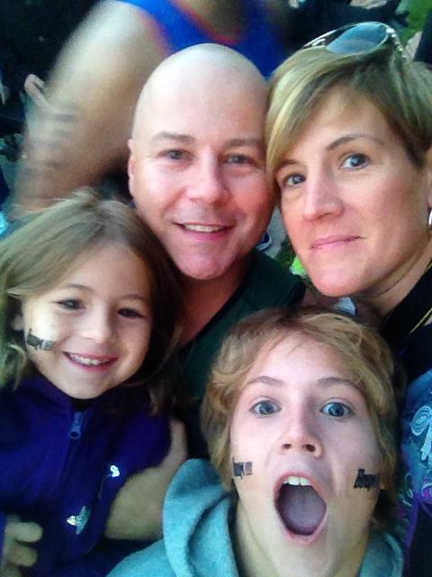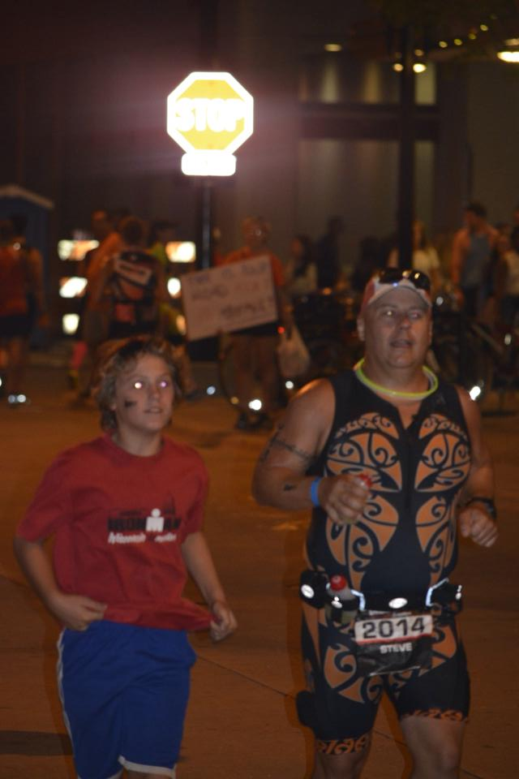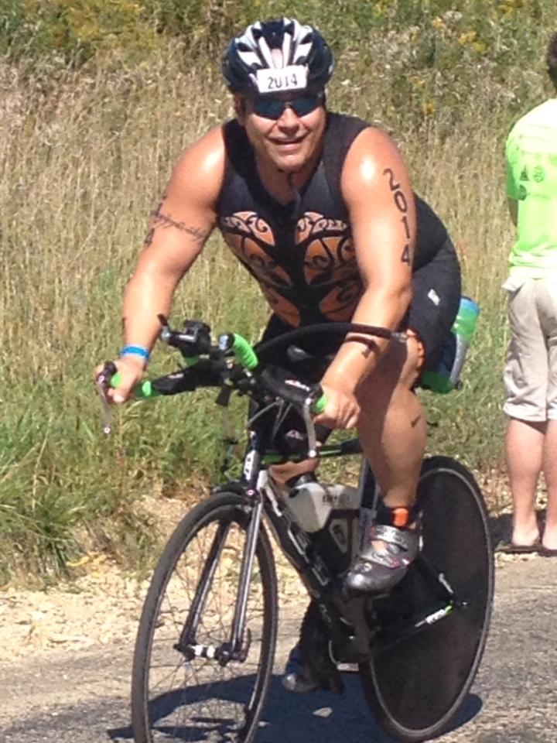
- SVYMG: What is your endurance sports background?
Steve: I just recently started to participate in endurance sports, right around the time my father passed away. I started with the 2011 Steelman Sprint Triathlon and the 2011 Musselman Triathlon (half IRONMAN distance). Then I did the 2012 Double Musselman Triathlon (88.7 miles total), 2012 IRONMAN Wisconsin (DNF), the 2013 Double Musselman Triathlon (aqua-bike for half distance only), the 2013 Quakerman Triathlon, the 2014 Musselman Triathlon (DNF), the 2014 Steelman Olympic Triathlon, and, finally, 2014 IRONMAN Wisconsin (Editor’s note: The above photos are all from IRONMAN Wisconsin).
- SVYMG: What are your top 3 endurance sports goals?
Steve: My three goals are…
- Finishing
- Have a strong bike leg
- Have fun during the event
- SVYMG: What has been your favorite race in which you've participated?
Steve: My favorite was the Musselman in Geneva, New York, located in the Finger Lakes. Musselman Has been voted as one of the USA’s top ten family-friendly triathlons. It is within driving distance and has astonishing community support (e.g. on the run there are several people who stand out on their lawns with hoses and will spray you down if you are hot).
As of today, it is IRONMAN Wisconsin (editor’s note: Steve’s 2014 Wisconsin was his first full IRONMAN distance race finish). I can't begin to say enough about this course and the crowd support is unbelievable. Rarely (seriously, rarely) can you find a location where there is not a crowd, even on the bike course. The mass start in Lake Monona is epic! Running up the Helix with 2-3 deep people cheering you on and riding down the Helix again with the same amount of people cheering you on is amazing! I realize that all IRONMAN events probably have great crowd support near the transitions, but what gets me is the amount of support throughout the bike course… At miles 15, 30, 45, 60, 90 there are huge parties taking place, six of which are located on the steepest, longest climbs on the course. The crowd is packed creating a small lane on these hills in which you have fans literally a foot away from you screaming and hollering and running next to you (I had my family parked at miles 60 and 90 so they could join in the fun). My wife said that a few riders had to unclip due to their chains getting caught and the fans would give them a small push once they clipped back in, just like a SAG support van! The run is equally amazing as it takes place in downtown Madison and throughout the University of Wisconsin. If the college kids are not hung over enough from Saturday’s big football game then they are out being loud and supportive during the run… running with you, blaring loud music, etc. The finish line is right in front of the state capital building and the crowd is ever vigilant with the support being as loud as it was at 9am. I can't say enough about IRONMAN Wisconsin and the crowd support. I’m not sure any other IRONMAN can stand up to the experience I had. I am sure everyone has their favorite, especially if it is their first IRONMAN experience. And finally, I will say that this bike course is no joke!!!!!!
- SVYMG: What is the race that you'd most like to do?
Steve: IRONMAN Wisconsin was my top race. Now that I’ve completed it I’m starting to look for my next big race and it will likely be IRONMAN Maryland or IRONMAN Lake Placid in 2016.
- SVYMG: What song would you most like to hear at the starting line of a race? How about the finish line?
Steve: Anything by Tool… 46&2, Jambi, Lateralus, etc.
- SVYMG: What has been your best endurance sports experience to date?
Steve: IRONMAN Wisconsin followed by Musselman.
- SVYMG: Do you have an endurance sports tip or two that you'd like to share?
Steve: Well, I am clearly not an experienced triathlete (editor’s note: I disagree), but over this past year I would have to say that cycle training with power single-handedly allowed me to finish the hardest IRONMAN bike course in North America and finish the race despite the fact that my training volume for the run was extremely limited due to several injuries. My coach applied a lot of Endurance Nation principles to my training (e.g. I did not do any out-season swimming; swimming started very late into the in-season, I was very nervous about this but shaved 20+ minutes off of my IRONMAN swim split).
- SVYMG: Who is your favorite professional endurance sports athlete?
Steve: I don't really follow the sport as a fan. I just go out and participate. I guess "Rinny" (Mirinda Carfrae) would have to be my favorite.
- SVYMG: Any other background info you'd like to share?
Steve: I once traveled from New Jersey to Virginia to see Tool play 3x in one week......not sure if that is interesting or nuts!!!!

