About a Gator #12: Brent Voynar
September 2014
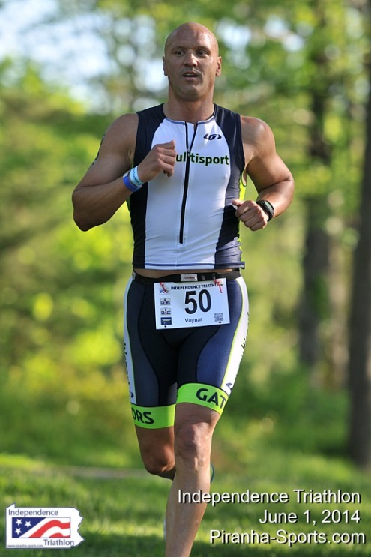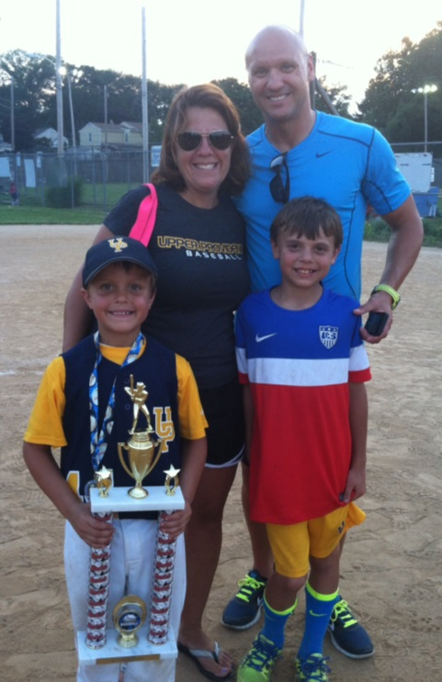
- SVYMG: What is your endurance sports background?
Brent: In the past, I never had an interest in or participated in endurance sports. I had always grown up playing “stick and ball sports” including baseball and football, which I played in college. However, about five years ago a group of friends asked if I wanted to do a Tough Mudder race. I said “yes” and started to do a little training for it. I really liked it and went on to complete several more along with a few others including the MS Mud Run, the Merrill Mud Run, and the Spartan Race multiple times. Then, three years ago, my neighbor Ken Beauchamp started talking to me about possibly doing a triathlon and I again agreed. I had a road bike but was not very good at riding it as all that we’d done were some casual rides. Also, I could run but not very far or fast. And I certainly could not swim. We joined the Spring Valley YMCA Tri Swim class and the Intro to Tri class and that’s where it started. I remember when 100 consecutive yards in the pool seemed to be never ending and completing 1,500 yards in an hour seemed like something only fish could do. So far, my triathlon career consists of approximately 10 sprint distance triathlons and one “half lite” distance event (Devilman). I have achieved one podium finish (top three in age group at the 2014 Independence Triathlon) and on Sunday, September 21, I will be racing in my first Half IRONMAN event at IRONMAN Princeton 70.3.
- SVYMG: What are your top 3 endurance sports goals?
Brent: My top three goals are…
  - Have Fun with great people
  - Train hard and stay in shape
  - Race smart and be mentally tough

- SVYMG: What has been your favorite race in which you've participated (include why if you'd like)?
Brent: Steelman has always been my favorite race. I love the way Dale Winterhoff runs the event, the size of the event, the field of participants, and the course.
- SVYMG: What is the race that you'd most like to do?
Brent: At some point I want to do a full IRONMAN race, mainly because I think it would be really cool (and play way into my ego) to have Mike Reilly say “Brent Voynar, You are an IRONMAN!” Most likely I will do Lake Placid for several reasons: First, it is close enough to drive so I do not have to have the added pressure of shipping my bike. Second, by all accounts it is a great course with a two loop swim which would help with my nervousness during a 2.4 mile swim. And, finally, I know I would have some of my Gator teammates there.
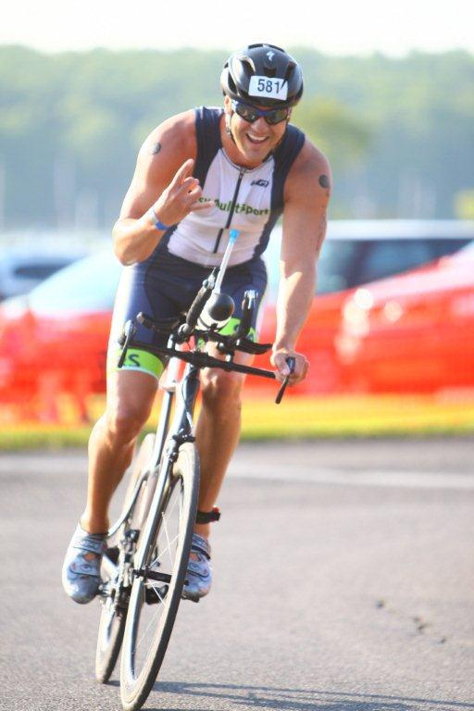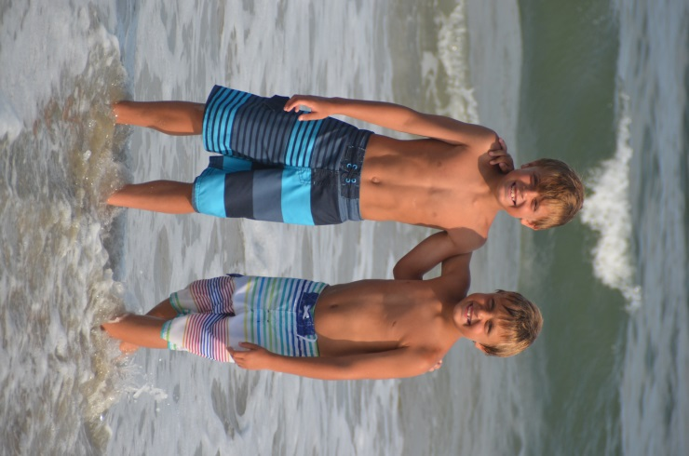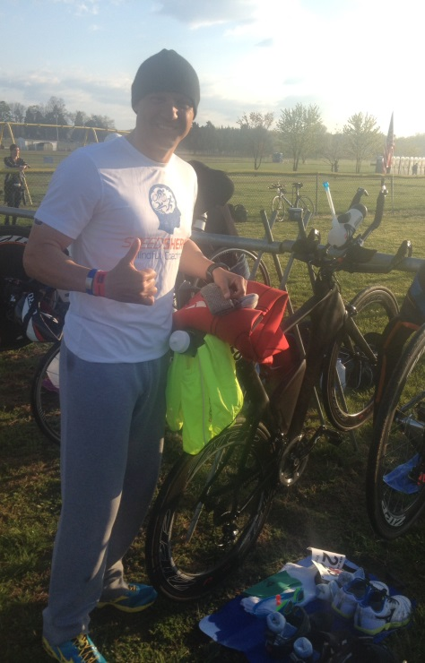
- SVYMG: What song would you most like to hear at the starting line of a race? How about the finish line?
Brent: Oh that is hard as I am not a music guy…I guess something upbeat at the starting line like Flo Rida’s “Good Feeling” and at the finish line…”The Man” by Aloe Blacc.
- SVYMG: What has been your best endurance sports experience to date?
Brent: I would say that when I first started (up until this year), I really enjoyed the training more than the races. I enjoyed the training sessions with Ken and his wife Kelly and now that we have the Tri Club, everyone I have trained with.
- SVYMG: Do you have an endurance sports tip or two that you'd like to share?
Brent: Train with a plan and an eye toward “your” goals. Do not beat yourself up if you miss a workout… This is for fun and we all have many things in our personal lives that are way more important and need our attention.
- SVYMG: Who is your favorite professional endurance sports athlete?
Brent: I would have said Lance Armstrong up until last year (this sport would have gone to another level with him involved). However, I would now say I really do not have a favorite. I follow the sport as a fan of everyone who participates…everyone who gets up and trains in the early morning darkness and who is still training when it gets dark again. Men and women, professionals or age groupers, fast or slow…I respect and commend everyone who participates in this great sport.
- SVYMG: Any other background info you'd like to share?
Brent: I am very thankful and grateful to my wife, Anne, and two boys, Jake and Zach, for allowing me the time to train and race. Since this is my only hobby I often justify to them the time I might otherwise be playing golf or sitting in the dark playing Call of Duty against a 14 year old kid from California. However they are very supportive of the time and energy it takes to do this.

