About a Gator #11: Jon Wesler
September 2014
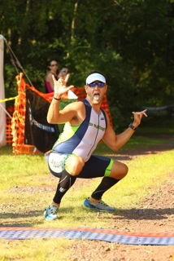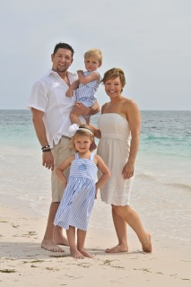
- SVYMG: What is your endurance sports background?
Jon: My endurance sports background I guess you could say started in the military where I willingly ran almost every morning from my sophomore year of college through four years of active duty in the army. To be honest, I really wasn’t that willing, and still do not know why I continued to endure it. I did my first triathlon in Texas, a sprint, and it included a pool swim. If I could not have touched the bottom to push off about every five strokes, I probably would have drowned. I borrowed a friend’s mountain bike and remember to this day him coming out about a mile out on the run to finish the race with me. Although motivating, I did not see the light and discontinued any type of racing until 2008 when Allison and I were somehow talked into doing a 5K (while pushing a stroller). From there I did a few more running races in 2008 and 2009 and then took another break until 2011. That is about when I weighed in a little heavier than I wanted; I’ve included my photos from the races that year for your amusement. I joined the Y’s “Intro to Tri” program and could not swim 50 yards without taking a break. I was even less impressed with myself while running around the outside track. I proceeded to buy a road bike and two days later did my second triathlon, the Trimax Bald Bear race, having no clue what I was doing. I did not even know how to shift gears and finished 9th out of 9! I guess I was hooked by then, so it was time to get a tri bike. Not long after I bought the bike, I was tracking Danny Friend and Vince Bellino all day when they were racing Ironman Cozumel and an ad kept popping up… “Buy this bike, and get a free entry to an IRONMAN race”. So I called the bike shop the next day to confirm and they said it was true. I then called Allison and she said go for it and to register for IRONMAN Florida… She was thinking vacation! HAHAHA! Anyhow that is how it really all started. From June 2013 through May 2014 I completed eight triathlons including four Half IRONMAN distance races and IRONMAN Florida, which were all great learning experiences.
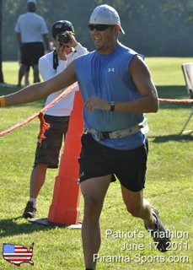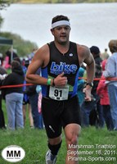
- SVYMG: What are your top 3 endurance sports goals?
Jon:
- Qualify and race at USAT Nationals with Allison
- Set an example for my children through the sport
- Race at IRONMAN Kona
- SVYMG: What has been your favorite race in which you've participated?
Jon: IRONMAN Florida… It gave me a lot of time to reflect and think about really what is important to me. And every time I was able to see my family I pushed it just a little bit harder.
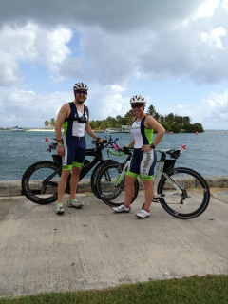
- SVYMG: What is the race that you'd most like to do?
Jon: IRONMAN Austria
- SVYMG: What song would you most like to hear at the starting line of a race? How about the finish line?
Jon: Starting line: Eye of the Tiger and finishing line: Today by Smashing Pumpkins
- SVYMG: What has been your best endurance sports experience to date?
Jon: After the race at IRONMAN St. Croix 70.3, I had the chance to meet Rinny Carfrae and Tim O’Donnell at the athletes’ dinner/awards. Even though you didn’t ask… The second best was winning a cheesesteak bet.
- SVYMG: Do you have an endurance sports tip or two that you'd like to share?
Jon: Put the training time in and have fun. Also, get a few good photo ops in along the way.
- SVYMG: Who is your favorite professional endurance sports athlete?
Jon: Tim O’Donnell
- SVYMG: What is one interesting thing about yourself that has nothing to do with endurance sports that you'd like to share?
Jon: I played ice hockey between 2003-2011… I didn’t just completely sit around.
- SVYMG: Any other background info you'd like to share?
Jon: Triathlons do not leave much spare time, but I have just started the MBA program at Saint Joseph’s University.
