About a Gator #10: Ruth Ann Subach
September 2014
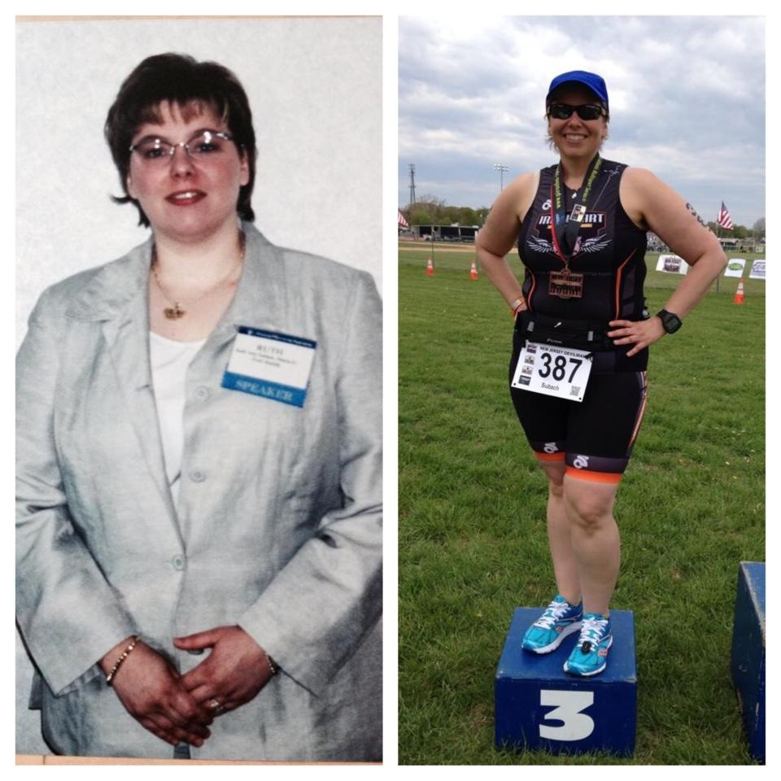
Ruth Ann’s “Before” (~1996-97) and “In-Progress” (2014)
- SVYMG: What is your endurance sports background?
Ruth Ann: My first sporting event as an adult was a 5K in 2006… the second annual Sandy Rollman Ovarian Cancer Society event. I was very overweight, so I thought I’d set a goal and train for something. This motivated me to get moving. I loved all of it, especially the charity component, and wanted more! I repeated that 5K in 2007, did another 5K for Rheumatoid Arthritis, and then went on to train for a 10 mile walk (including 1000 stairs) for the American Diabetes Association. While training for the 10 mile walk, I had 3 key people inspire me to expand what I was doing… Two friends, Holly Green and Mary Larson, and a guy named Dan, who was a business associate. Holly had just finished her first Ironman (Coeur d’Alene 2007), and couldn’t believe such a thing could be done. Mary was running and had her sights set on triathlon. And when I was speaking with Dan one night over drinks, I mentioned in passing that “I’d like to do a triathlon someday”. Well, he told me he was a triathlete, and suggested that I started spinning at the gym. He helped me to get started. I fell in love with spinning during my first class and became a spinning instructor in 2008.
Now that I had my bike legs…I purchased a hybrid bike and started riding outside. I did my first “triathlon” in 2008, the Marshalton Triathlon (West Chester, PA), which is comprise of bike, canoe, walk, and bike legs. I loved it! In 2009, I completed my first 25 mile bike ride (Girls with Gears) and then my first 40 mile bike ride for the ADA. I upgraded to a road bike in June 2009, as I’d registered for MS City to Shore, and knew I wouldn’t enjoy a hybrid for 75 miles. I was right. I loved my road bike for all 75 of the miles from Cherry Hill to Ocean City, and I raised $1000 for the organization. In the winter of 2010, I signed up for my first century ride with Team in Training. I trained with them and completed the America’s Most Beautiful Bike Ride event around Lake Tahoe in June 2010, which was a year to the day after I got my road bike. It took me 12 hours but I got it done and didn't walk any hills. I raised about $3,500 for the Leukemia and Lymphoma Society.
Later that year while on vacation, Marc and I happened to be staying at the hotel where the first “Tri Key West” triathlon was being held. We got up early and watched the race. I was certain I wanted to do a “real triathlon” after seeing the race. Later in December, while visiting my friend Holly, I saw all of her triathlon and Ironman medals displayed in her basement. We talked about what it would take to do a triathlon and Holly encouraged me to “give it a tri”! As soon as I got home from that trip I signed up for my first triathlon.
In 2011-12 I completed six triathlons. The first was a YWCA women's triathlon in York, PA. I chose this as my first because it had a pool swim and was open to women only, so it was less intimidating. I successfully completed that event and then did SheRox in Philadelphia. I was extremely proud of myself to have completed my first river open water swim. I was hooked! In 2012 I joined the Tri Club at Spring Valley YMCA, and did four triathlons (three sprints and the Tri Key West Olympic race where I placed 2nd in Athena over 40!). Danny Friend and the club were instrumental in preparing me to complete my first sprint, where I RAN the entire 5K, and my first Olympic event. During this time my friend Mary Larson trained for and completed IRONMAN Wisconsin (IMWI) 2011. I witnessed her progress on Facebook and became increasingly interested in longer events.
In the midst of training for Tri Key West I volunteered for IMWI 2012. In the months and days leading up to the race, my friends were encouraging me to sign up for IMWI 2013. I talked to Danny and he said we’d work together to achieve that goal, so I signed up. I couldn't believe I registered and subsequently followed the vast majority of my training plan.
However, 2013 was a difficult year. While I had some successes, I faced three DNFs and one race that was ended short due to a lightning storm (IRONMAN Syracuse 70.3). Two DNFs were caused by cold water-induced bronchoconstriction/asthma and/or swimming induced pulmonary edema. In fact one race, IRONMAN Racine 70.3 landed me in the emergency room.
The results of the testing of my breathing issues resulted in me being asked by my physicians to stay out of the water until we figured things out. For the most part I followed their advice, but in mid-August I got back in the water and tried to continue to train for IMWI; IMWI 2013 was an amazing experience. My friend Holly came to race with me and Mary was racing as well! I felt that I had been trained well and I had lost a lot of weight, so I felt very good about my body image and athletic ability. I had a reasonable degree of confidence that I could complete the race, as I’d swam between 2.4 and 4 mile distances three times, completed a training ride of 117.5 miles on the IMWI bike course, and completed a long run of over 15 miles. On race day, however, a strong wind caused a lot of chop in Lake Monona. I started the swim feeling very calm and peaceful. When the cannon went off, we all just started swimming! I was amazed at how fast I felt I was moving in the water being pulled by 2,500 other athletes. Despite that, the way the wind pushed me off course and, since I typically tend to swim to the right, I was even more off course. On one portion of the course, I was fighting the waves/chop directly for about 1.5 miles. I didn’t give up…but I missed the swim cut off by 4:43.
Long story short, I signed up IMWI 2014 knowing that there was a chance I wouldn’t finish in 2013 and then I also registered for several other 2014 races including Challenge Atlantic City 140.6 (CAC). 2014 has treated me fairly well, including 3rd place age group at the New Jersey Devilman Sprint. However, I missed the swim cut-off at CAC due to some extremely strong currents, which I was not strong enough or swim-smart enough to overcome. I was going to withdraw from IMWI due to the fact that I had some right foot issues all season and I hadn’t been running and my motivation had been pretty low. Additionally, travel/life kept being a great excuse for getting in the way… but I “forgot” to withdraw, so here I go!
As I head into IMWI 2014, I know that I have practiced my swimming well and have a good shot at finishing that swim on time. I completed my first 5K swim in under 2:30 and most of my other timed swims indicate that I should beat the 2:20 cut-off. As far as the rest of IMWI, I don't know. Anything after the swim is gravy! From a training standpoint, this year has been a tough one both mentally and physically. I’ve gained some weight, but that's not going to stop me! I will give it my all!
Throughout this entire adventure, I’ve had so many people help me; it’s impossible to name them all. But you all are part of this journey with me… I have SO MUCH MORE TO SAY! Watch for my “book”… there will be plenty of names and stories in there!
- SVYMG: What are your top 3 endurance sports goals?
Ruth Ann: My top three endurance sports goals are…
  - Finish a full IRONMAN distance race (140.6 miles) before I am 50ish
  - To be successful, I know I need to win this weight loss battle that I have been fighting my entire life. Managing a consistently healthy diet is the hardest part for me. My goal is to weigh between 155-165 lbs by the end of 2015
  - In the next two years I plan on increasing my speed and endurance in all three sports. Specifically, I would like to be able to swim 100's consistently at a sub-2:20 pace, run a 5K in under 34 minutes, and ride my bicycle up hills in a steady consistent manner and not drop speed. I’ll attempt my next 140.6 in 2016.

- SVYMG: What has been your favorite race in which you've participated?
Ruth Ann: The Tri Key West Olympic distance triathlon has been my favorite race. I went into that race physically strong, physically fit, and mentally strong. I had an amazing day! Next would be IRONMAN Syracuse 70.3 where I battled the long climb with positivity and mastered a steep downhill followed by a steep uphill. At this race I found that I had some grit. I really wanted to keep running even in the thunder and lightning!
- SVYMG: What is the race that you'd most like to do?
Ruth Ann: I really want to complete IMWI. I believe that course will eventually fit my skills perfectly. It is a technical and beautiful course with spectators from the beginning to the end. On Sept 1, 2014, during a strength session with my personal trainer Kevin McLemore, I also got it in my head to aim for Kona… seriously. If you shoot for the stars, you may just land on the moon. I’m not 100% committed to it yet, as it seems so unreachable for me to go from an Athena, back-of-the-packer, to a top placer in an IRONMAN, but wouldn’t it be great if I did it?!?!
- SVYMG: What song would you most like to hear at the starting line of a race? How about the finish line?
Ruth Ann: At the start... “The Distance” by Cake. During the run, I would love to hear “Defying Gravity” by Idina Menzel. At the finish... “She's Got Legs” by ZZ Top.
- SVYMG: What has been your best endurance sports experience to date?
Ruth Ann: My first half marathon, up in the mountains of Utah, was an amazing experience. Between the altitude and the course elevation change, I thought the course might kill me… but it didn't. And it brought out the true competitor in me as I was racing one other person to the finish line and made sure that even a “stop in the woods” wouldn't put me behind her again.
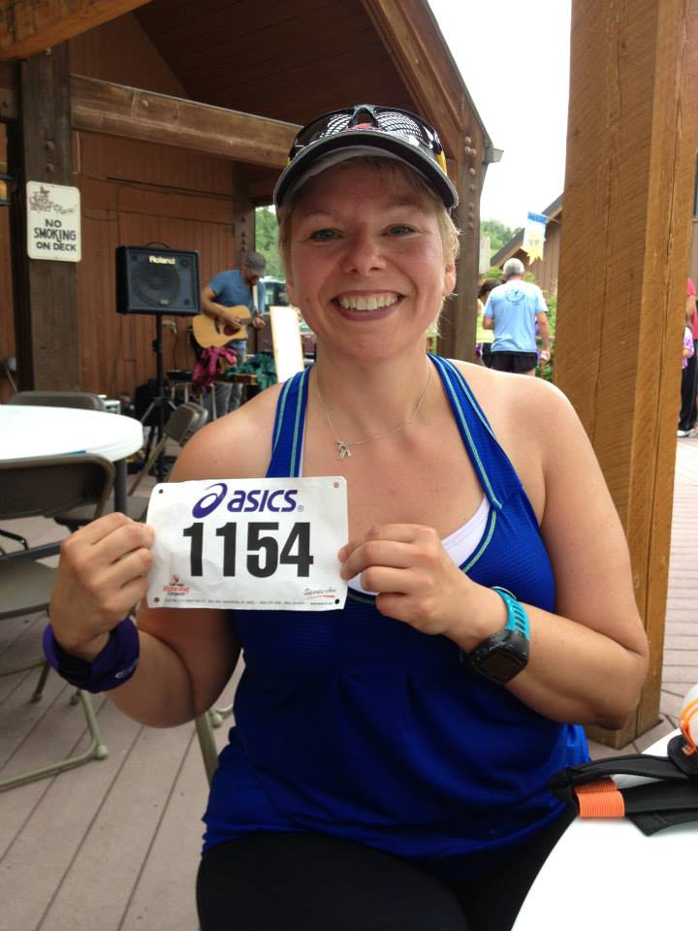
Ruth’s ½ Marathon - Canyon to Canyon - July 13, 2013
- SVYMG: Do you have an endurance sports tip or two that you'd like to share?
Ruth Ann: For an Ironman, on race morning, take three bags with you… Bag #1 is what you're actually going to put on your bicycle (e.g. water bottles). Bag #2 is what you're going to need to top off your T1 bag. And bag #3 is what you’re going to need to top off your T2 bag. If you try to place what you're going to put on your bicycle inside your T1 or T2 bag additions, you may find yourself going back-and-forth between the different places.
And use a lot of anti-chafing products… Seriously… I love Trislide!
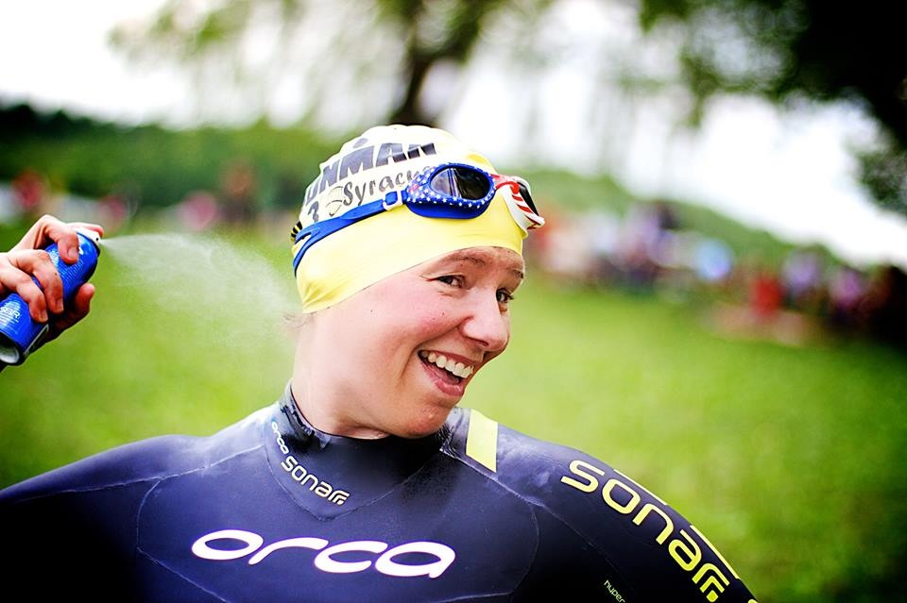
- SVYMG: Who is your favorite endurance sports athlete?
Ruth Ann: Chrissie Wellington… Her book was so good I bought it all three versions… hard copy, electronic, and audiobook! Also, Mirinda Carfae... She’s a tiny powerhouse. I got to meet her at CAC 2013 and she was really sweet. And Ryan Leong, an Ironheart athlete... You think you have it tough? Read about Ryan here: https://evolve.againfaster.com/portfolio/addict/
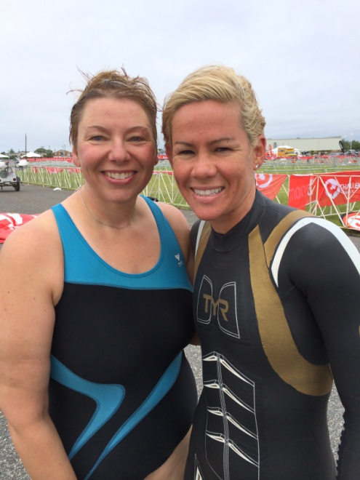
Ruth Ann & Mirinda Carfrae at Challenge Atlantic City 2013

- SVYMG: What is one interesting thing about yourself that has nothing to do with endurance sports that you'd like to share?
Ruth Ann: I took belly dancing lessons for two years and performed at Casablanca in Warrington with my instructor and class. Talk about getting out of your shell!!! And after IMWI Marc and I are headed to South Africa for three weeks where I hope to meet some members of the Ironheart Foundation… as well as see a lion or two.
- SVYMG: Any other background info you'd like to share?
Ruth Ann: I am married to a great guy named Marc… He doesn’t do these crazy triathlon things, but he runs and lifts weights and is “happy” to Sherpa for me at races. It was he whom I had to convince to support me in my IRONMAN adventures… Without family support, I’d bet the journey would be 100x more difficult. We have four pets… a cat named Cipro and three dogs named Cosmo Kramer, George Costanza, and Stella Rigel. We also have two nieces (Irma and Madelane), a nephew (Isaac), and another niece on the way! Professionally, I’ve completed my bachelors and doctorate in Pharmacy (yes, you may call me Dr. Ruth) and a post-doc research fellowship in nephrology and transplant. I currently work in the pharmaceutical industry designing and managing clinical research trials… This is my way of giving back to humanity. However, in the long run, “all work and no play” doesn’t work. That used to be my life, and it contributed to weighing nearly 250 pounds on my 5’5” frame. Now, I give back through my work and through the charitable causes that I represent when training and racing. Since 2013, I’ve been a member of the Ironheart Foundation Racing team, as my family has been plagued by cardiovascular disease. My father died of sudden cardiac death on the way home from a spinning class at age 56, my mom had triple bypass at age 49, and my brother had a heart attack at age 39. Luckily my sister and I have been “cardiovascular event-free” so far. Part of my racing is for a very selfish reason… I’m trying to minimize or prevent cardiovascular disease through lifestyle changes. I hope it works!

