About a Gator #9: Maddie Matarazzo
August 2014
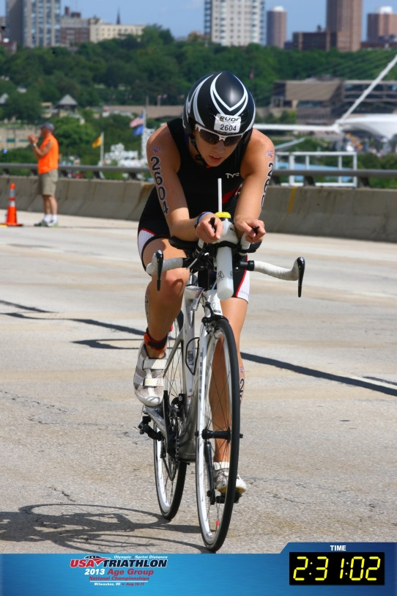
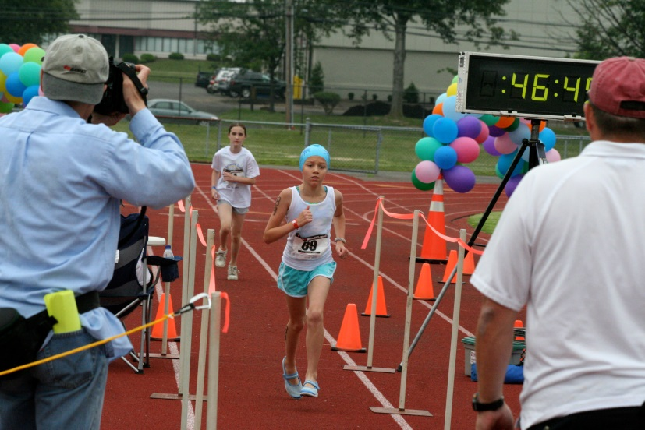

- SVYMG: What is your endurance sports background?
Maddie: I began competitively swimming when I was six and I signed up for my first triathlon at age nine after seeing a flyer for one on the side of the road. It was the “Schools Out Kids Triathlon”, a 50 yard swim, 3 mile bike and ¾ mile run. I just got a little taste of endurance sports and I was hooked. I kept signing up for kid distance races, but never really trained for anything other than the swim. A shoulder injury when I was 12 forced me out of the water for almost two seasons, so naturally I turned to biking and running for exercise. I signed up for my first adult race when I was 12. It was a short DQ sponsored sprint triathlon and I loved every second of it! I also completed the kids’ triathlon they hosted later that day… Two triathlons in one day and I was all smiles! I kept singing up for more races and got more serious with my training, at least as serious as a 13 year old can get with triathlon training! My freshman year in high school my shoulder was still giving me trouble and my swim coach wouldn’t permit me to cross train, so I quit competitive swimming completely and since then have fully been focused on triathlons.
- SVYMG: What are your top 3 endurance sports goals?
Maddie: Naturally, I want to race Kona. It’s been a dream of mine ever since my first triathlon. I also really would like to return to the USAT Age Group Nationals and take top five in my age group (Editor’s Note: Maddie placed in the top 10 in the 2013 USAT Nationals, high enough to qualify for the 2014 ITU World Championships taking place in Edmonton, Alberta, Canada from August 26 through September 1, 2014). My third goal is to get my entire family to do a triathlon together.
- SVYMG: What has been your favorite race in which you've participated?
Maddie: My favorite race has been USAT Age Group Nationals in Milwaukee. It was the largest race in which I’ve ever participated and being surrounded by thousands of triathletes was an awesome feeling! The course was incredible (we got to bike on an expressway!) and the entire atmosphere of the race was so amazing. Plus, four-time IRONMAN World Champion, Chrissie Wellington, put my finisher’s medal on.
- SVYMG: What is the race that you'd most like to do?
Maddie: Other than Kona, I would love to try to complete IRONMAN Lake Placid (maybe in 2016?!). I think it would be great to be able to complete my first IRONMAN event with the team there to support me.
- SVYMG: What song would you most like to hear at the starting line of a race? How about the finish line?
Maddie: It would be awesome to hear “Till I Collapse” by Eminem at the starting line and Fort Minor’s “Remember the Name” at the finish line.
- SVYMG: What has been your best endurance sports experience to date?
Maddie: My best triathlon experience was in 2010 at the New Jersey Devilman triathlon. I got off the bike a few seconds behind a girl in my age group and caught up to her in the beginning of the four-mile run. As I reached her, she started a conversation with me and introduced herself as Brooke Saunders. We ran 10+ minute miles and talked the entire time, mostly about how much we hated running! When the finish line was in sight we sped up and crossed the finish line at the same time. My split was .02 seconds faster, so I won our age group. Ever since then Brooke and I have been friends, meeting up at races and talking on Facebook. Brooke went on to win USAT Nationals for the 16-19 age group in 2012 and came in second at the 2013 ITU Worlds in London.
- SVYMG: Do you have an endurance sports tip or two that you'd like to share?
Maddie: If you feel like you need a rest day, take a rest day. Being an athlete means training hard, but knowing when you need to recover. When you’re racing remember that it’s okay to be competitive, but it doesn’t hurt to smile and to give out a few “good jobs” or “keep it ups” along the way. We’re all in this together as triathletes and we all need to support each other!
- SVYMG: If you have one, who is your favorite professional endurance sports athlete?
Maddie: Chrissie Wellington… Her story is incredible and I think she is an amazing role model for female athletes.
- SVYMG: What is one interesting thing about yourself that has nothing to do with endurance sports that you'd like to share?
Maddie: I am now a senior at Owen J. Roberts High School, so the college search has started. My top school as of right now is James Madison University. Outside of training for triathlons I love to ski and hike!
SVYMG: Any other background info you'd like to share?
Maddie: My parents both are doing their first triathlon this past weekend! (Editor’s Note: Both Mindy and Al successfully finished the Medford Lakes, NJ sprint triathlon on August 24, 2014.) For the first time I got to cheer them on while they raced. My mom is already planning her next racing season; I think she may be hooked already! My brother is a sophomore at Bucknell University… Maybe one day he will join in on the triathlons as well!
