About a Gator #8: Mary Cook
August 2014
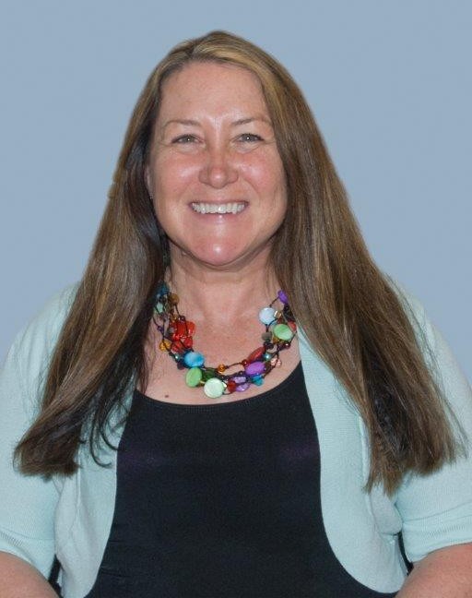
- SVYMG: What is your endurance sports background?
Mary: I was a runner in high school (events: mile, two mile, and discus) and continued running recreationally throughout college and completing two Philadelphia Distance Runs in 1982 and 1983. I got married in 1984 (on the Distance Run weekend) and then moved to Maine. I took a long break from training for events, but I transitioned to swimming at two local YMCAs. While raising three girls (now ages 22, 24, and 26) as well as hosting 19 Rotary Youth Exchange students in 21 years, my personal life was dedicated to them, but I was always swimming and running on my own. I trained for my first triathlon in 1997 in Massachusetts. It included a pool swim, a 10 mile bike ride, and a 3.2 mile run. For the race, I borrowed a bike from someone I coached who now is an R & D engineer for Specialized Bicycle Components. I was a YMCA swim coach at the time and our team kept growing and getting better, so I was traveling all around the country with them.
Then my personal life went through another change... We moved to Pennsylvania in October 1999. I joined the Phoenixville YMCA and got an online triathlon coach from Canada and started training for an Olympic event. I trained all of 2000. I finished the Lancaster Olympic triathlon in September 2001.
One thing I realized with an online coach is that there is no psychological training. Training in a pool is great, but swimming in a mucky lake is totally different, especially one that smells like cow manure. On top of that, it was freezing! I had no wetsuit and when I first entered the water, I thought it was warm… The water temperature ended up being 64 degrees! It took me to the turn-around point to warm up. Despite that, I finished and wanted to continue. But I took a break when I got a job at Perkiomen Valley School District’s Community Education revamping their swim program and coaching the aquatic club.
Flash forward a few years… I started working at the Spring-Valley YMCA and my job was to run the aquatic fitness program. At the time we had a total of 12 hours of adult fitness programming and 90% of it was geared towards seniors. We had three people on our Masters swim team, so I initially focused on the Masters team and then formed the Tri Club in 2006. We had a 10 week program that included a 70 day work out regimen and we finished the last class with a sprint tri. Members could pick their swim distance (quarter, half, or full mile swim), the bike duration (30 or 45 minute spin), and the run distance (5K or 10K on the outside track). We practiced our T1 and T2 transitions in the locker rooms. I also started the Tri Swim Class on Mondays and Wednesdays and had up to 16 people in two lanes training… That was fun! Talk about psychological training…I then started taking the Tri Club folks to Marsh Creek and swimming outside on Tuesday nights. Some nights we threw in a bike ride or a run. I had the great fortune of working with Ellen Friend and she signed Danny up for private swim lessons with me. It took me a few years to get Danny on our team and the rest is history!
I am sooooo proud of all of your accomplishments! I love reading your bios, the race recaps, and all of your emails. I am proud of the growth of our aquatic fitness program and the fact that we now have over 50 people on our Spring-Valley Multisport Gators team.
- SVYMG: What are your top 3 endurance sports goals?
Mary: Ever since I visited France in 2004, I have wanted to travel with the Tour De France. Ever since I went to Hawaii in 1996, I have wanted to be in the finish area of IRONMAN in Kona. And, someday I would like to participate in a full distance aqua bike event that includes a 2.4 mile swim and 112 mile bike ride.
- SVYMG: What has been your favorite race in which you've participated?
Mary: I really enjoyed competing in the Philly Olympic triathlon a few years ago… Seeing my husband near T2 was great!
- SVYMG: What is the race that you'd most like to do?
Mary: At this point in my life, I just want to sign up for an event and actually finish it. I know I have an ideal work location for this type of hobby and I should have no excuses for working out, but after a long day at the office, I really just want to go home. I have gained twenty pounds while working at the Y... Totally not acceptable I know and I don’t want to run until I get some weight off, because I have had stress fractures in my feet and have torn my meniscus (surgery in2009).
- SVYMG: What song would you most like to hear at the starting line of a race? How about the finish line?
Mary: Bruce Springsteen serenading me with “Born to Run”… Live, of course… Both at the start and finish!
- SVYMG: What has been your best endurance sports experience to date?
Mary: Raising three girls through their teens.
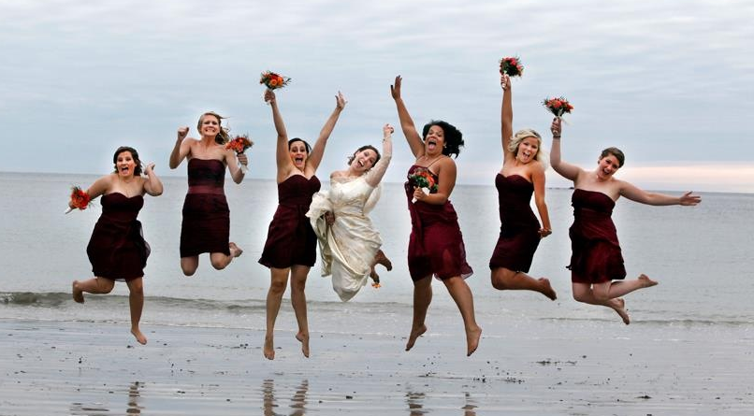
Mary's Daughters (two ends and middle)
- SVYMG: Do you have an endurance sports tip or two that you'd like to share?
Mary: Train without socks. You have to wash your running shoes more often, but it really toughens your feet and it cuts down time in the transitions.
- SVYMG: If you have one, who is your favorite endurance sports athlete?
Mary: Ruth Subach... She inspires me.
- SVYMG: What is one interesting thing about yourself that has nothing to do with endurance sports that you'd like to share?
Mary: I have a granddaughter who will turn one year old on August 28… I absolutely love being a grand mom!

- SVYMG: Any other background info you'd like to share?
Mary: In addition to what I mentioned at the beginning, some other things about me… There is always a method to my madness. The reason I focused on developing the Masters Team when I arrived was because masters swimmers understand how long it takes to learn how to swim; it literally takes years (on average about eight years). Masters team members understand that and they sign their children up for lessons, which, in turn, expands our youth program.
I focused on the triathlon program because I know the YMCA is a great place to build a community. I hated training alone and I hated having an online coach. Multisport people usually start as runners or cyclists and then they finally take up swimming because they want to do a triathlon. But they struggle with it at first. This is the type of person I love to work with. I have been fortunate to work with some really great swim coaches throughout my career, and since I wasn’t a great swimmer growing up, I absorbed their knowledge like a sponge. I am a huge proponent of swimming “with your brain in total function”. If you ever want to learn more about it, contact me… I could talk swimming for hours!
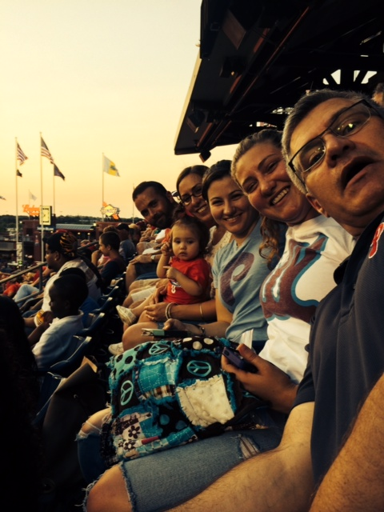
Mary's Family

